**APPLICATION OF DISCRETE MATHEMATICS**

**Some terminology :**

**Theorem** : A theorem is a statement that can be shown to be true. We demonstrate that a theorem is true with a proof.

**Proposition** : Less important theorem

**Axioms** or **postulates** : Statements we assume to be true.

**Lemma** : A less important theorem that is helpful in the proof of other results.

**Corollary** : Theorem that can be established directly from a theorem that has been proved.

**Conjecture** : A statement that is being proposed to be a true statement, usually on the basis of some partial evidence, a heuristic argument, or the intuition of an expert.

1. **The Foundations: Logic and Proofs**
   1. **Propositional Logic** :

A **proposition** is a declarative sentence (that is, a sentence that declares a fact) that is either true or false, but not both. For example : All the following declarative sentences are propositions.

1. Washington, D.C., is the capital of the United States of America.
2. Toronto is the capital of Canada.
3. 1 + 1 = 2.
4. 2 + 2 = 3. Propositions 1 and 3 are true, whereas 2 and 4 are false.

We use letters to denote **propositional variables** (or sentential variables), that is, variables that represent propositions, just as letters are used to denote numerical variables. New propositions, called **compound propositions**, are formed from existing propositions using logical operators (Not operator, Conjunction (and), disjunction, exclusive or (XOR)).

* *For example* : Find the negation of the proposition “Vandana’s smartphone has at least 32 GB of memory” and express this in simple English.

*Solution*: The negation is “It is not the case that Vandana’s smartphone has at least 32 GB of memory.”

This negation can also be expressed as “Vandana’s smartphone does not have at least 32 GB of memory” or even more simply as “Vandana’s smartphone has less than 32 GB of memory.”

* Let p and q be the propositions that state “A student can have a salad with dinner” and “A student can have soup with dinner,” respectively. What is p ⊕ q, the exclusive or of p and q?

*Solution*: The exclusive or of p and q is the statement that is true when exactly one of p and q is true. That is, p ⊕ q is the statement “A student can have soup or salad, but not both, with dinner.” Note that this is often stated as “A student can have soup or a salad with dinner,” without explicitly stating that taking both is not permitted.

***Conditional Statements*** : The statement p → q is called a conditional statement because p → q asserts that q is true on the condition that p holds. A conditional statement is also called an **implication**.

Different meanings:

“if p, then q”

“p implies q”

“if p, q”

“p only if q”

“p is sufficient for q”

“a sufficient condition for q is p”

“q if p”

“q whenever p”

“q when p”

“q is necessary for p”

“a necessary condition for p is q”

“q follows from p”

“q unless ¬p”

“q provided that p”

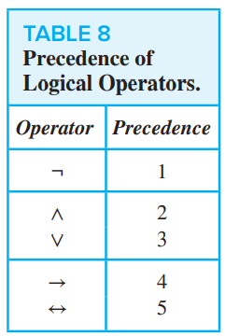***Converse, Contrapositive, And Inverse*** :

The proposition q → p is called the converse of p → q.

The contrapositive of p → q is the proposition ¬q → ¬p.

The proposition ¬p → ¬q is called the inverse of p → q.

***Biconditional Statement*** : The biconditional statement p ↔ q is the proposition “p if and only if q.” The biconditional statement p ↔ q is true when p and q have the same truth values, and is false otherwise. Biconditional statements are also called **bi-implications.**

Different meaning ***:***

“p is necessary and sufficient for q”

“if p then q, and conversely”

“p iff q.”

“p exactly when q.”

Truth table of compound proposition :

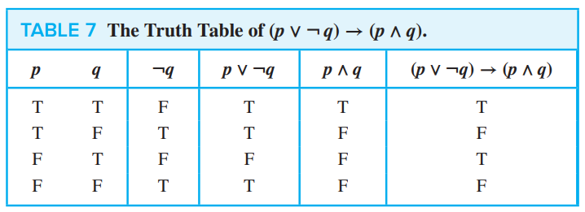

* 1. **Application of Propositional Logic** :

**Translating English sentence** :

* Example : How can this English sentence be translated into a logical expression? “You cannot ride the roller coaster if you are under 4 feet tall unless you are older than 16 years old.”

Solution: Let q, r, and s represent “You can ride the roller coaster,” “You are under 4 feet tall,” and “You are older than 16 years old,” respectively. Then the sentence can be translated to (r ∧ ¬s) → ¬q.

**System Specification (Consistent and Inconsistent)** : System specifications should be **consistent**, that is, they should not contain conflicting requirements that could be used to derive a contradiction. When specifications are **not consistent**, there would be no way to develop a system that satisfies all specifications.

* *For example* : Determine whether these system specifications are consistent :

“The diagnostic message is stored in the buffer or it is retransmitted.”

“The diagnostic message is not stored in the buffer.”

“If the diagnostic message is stored in the buffer, then it is retransmitted.”

*Solution*: To determine whether these specifications are consistent, we first express them using logical expressions. Let p denote “The diagnostic message is stored in the buffer” and let q denote “The diagnostic message is retransmitted.” The specifications can then be written as p ∨ q, ¬p, and p → q. An assignment of truth values that makes all three specifications true must have p false to make ¬p true. Because we want p ∨ q to be true but p must be false, q must be true. Because p → q is true when p is false and q is true, we conclude that these specifications are consistent, because they are all true when p is false and q is true.

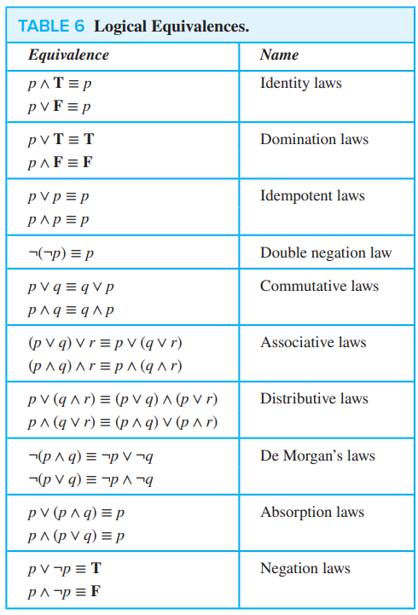

* 1. **Propositional Equivalences :**

A compound proposition that is always true, no matter what the truth values of the propositional variables that occur in it, is called a **tautology**. A compound proposition that is always false is called a **contradiction**. A compound proposition that is neither a tautology nor a contradiction is called a **contingency**.

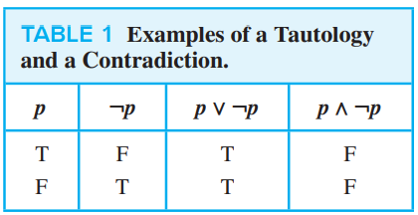

Compound propositions that have the same truth values in all possible cases are called **logically equivalent**. We can also define this notion as follows. The compound propositions p and q are called *logically equivalent* if p ↔ q is a tautology. The notation p ≡ q denotes that p and q are logically equivalent.

**NOTE** : The symbol ≡ is not a logical connective, and p ≡ q is not a compound proposition but rather is the statement that p ↔ q is a tautology. The symbol ⇔ is sometimes used instead of ≡ to denote logical equivalence.

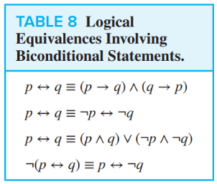

**De-Morgan’s Law** : Because the truth values of the compound propositions ¬(p ∨ q) and ¬p ∧ ¬q agree for all possible combinations of the truth values of p and q, it follows that ¬(p ∨ q) ↔ (¬p ∧ ¬q) is a tautology and that these compound propositions are logically equivalent.

p → q and ¬p ∨ q is logically equivalent. (This is known as the **conditional-disjunction equivalence**.)

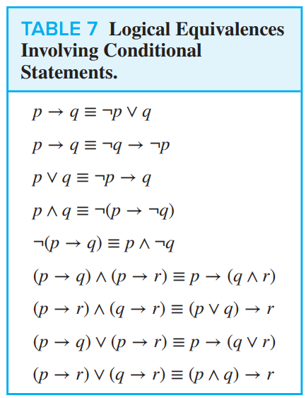

**Satisfiability** : A compound proposition is **satisfiable** if there is an assignment of truth values to its variables that makes it true (that is, when it is a tautology or a contingency). When no such assignments exist, that is, when the compound proposition is false for all assignments of truth values to its variables, the compound proposition is **unsatisfiable**. **Valid** means it should be tautology only. A propositional formula is satisfiable if there is at least one true result in its truth table, valid if all values it returns in the truth table are true.

The sentence S is a logical consequence of S1,..., Sn if and only if S1 ∧ S2 ∧........ ∧Sn → S is valid.

* 1. **Predicates and Quantifiers :**

Propositional logic, studied in Sections 1.1–1.3, cannot adequately express the meaning of all statements in mathematics and in natural language. For example, suppose that we know that “Every computer connected to the university network is functioning properly.”

**Predicate** : Statements involving variables, such as “x > 3,” “x = y + 3,” “x + y = z,

The statement “x is greater than 3” has two parts. The first part, the variable x, is the subject of the statement. The second part—the **predicate**, “is greater than 3”—refers to a property that the subject of the statement can have. We can denote the statement “x is greater than 3” by P(x), where P denotes the predicate “is greater than 3” and x is the variable. The statement P(x) is also said to be the value of the **propositional function** P at x.

* *For example* : Let P(x) denote the statement “x > 3.” What are the truth values of P(4) and P(2)?

*Solution*: We obtain the statement P(4) by setting x = 4 in the statement “x > 3.” Hence, P(4), which is the statement “4 > 3,” is true. However, P(2), which is the statement “2 > 3,” is false.

* We can also have statements that involve more than one variable. For instance, consider the statement “x = y + 3.” We can denote this statement by Q(x, y), where x and y are variables and Q is the predicate.
* *For example* : Let Q(x, y) denote the statement “x = y + 3.” What are the truth values of the propositions Q(1, 2) and Q(3, 0)?

*Solution*: To obtain Q(1, 2), set x = 1 and y = 2 in the statement Q(x, y). Hence, Q(1, 2) is the Extra Examples statement “1 = 2 + 3,” which is false. The statement Q(3, 0) is the proposition “3 = 0 + 3,” which is true.

**Precondition and Postcondition** : The statements that describe valid input are known as **preconditions** and the conditions that the output should satisfy when the program has run are known as **postconditions**.

* *For example* : Consider the following program, designed to interchange the values of two variables x and y.

temp := x

x := y

y := temp

*Solution*: For the precondition, we need to express that x and y have particular values before we run the program. So, for this precondition we can use the predicate P(x, y), where P(x, y) is the statement “x = a and y = b,” where a and b are the values of x and y before we run the program. Because we want to verify that the program swaps the values of x and y for all input values, for the postcondition we can use Q(x, y), where Q(x, y) is the statement “x = b and y = a.” To verify that the program always does what it is supposed to do, suppose that the precondition P(x, y) holds. That is, we suppose that the statement “x = a and y = b” is true. This means that x = a and y = b. Consequently, after this program is run, the postcondition Q(x, y) holds, that is, the statement “x = b and y = a” is true.

***Quantifier*** :

**Quantification** expresses the extent to which a predicate is true over a range of elements. In English, the words all, some, many, none, and few are used in quantifications. We will focus on two types of quantification : **universal quantification(∀)**, which tells us that a predicate is true for every element under consideration, and **existential quantification(∃)**, which tells us that there is one or more element under consideration for which the predicate is true.

* The *universal quantification* of P(x) is the statement “P(x) for all values of x in the domain.” The notation ∀xP(x) denotes the universal quantification of P(x). Here ∀ is called the universal quantifier. We read ∀xP(x) as “for all xP(x)” or “for every xP(x).” An element for which P(x) is false is called a **counterexample** to ∀xP(x).

Universal Quantifier can be expressed in terms of AND operation when applied to finite number of predicates (P(X)).

* The *existential quantification* of P(x) is the proposition “There exists an element x in the domain such that P(x).” We use the notation ∃xP(x) for the existential quantification of P(x). Here ∃ is called the existential quantifier. Other meanings : “There is an x such that P(x),” “There is at least one x such that P(x),” “For some xP(x).”

Existential Quantifier can be expressed in terms of OR operation when applied to finite number of predicates (P(X)).

* **Uniqueness quantifier**, denoted by ∃! or ∃1. The notation ∃!xP(x) [or ∃1xP(x)] states “There exists a unique x such that P(x) is true.” (Other phrases for uniqueness quantification include “there is exactly one” and “there is one and only one.”)

∃!x (P(x) ∧Q(x)) → ∃!xP(x) ∧ ∃!xQ(x)

Above statement is false. Consider P(x) is true only for x1. And Q(x) is true for x1 and x2. So lefthand side is true. But righthand side is false since Q(x) is not true for unique x.

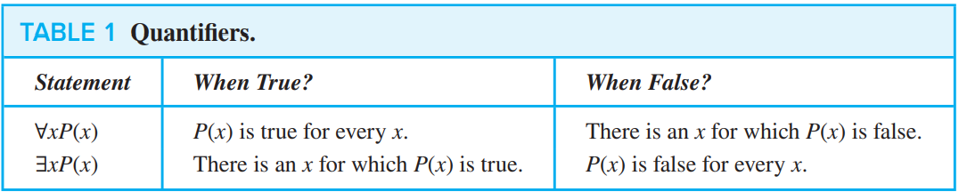 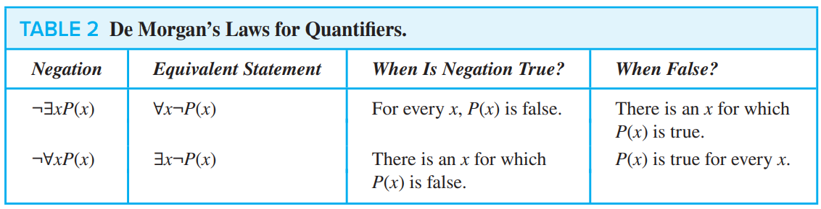

***Quantifiers with Restricted Domains*** : for example :

* The statement ∀x < 0 (x2 > 0) states that for every real number x with x < 0, x2 > 0. That is, it states “The square of a negative real number is positive.” This statement is the same as ∀x(x < 0 → x2 > 0).
* The statement ∀y ≠ 0 (y3 ≠ 0) states that for every real number y with y ≠ 0, we have y3 ≠ 0. That is, it states “The cube of every nonzero real number is nonzero.” This statement is equivalent to ∀y(y ≠ 0 → y3 ≠ 0).
* Finally, the statement ∃z > 0 (z2 = 2) states that there exists a real number z with z > 0 such that z2 = 2. That is, it states “There is a positive square root of 2.” This statement is equivalent to ∃z(z > 0 ∧ z2 = 2).

***English to quantifier* :** Consider these statements. The first two are called **premises** and the third is called the **conclusion**. The entire set is called an **argument**.

1. “All lions are fierce.” “Some lions do not drink coffee.” “Some fierce creatures do not drink coffee.”

Solution :

∀x(P(x) → Q(x)).

∃x(P(x) ∧ ¬R(x)).

∃x(Q(x) ∧ ¬R(x)).

1. “All hummingbirds are richly colored.” “No large birds live on honey.” “Birds that do not live on honey are dull in color.” “Hummingbirds are small.”

Solution : Let P(x), Q(x), R(x), and S(x) be the statements “x is a hummingbird,” “x is large,” “x lives on honey,” and “x is richly colored,” respectively.

∀x(P(x) → S(x)).

¬∃x(Q(x) ∧ R(x)).

∀x(¬R(x) → ¬S(x)).

∀x(P(x) → ¬Q(x)).

* 1. **Nested Quantifiers :** ∀x∃y(x + y = 0)

***1.5.1) Understanding Statements Involving Nested Quantifiers*** :

Translate into English the statement ∀x∀y((x > 0) ∧ (y < 0) → (xy < 0)) : The product of a positive real number and a negative real number is always a negative real number.

***1.5.2) The Order of Quantifiers*** :

* Let P(x, y) be the statement “x + y = y + x.” What are the truth values of the quantifications ∀x∀yP(x, y) and ∀y∀xP(x, y), where the domain for all variables consists of all real numbers?

Solution : Note that the statement ∀y∀xP(x, y) says “For all real numbers y, for all real numbers x, x + y = y + x.” This has the same meaning as the statement “For all real numbers x, for all real numbers y, x + y = y + x.” That is, ∀x∀yP(x, y) and ∀y∀xP(x, y) have the same meaning, and both are true.

* 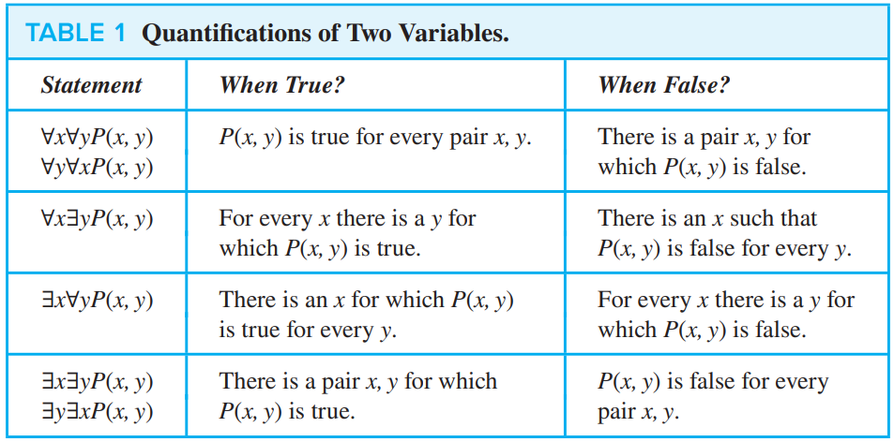Let Q(x, y) denote “x + y = 0.” What are the truth values of the quantifications ∃y∀xQ(x, y) and ∀x∃yQ(x, y), where the domain for all variables consists of all real numbers?

Solution : ∃y∀xQ(x, y) denotes the proposition “There is a real number y such that for every real number x, Q(x, y).” Because there is no real number y such that x + y = 0 for all real numbers x, the statement ∃y∀xQ(x, y) is false.

∀x∃yQ(x, y) denotes the proposition “For every real number x there is a real number y such that Q(x, y).” Given a real number x, there is a real number y such that x + y = 0; namely, y = −x. Hence, the statement ∀x∃yQ(x, y) is true.

***1.5.3) Translating Mathematical Statements into Statements Involving Nested Quantifiers*** :

* Translate the statement “The sum of two positive integers is always positive” into a logical expression. “For every two integers, if these integers are both positive, then the sum of these integers is positive.”

*Solution* : ∀x∀y((x > 0) ∧ (y > 0) → (x + y > 0)) where the domain for both variables consists of all integers.

∀x∀y(x + y > 0), where the domain for both variables consists of all positive integers.

* Translate the statement “Every real number except zero has a multiplicative inverse”

*Solution* : “For every real number x except zero, x has a multiplicative inverse.” We can rewrite this as “For every real number x, if x ≠ 0, then there exists a real number y such that xy = 1.” This can be rewritten as ∀x((x ≠ 0) → ∃y(xy = 1)).

***1.5.4) Translating from Nested Quantifiers into English*** :

* Translate the statement ∀x(C(x) ∨ ∃y(C(y) ∧ F(x, y))) into English, where C(x) is “x has a computer,” F(x, y) is “x and y are friends,” and the domain for both x and y consist of all students in your school.

*Solution*: The statement says that for every student x in your school, x has a computer or there is a student y such that y has a computer and x and y are friends. In other words, every student in your school has a computer or has a friend who has a computer.

* Translate the statement ∃x∀y∀z((F(x, y) ∧ F(x, z) ∧ (y ≠ z)) → ¬F(y, z)) into English, where F(a, b) means a and b are friends and the domain for x, y, and z consists of all students in your school.

*Solution* : Says that there is a student x such that for all students y and all students z other than y, if x and y are friends and x and z are friends, then y and z are not friends. In other words, there is a student none of whose friends are also friends with each other.

***1.5.5) Translating English Sentences into Logical Expressions*** :

* Express the statement “If a person is female and is a parent, then this person is someone’s mother”

*Solution* : We introduce the propositional functions F(x) to represent “x is female,” P(x) to represent “x is a parent,” and M(x, y) to represent “x is the mother of y.” The original statement can be represented as ∀x((F(x) ∧ P(x)) → ∃yM(x, y)) or ∀x∃y((F(x) ∧ P(x)) → M(x, y))

* Express the statement “Everyone has exactly one best friend”

*Solution* : we see that this statement is the same as “∀x(person x has exactly one best friend),” where the domain consists of all people. To say that x has exactly one best friend means that there is a person y who is the best friend of x, and furthermore, that for every person z, if person z is not person y, then z is not the best friend of x. When we introduce the predicate B(x, y) to be the statement “y is the best friend of x,” the statement that x has exactly one best friend can be represented as ∃y(B(x, y) ∧ ∀z((z ≠ y) → ¬B(x, z))). Consequently, our original statement can be expressed as ∀x∃y(B(x, y) ∧ ∀z((z ≠ y) → ¬B(x, z))).

* Negation of ∃w∀a∃f(P(w, f) ∧ Q( f, a)) :

*Solution* : ∀w¬∀a∃f(P(w, f) ∧ Q( f, a)) ≡ ∀w∃a¬∃f(P(w, f) ∧ Q( f, a))

≡ ∀w∃a∀f¬(P(w, f) ∧ Q( f, a))

≡ ∀w∃a∀f(¬P(w, f) ∨ ¬Q( f, a))

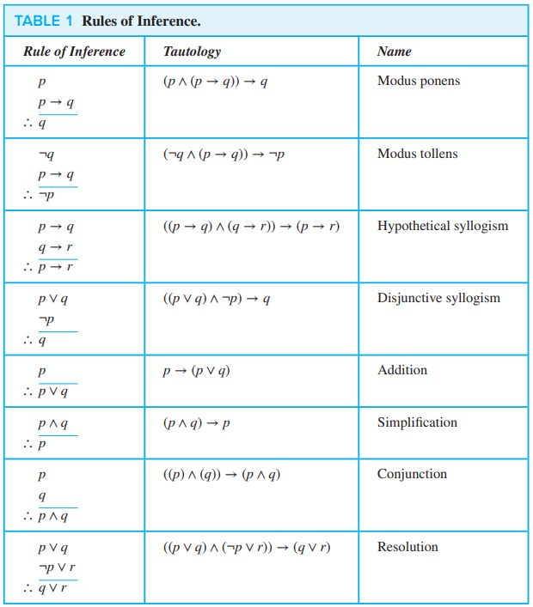

* 1. **Rules of Inference :**

**1.6.1) Argument** : A sequence of statements that end with a conclusion.

Argument to be **valid** : The conclusion, or final statement of the argument, must follow from the truth of the preceding statements, or **premises**, of the argument.

An *argument* in propositional logic is a sequence of propositions. All but the final proposition in the argument are called *premises* and the final proposition is called the *conclusion*. An argument is valid if the truth of all its premises implies that the conclusion is true. An *argument form* in propositional logic is a sequence of compound propositions involving propositional variables. An argument form is *valid* if no matter which particular propositions are substituted for the propositional variables in its premises, the conclusion is true if the premises are all true.

***1.6.2) Using Rules of Inference to Build Arguments*** :

Show that the premises “It is not sunny this afternoon and it is colder than yesterday,” “We will go swimming only if it is sunny,” “If we do not go swimming, then we will take a canoe trip,” and “If we take a canoe trip, then we will be home by sunset” lead to the conclusion “We will be home by sunset.”

Solution : Let p be the proposition “It is sunny this afternoon,” q the proposition “It is colder than yesterday,” r the proposition “We will go swimming,” s the proposition “We will take a canoe trip,” and t the proposition “We will be home by sunset.” Then the premises become ¬p ∧ q, r → p, ¬r → s, and s → t. The conclusion is simply t. We need to give a valid argument with premises ¬p ∧ q, r → p, ¬r → s, and s → t and conclusion t. We construct an argument to show that our premises lead to the desired conclusion as follows.

**Step** **Reason**

1. ¬p ∧ q Premise

2. ¬p Simplification using (1)

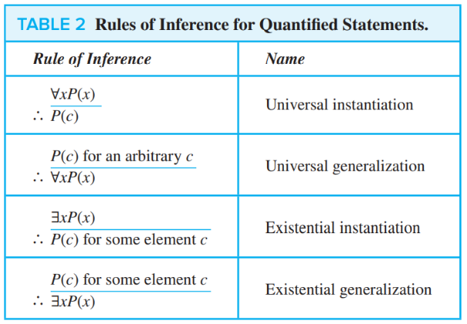3. r → p Premise

4. ¬r Modus tollens using (2) and (3)

5. ¬r → s Premise

6. s Modus ponens using (4) and (5)

7. s → t Premise

8. t Modus ponens using (6) and (7)

**Resolution** : ((p ∨ q) ∧ (¬p ∨ r)) → (q ∨ r)

**Fallacy of affirming the conclusion** : ((p → q) ∧ q) → p (For p false and q true)

**Fallacy of denying the hypothesis** : ((p → q) ∧ ¬p) → ¬q (For q true and p false)

* Show that the premises “A student in this class has not read the book,” and “Everyone in this class passed the first exam” imply the conclusion “Someone who passed the first exam has not read the book.”

*Solution*: Let C(x) be “x is in this class,” B(x) be “x has read the book,” and P(x) be “x passed the first exam.” The premises are ∃x(C(x) ∧ ¬B(x)) and ∀x(C(x) → P(x)). The conclusion is ∃x(P(x) ∧ ¬B(x)). These steps can be used to establish the conclusion from the premises.

**Step** **Reason**

1. ∃x(C(x) ∧ ¬B(x)) Premise

2. C(a) ∧ ¬B(a) Existential instantiation from (1)

3. C(a) Simplification from (2)

4. ∀x(C(x) → P(x)) Premise

5. C(a) → P(a) Universal instantiation from (4)

6. P(a) Modus ponens from (3) and (5)

7. ¬B(a) Simplification from (2)

8. P(a) ∧ ¬B(a) Conjunction from (6) and (7)

9. ∃x(P(x) ∧ ¬B(x)) Existential generalization from (8)

***1.6.3) Combining Rules of Inference for Propositions and Quantified Statements :***

**Universal modus ponens** : ∀x(P(x) → Q(x))

P(a), where a is a particular element in the domain

∴ Q(a) *🡨* *Conclusion*

**Universal modus tollens** : ∀x(P(x) → Q(x))

¬Q(a), where a is a particular element in the domain

∴ ¬P(a)

By the rule of distributing quantifiers, we know that ∀ can be distributed over conjunction and ∃ can be distributed over disjunction.

**Questions on predicate and logic, English to math and vice versa.**

1. Which one of the following is the most appropriate logical formula to represent the statement? "Gold and silver ornaments are precious". The following notations are used: G(x): x is a gold ornament S(x): x is a silver ornament P(x): x is precious

*∀x(P(x)→(G(x)∧S(x)))*

*∀x((G(x)∧S(x))→P(x))*

*∃x((G(x)∧S(x))→P(x)*

*∀x((G(x)∨S(x))→P(x))*

**Answer** : this does not means if is gold and silver then it is precious but it means if it is gold or silver then it is precious. As x cannot be gold and silver simultaneously, Therefore, answer is D.

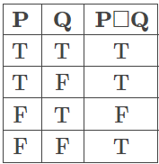

1. The binary operation □ is defined as follows

Which one of the following is equivalent to P∨Q?

*¬Q□¬P*

*P□¬Q*

*¬P□Q*

*¬P□¬Q*

**Answer** : form table it is clear that Q->P, which means ¬Q+P. P□Q means do summation of P and negation of Q. converting all option in +,¬ formate we will get second option as answer.

1. Which of the following is TRUE about formulae in Conjunctive Normal Form?

*For any formula, there is a truth assignment for which at least half the clauses evaluate to true.*

*For any formula, there is a truth assignment for which all the clauses evaluate to true*

*There is a formula such that for each truth assignment, at most one-fourth of the clauses evaluate to true.*

*None of the above*

**Answer** : A just remember.

1. Which one of the first order predicate calculus statements given below correctly expresses the following English statement?

Tigers and lions attack if they are hungry or threatened.

∀x[(tiger(x)∧lion(x))→(hungry(x)∨threatened(x))→attacks(x)]

∀x[(tiger(x)∨lion(x))→(hungry(x)∨threatened(x))∧attacks(x)]

∀x[(tiger(x)∨lion(x))→attacks(x)→(hungry(x)∨threatened(x))]

∀x[(tiger(x)∨lion(x))→(hungry(x)∨threatened(x))→attacks(x)]

**Answer** : q if p means p→q now solve the problem

1. Which of the following is a valid first order formula? (Here α and β are first order formulae with x as their only free variable)

*((∀x)[α]⇒(∀x)[β])⇒(∀x)[α⇒β]*

*(∀x)[α]⇒(∃x)[α∧β]*

*((∀x)[α∨β]⇒(∃x)[α])⇒(∀x)[α]*

*(∀x)[α⇒β]⇒(((∀x)[α])⇒(∀x)[β])*

**Answer** : A, Let X={3,6,9,8}. Let α denote multiple of 3 and β denote multiple of 4.(∀x)[α] becomes false as 8 is not a multiple of 3, and so (∀x)[α]⇒(∀x)[β] becomes TRUE. Now, this won't imply (∀x)[α⇒β] as multiple of 3 doesn't imply multiple of 4 for 3,6 or 9.

B, Let X={3,6,9}. Let α denote multiple of 3 and β denote multiple of 4. Now LHS is TRUE but RHS is false as none of the x in X, is a multiple of 4.

C, Let X={3,6,9,7}. Let α denote multiple of 3 and β denote multiple of 4. Now (∀x)[α∨β] becomes false and hence LHS =((∀x)[α∨β]⇒(∃x)[α]) becomes true. But RHS is false as 7 is not a multiple of 3.

D, This is valid. LHS is saying that if α is holding for any x, then β also holds for that x. RHS is saying if α is holding for all x, then β also holds for all x. Clearly LHS ⟹ RHS (but RHS does not imply LHS).

For example, let X={4,8,12},α denote multiple of 2 and β denote multiple of 4. LHS =(∀x)[α⇒β], is TRUE. RHS is also true. If we add '3' to X, then LHS is true, first part of RHS becomes false and thus RHS also becomes TRUE. There is no way we can make LHS true and RHS false here. But if we add 2 and 3 to X, RHS will be true and LHS will be false. So, we can't say RHS implies LHS.

1. Consider the following formula a and its two interpretations I1 and I2

α:(∀x)[Px⇔(∀y)[Qxy⇔¬Qyy]]⇒(∀x)[¬Px]

I1 : Domain: the set of natural numbers

Px = 'x is a prime number'

Qxy = 'y divides x'

I2 : same as I1 except that Px = 'x is a composite number'.

Which of the following statements is true ?

*I2 satisfies α, I1 does not*

*Neither I2 nor I2 satisfies α*

*Both I1 and I2 satisfy α*

*I1 satisfies α, I2 does not*

**Answer** : Qyy is always True, this makes ¬Qyy False.

Writing (∀y)[Qxy⇔¬Qyy] is same as writing (∀y)[Qxy⇔False]]

This is equivalent to saying that, for all y Qxy is false and finally we can rewrite (∀y)[Qxy⇔¬Qyy]] as (∀y)[¬Qxy]

α:(∀x)[Px⇔(∀y)[¬Qxy]]⇒(∀x)[¬Px]

LHS:(∀x)[Px⇔(∀y)[¬Qxy]]

consider only (∀y)[¬Qxy] it says all values of y does not divide x, but there will be at least one value of y (when y=x, or when y=1) that divides x, i.e. [¬Qxy] is not true for all values of y. (∀y)[¬Qxy] is false.

Now LHS becomes (∀x)[Px⇔False], "Px⇔False" this means Px is False, which is same as writing "¬Px".

Finally, we reduced LHS to (∀x)[¬Px]

α:(∀x)[¬Px]⇒(∀x)[¬Px] (which is trivial, P(x)⇒P(x) is trivially true)

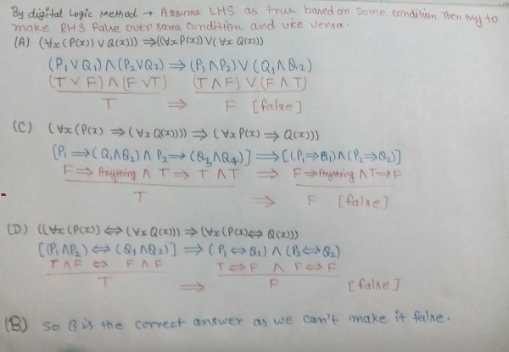Hence (∀x)[¬Px]⇒(∀x)[¬Px] is trivially true for any P(x), doesn't matter if P(x) is for prime number or for composite number (I1 or I2).

⇒I1 and I2 both satisfies α.

1. Let P(x) and Q(x) be arbitrary predicates. Which of the following statements is always TRUE?

((∀x(P(x)∨Q(x))))⟹((∀xP(x))∨(∀xQ(x)))

(∀x(P(x)⟹Q(x)))⟹((∀xP(x))⟹(∀xQ(x)))

(∀x(P(x))⟹∀x(Q(x)))⟹(∀x(P(x)⟹Q(x)))

(∀x(P(x))⇔(∀x(Q(x))))⟹(∀x(P(x)⇔Q(x)))

**Answer** : **(∀x(P(x)⟹Q(x)))⟹((∀xP(x))⟹(∀xQ(x)))** this is important property.

1. Which of the following first order formula is logically valid? Here α(x) is a first order formula with x as a free variable, and β is a first order formula with no free variable.

[β→(∃x,α(x))]→[∀x,β→α(x)]

[∃x,β→α(x)]→[β→(∀x,α(x))]

[(∃x,α(x))→β]→[∀x,α(x)→β]

[(∀x,α(x))→β]→[∀x,α(x)→β]

**Answer** : [(∃x,α(x))→β]→[∀x,α(x)→β]

LHS: If there is an x such that α(x) is true, then β is true.

RHS: For all x, if α(x) is true, then β is true.

Here, both LHS and RHS are in fact same as β is a formula which is independent of x. (if β is true for one x, it is true for every x and vice versa).

So, RHS⟹LHS and LHS⟹RHS.

1. What is the converse of the following assertion? I stay only if you go.

*I stay if you go*

*If I stay then you go*

*If you do not go then I do not stay*

*If I do not stay then you go*

**Answer** *: assertion can be translated into p->q*

q if p = p->q converse is p if q (q->p)

1. In propositional logic if (P → Q) ∧ (R → S) and (P ∨ R) are two premises such that (P → Q) ∧ (R → S) P ∨ R / Y . Y is the premise :

*P ∨ R*

*P ∨ S*

*Q ∨ R*

*Q ∨ S*

**Answer** : For P-->Q: If you work hard(P) then you will qualify NET(Q).

For R-->S: If you play game(R) then you will get gold(S).

Given premise is PVR : means if u work hard(P) OR(v) if you play game(R), then conclusion will be-

than You will qualify NET(Q) OR(v) you will get gold(S). Which is nothing but Q V S.

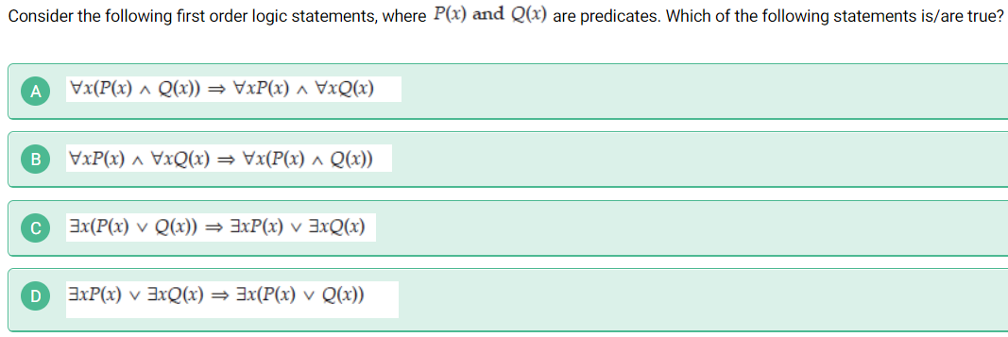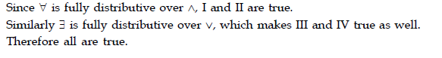

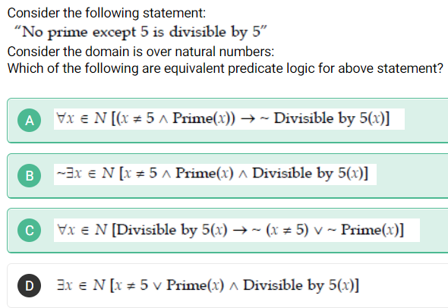your answer was correct i.e. A but if you solve option B it is equivalent and so as c. for c to be correct note that p→q is same as -p∨q you can interchange –(-q) ∨ -p which will result in -q→-p. now try to apply into c. so option a,b,c is correct option.

1. **Basic Structures : Sets, Functions, Sequences, Sums, And Matrices**
   1. **Sets** :

A set is an unordered collection of distinct objects, called elements or members of the set. A set is said to *contain* its elements. We write a ∈ A to denote that a is an element of the set A. The notation a ∉ A denotes that a is not an element of the set A.

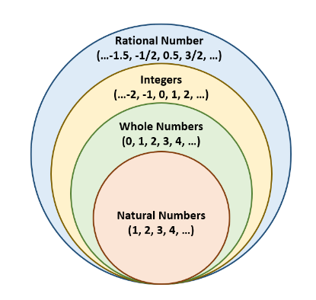Representation = **Roster method** : {a, b, c, d}, **Set builder Notation** : {x|x has property P} or “the set of all x such that x has property P.”

Important Notation : **N** = {0, 1, 2, 3, …}, the set of all-natural numbers

**Z** = {… ,−2,−1, 0, 1, 2, …}, the set of all integers

**Z+** = {1, 2, 3, …}, the set of all positive integers

**Q** = {p∕q ∣ p ∈ Z, q ∈ Z, and q ≠ 0}, the set of all rational numbers

**R**, the set of all real numbers

**R+**, the set of all positive real numbers

**C**, the set of all complex numbers.

[a, b] is called the **closed interval** means include all element and also include a,b, (a, b) is called the **open interval** from a to b, means include all element between a and b except a and b.

* Two sets are *equal* if and only if they have the same elements. Therefore, if A and B are sets, then A and B are equal if and only if ∀x(x ∈ A ↔ x ∈ B). We write A = B if A and B are equal sets.

Null Set or Empty set : { } or ∅

Singleton set : {∅}, {a}

* The set A is a subset of B, and B is a superset of A, if and only if every element of A is also an element of B. We use the notation A ⊆ B to indicate that A is a subset of the set B. If, instead, we want to stress that B is a superset of A, we use the equivalent notation B ⊇ A. (So, A ⊆ B and B ⊇ A are equivalent statements.) **OR** A ⊆ B if and only if the quantification ∀x(x ∈ A → x ∈ B) is true.
* Let S be a set. If there are exactly n distinct elements in S where n is a nonnegative integer, we say that S is a finite set and that n is the cardinality of S. The cardinality of S is denoted by |S|.
* Given a set S, the power set of S is the set of all subsets of the set S. The power set of S is denoted by P(S).

*Example* : What is the power set of the set {0, 1, 2}?

*Solution*: The power set P({0, 1, 2}) is the set of all subsets of {0, 1, 2}. Hence, Examples P({0, 1, 2}) = {∅, {0}, {1}, {2}, {0, 1}, {0, 2}, {1, 2}, {0, 1, 2}}. Note that the empty set and the set itself are members of this set of subsets.

P(∅) = {∅}.

P({∅}) = {∅, {∅}}.

* Let A and B be sets. The Cartesian product of A and B, denoted by A × B, is the set of all ordered pairs (a, b), where a ∈ A and b ∈ B. Hence, A × B = {(a, b) ∣ a ∈ A ∧ b ∈ B}.

*Example* : A = {1, 2} and B = {a, b, c}, A × B = {(1, a), (1, b), (1, c), (2, a), (2, b), (2, c)}.

**NOTE** : if A ∈ B and B ∈ C then A ∈ C is not always true. Why ? See this counterexample, A = {b}, B = {{b}, 1}, C = {{{b}, 1}, 2}. Cartesian product of any set with empty set or empty set with any set is empty set.

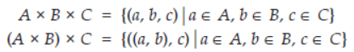It’s not associative. Both have different meaning.

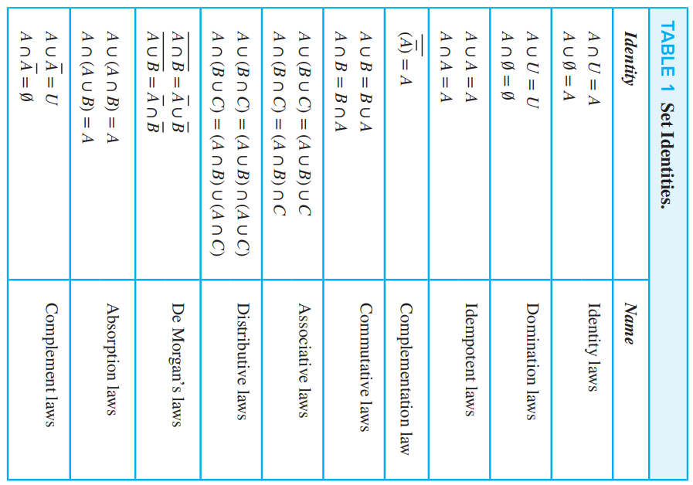

* 1. **Set Operation** :

Union : A ∪ B = {x ∣ x ∈ A ∨ x ∈ B}.

Intersection : A ∩ B = {x ∣ x ∈ A ∧ x ∈ B}.

* Two sets are called **disjoint** if their intersection is the empty set. i.e. A ∩ B = ∅

Imp property : |A ∪ B| = |A| + |B| − |A ∩ B|.

Set difference : A − B = {x ∣ x ∈ A ∧ x ∉ B} = A − B = A ∩ ¬B.

Complementary : ¬A = {x ∈ U ∣ x ∉ A}

Symmetric difference : A ⊕ B, (A ∪ B) − (A ∩ B).

Example : Suppose that P and Q are the multisets {4 ⋅ a, 1 ⋅ b, 3 ⋅ c} and {3 ⋅ a, 4 ⋅ b, 2 ⋅ d}, respectively. Find P ∪ Q, P ∩ Q, P − Q, and P + Q.

Solution: We have P ∪ Q = {max(4, 3) ⋅ a, max(1, 4) ⋅ b, max(3, 0) ⋅ c, max(0, 2) ⋅ d} = {4 ⋅ a, 4 ⋅ b, 3 ⋅ c, 2 ⋅ d},

P ∩ Q = {min(4, 3) ⋅ a, min(1, 4) ⋅ b, min(3, 0) ⋅ c, min(0, 2) ⋅ d} = {3 ⋅ a, 1 ⋅ b, 0 ⋅ c, 0 ⋅ d}={3 ⋅ a, 1 ⋅ b},

P − Q = {max(4 − 3, 0) ⋅ a, max(1 − 4, 0) ⋅ b, max(3 − 0, 0) ⋅ c, max(0 − 2, 0) ⋅ d} = {1 ⋅ a, 0 ⋅ b, 3 ⋅ c, 0 ⋅ d}={1 ⋅ a, 3 ⋅ c}, and

P + Q = {(4 + 3) ⋅ a, (1 + 4) ⋅ b, (3 + 0) ⋅ c, (0 + 2) ⋅ d} = {7 ⋅ a, 5 ⋅ b, 3 ⋅ c, 2 ⋅ d}.

*Some more properties* :

|A ∪ B|<=|A| + |B|

|A ∩ B|= S -|A’ ∪ B’|

Using above property, we have |A∩B| ≥ S − |A'|−|B'|

* 1. **Function** :

Let A and B be nonempty sets. A function f from A to B is an assignment of exactly one element of B to each element of A. We write f(a) = b if b is the unique element of B assigned by the function f to the element a of A. If f is a function from A to B, we write f : A → B

* If f is a **function** from A to B, we say that A is the **domain** of f and B is the **codomain** of f. If f(a) = b, we say that b is the **image** of a and a is a **preimage** of b. The **range**, or **image**, of f is the set of all images of elements of B. Also, if f is a function from A to B, we say that f *maps* A to B.
* Let f be a function from A to B and let S be a subset of A. The image of S under the function f is the subset of B that consists of the images of the elements of S. We denote the image of S by f(S), so f(S) = {t ∣ ∃s∈S (t = f(s))}.

*Example* : Let A = {a, b, c, d, e} and B = {1, 2, 3, 4} with f(a) = 2, f(b) = 1, f(c) = 4, f(d) = 1, and f(e) = 1. The image of the subset S = {b, c, d} is the set f(S) = {1, 4}.

***2.3.1) Types of function*** :

**One to one function** : A function f is said to be one-to-one, or an injection, if and only if f(a) = f(b) implies that a = b for all a and b in the domain of f. A function is said to be injective if it is one-to-one. ∀a∀b( f(a) = f(b) → a = b)

* A function f whose domain and codomain are subsets of the set of real numbers is called increasing if f(x) ≤ f(y), and strictly increasing if f(x) < f(y), whenever x < y and x and y are in the domain of f. Similarly, f is called decreasing if f(x) ≥ f(y), and strictly decreasing if f(x) > f(y), whenever x < y and x and y are in the domain of f. (The word strictly in this definition indicates a strict inequality.)
* A function f is increasing if ∀x∀y(x < y → f(x) ≤ f(y)), strictly increasing if ∀x∀y(x < y → f(x) < f(y)), decreasing if ∀x∀y(x < y → f(x) ≥ f(y)), and strictly decreasing if ∀x∀y(x < y → f(x) > f(y)), where the universe of discourse is the domain of f.

**Onto function** : A function f from A to B is called onto, or a surjection, if and only if for every element b ∈ B there is an element a ∈ A with f(a) = b. A function f is called surjective if it is onto.

**One to one correspondence (Bijection)** : The function f is a one-to-one correspondence, or a bijection, if it is both one-to-one and onto. We also say that such a function is bijective.

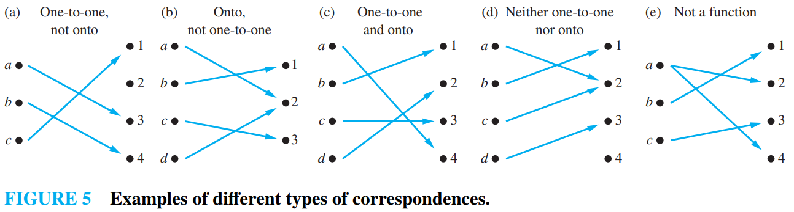

Suppose that f : A → B.

To show that f is injective Show that if f(x) = f(y) for arbitrary x, y ∈ A, then x = y.

To show that f is not injective Find particular elements x, y ∈ A such that x ≠ y and f(x) = f(y).

To show that f is surjective Consider an arbitrary element y ∈ B and find an element x ∈ A such that f(x) = y.

To show that f is not surjective Find a particular y ∈ B such that f(x) ≠ y for all x ∈ A.

* Let f be a one-to-one correspondence from the set A to the set B. The inverse function of f is the function that assigns to an element b belonging to B the unique element a in A such that f(a) = b. The inverse function of f is denoted by f −1. Hence, f −1(b) = a when f(a) = b.
* 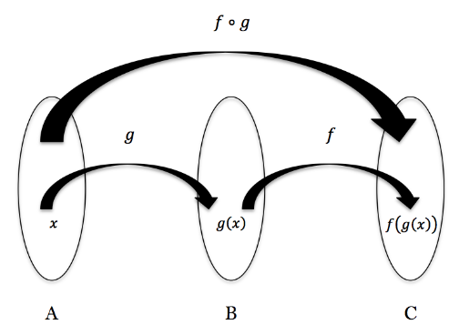A one-to-one correspondence is called invertible because we can define an inverse of this function. A function is not invertible if it is not a one-to-one correspondence, because the inverse of such a function does not exist.
* Suppose that f is function from A to B and g is a function from B to C. If both f and g are one to one function, then f o g is also one to one. And similarly, if both f and g are onto functions, then f o g is also onto function.
* 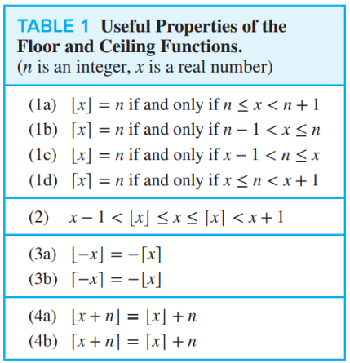A partial function f from a set A to a set B is an assignment to each element a in a subset of A, called the domain of definition of f , of a unique element b in B. The sets A and B are called the domain and codomain of f , respectively. We say that f is undefined for elements in A that are not in the domain of definition of f . When the domain of definition of f equals A, we say that f is a total function.

**|f({1,2})| = 2**. This sentence does not mean that f(1) = f(2) = 2. It means f(1) maps to some element which is different from f(2) mapping. If both mapping would be same then cardinality should be 1. But here 2 is given so both mapping must be different.

* 1. 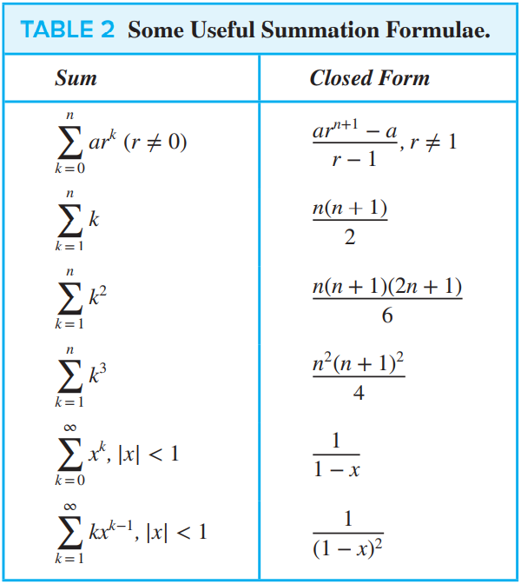**Sequences and Summations** **:**

***2.4.1) Recurrence Relations*** : A recurrence relation for the sequence {an} is an equation that expresses an in terms of one or more of the previous terms of the sequence, namely, a0, a1, … , an−1, for all integers n with n ≥ n0, where n0 is a nonnegative integer. A sequence is called a solution of a recurrence relation if its terms satisfy the recurrence relation.

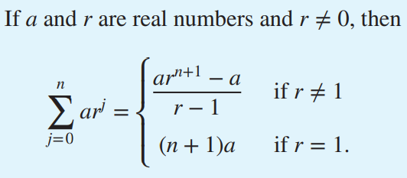

Number of prime numbers in between 1 to 100 is 25. And 1 to 1000 is 168.



**a^3 + b^3 + c^3 - 3abc = (a+b+c) (a^2 + b^2 + c^2 - ab - bc -ac)**

1. **Algorithms**
   1. **Algorithms :**

**Definition** : An **algorithm** is a finite sequence of precise instructions for performing a computation or for solving a problem.

* 1. **The Growth of Functions :**

***3.2.1) Big-O Notation*** : Let f and g be functions from the set of integers or the set of real numbers to the set of real numbers. We say that f(x) is O(g(x)) if there are constants C and k such that |f(x)| ≤ C|g(x)| whenever x > k. [This is read as “f(x) is big-oh of g(x).”]

Remark: Intuitively, the definition that f(x) is O(g(x)) says that f(x) grows slower than some fixed multiple of g(x) as x grows without bound.

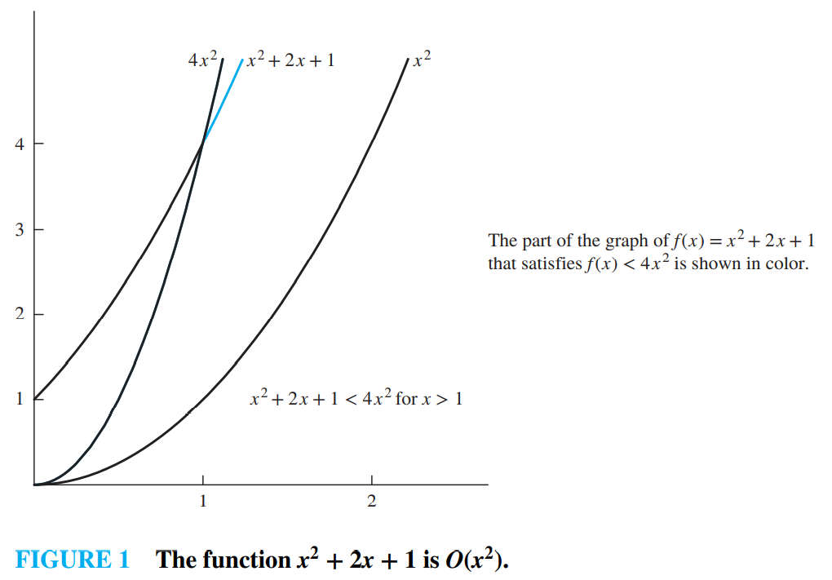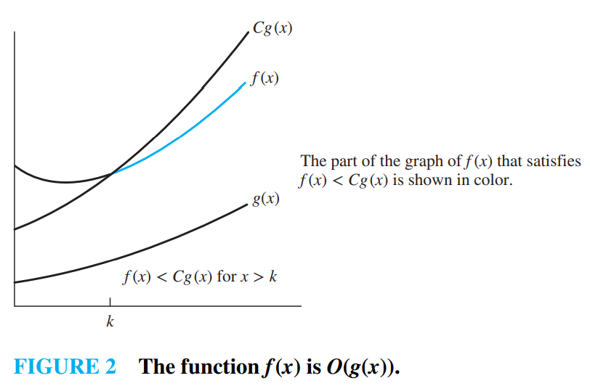

**Definition** : Suppose that f1(x) is O(g1(x)) and that f2(x) is O(g2(x)). Then ( f1 + f2)(x) is O(g(x)), where g(x) = (max(|g1(x)|, |g2(x)|) for all x.

**Definition** : Suppose that f1(x) is O(g1(x)) and f2(x) is O(g2(x)). Then ( f1f2)(x) is O(g1(x)g2(x)).

***3.2.2) Big Omega Notation :***

**Definition** : Let f and g be functions from the set of integers or the set of real numbers to the set of real numbers. We say that f(x) is Ω(g(x)) if there are constants C and k with C positive such that |f(x)| ≥ C|g(x)| whenever x > k. [This is read as “f(x) is big-Omega of g(x).”]

***3.2.3) Big Theta Notation :***

**Definition** : Let f and g be functions from the set of integers or the set of real numbers to the set of real numbers. We say that f(x) is Θ(g(x)) if f(x) is O(g(x)) and f(x) is Ω(g(x)). When f(x) is Θ(g(x)), we say that f is big-Theta of g(x), that f(x) is of order g(x), and that f(x) and g(x) are of the same order.

* 1. **Complexity of Algorithms** :

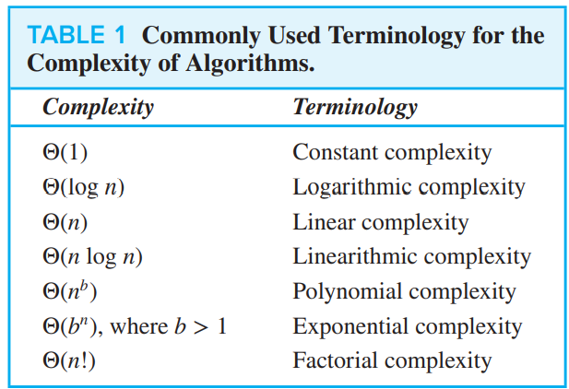**Tractability** : A problem that is solvable using an algorithm with polynomial (or better) worst-case complexity is called tractable, because the expectation is that the algorithm will produce the solution to the problem for reasonably sized input in a relatively short time.

1. **COUNTING**
   1. **The basic of counting** :

**THE PRODUCT RULE** : Suppose that a procedure can be broken down into a sequence of two tasks. If there are n1 ways to do the first task and for each of these ways of doing the first task, there are n2 ways to do the second task, then there are n1n2 ways to do the procedure.

Example :

* Counting Functions How many functions are there from a set with m elements to a set with n elements?

*Solution*: A function corresponds to a choice of one of the n elements in the codomain for each of the m elements in the domain. Hence, by the product rule there are n ⋅ n ⋅⋯⋅ n = nm functions from a set with m elements to one with n elements. For example, there are 53 = 125 different functions from a set with three elements to a set with five elements.

* Counting One-to-One Functions How many one-to-one functions are there from a set with m elements to one with n elements?

*Solution*: First note that when m > n there are no one-to-one functions from a set with m elements to a set with n elements. Now let m ≤ n. Suppose the elements in the domain are a1, a2, … , am. There are n ways to choose the value of the function at a1. Because the function is one-to-one, the value of the function at a2 can be picked in n − 1 ways (because the value used for a1 cannot be used again). And so on. (as one to one function cannot have same output value for different input values.)Therefore, n(n − 1)(n − 2) ⋯ (n − m + 1)

* Counting Subsets of a Finite Set Use the product rule to show that the number of different subsets of a finite set S is 2|S|.

*Solution*: Let S be a finite set. List the elements of S in arbitrary order. Recall from Section 2.2 that there is a one-to-one correspondence between subsets of S and bit strings of length |S|. Namely, a subset of S is associated with the bit string with a 1 in the ith position if the ith element in the list is in the subset, and a 0 in this position otherwise. By the product rule, there are 2|S| bit strings of length |S|. Hence, |P(S)| = 2|S|.

*One nice example* :

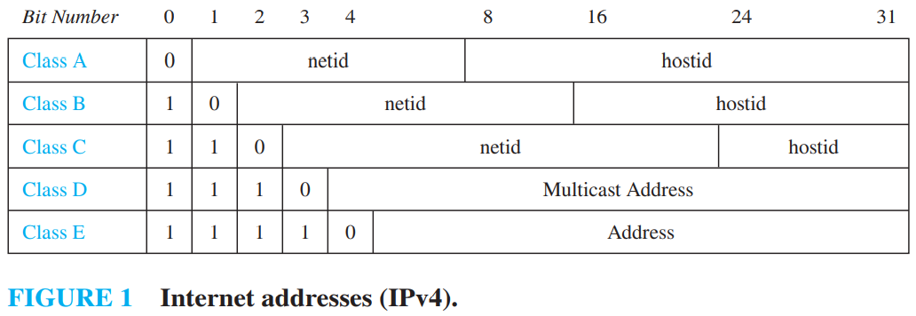The *netid* is followed by a host number (*hostid*), which identifies a computer as a member of a particular network.

* How many different IPv4 addresses are available for computers on the Internet?

*Restriction* : 1111111 is not available as the netid of a Class A network, and the hostids consisting of all 0s and all 1s are not available for use in any network.

*Solution* : Let x be the number of available addresses for computers on the Internet, and let xA, xB, and xC denote the number of Class A, Class B, and Class C addresses available, respectively. By the sum rule, x = xA + xB + xC. To find xA, note that there are 27 − 1 = 127 Class A netids, recalling that the netid 1111111 is unavailable. For each netid, there are 224 − 2 = 16,777,214 hostids, recalling that the hostids consisting of all 0s and all 1s are unavailable. Consequently, xA = 127 ⋅ 16,777,214 = 2,130,706,178. To find xB and xC, note that there are 214 = 16,384 Class B netids and 221 = 2,097,152 Class C netids. For each Class B netid, there are 216 − 2 = 65,534 hostids, and for each Class C netid, there are 28 − 2 = 254 hostids, recalling that in each network the hostids consisting of all 0s and all 1s are unavailable. Consequently, xB = 1,073,709,056 and xC = 532,676,608. We conclude that the total number of IPv4 addresses available is x = xA + xB + xC = 2,130,706,178 + 1,073,709,056 + 532,676,608 = 3,737,091,842.

**Principle of inclusion–exclusion** : |A1 ∪ A2| = |A1| + |A2| − |A1 ∩ A2|

* 1. **The Pigeonhole Principle (Dirichlet drawer principle)** :

***4.2.1) Introduction*** *:*

If k is a positive integer and k + 1 or more objects are placed into k boxes, then there is at least one box containing two or more of the objects.

*Uses of this principle* : A function f from a set with k + 1 or more elements to a set with k elements is not one-to-one.

**THE GENERALIZED PIGEONHOLE PRINCIPLE** : If N objects are placed into k boxes, then there is at least one box containing at least ⌈N ∕ k⌉ objects.

* What is the minimum number of students required in a discrete mathematics class to be sure that at least six will receive the same grade, if there are five possible grades, A, B, C, D, and F?

*Solution* : The minimum number of students needed to ensure that at least six students receive the same grade is the smallest integer N such that ⌈N∕5⌉ = 6. The smallest such integer is N = 5 ⋅ 5 + 1 = 26. If you have only 25 students, it is possible for there to be five who have received each grade so that no six students have received the same grade. Thus, 26 is the minimum number of students needed to ensure that at least six students will receive the same grade.

* 1. **Permutation and combination** :

***4.3.1) Permutation*** : If n is a positive integer and r is an integer with 1 ≤ r ≤ n, then there are P(n, r) = n(n − 1)(n − 2) ⋯ (n − r + 1) r-permutations of a set with n distinct elements. P(n, r) = n! / (n − r)!

Example : P(8, 3) = 8 ⋅ 7 ⋅ 6 = 336

How many permutations of the letters ABCDEFGH contain the string ABC ?

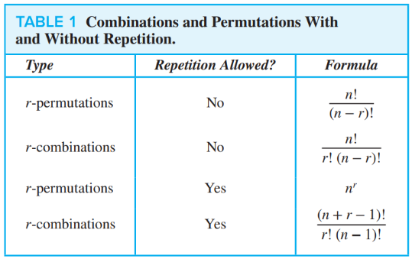*Solution* : Because the letters ABC must occur as a block, we can find the answer by finding the number of permutations of six objects, namely, the block ABC and the individual letters D, E, F, G, and H. Because these six objects can occur in any order, there are 6! = 720 permutations.

***4.3.2) Combination*** : The number of r-combinations of a set with n elements, where n is a nonnegative integer and r is an integer with 0 ≤ r ≤ n, equals C(n, r) = n! / r! (n − r)!

**P(n, r) = C(n, r) ⋅ P(r, r)**

**C(n, r) = C(n, n − r)**

Last one in table is **(n+r-1)! / r! (n-1)! = C(n + r − 1, r) = C(n + r − 1, n − 1)**

* 1. **Binomial Coefficient and Identities :**

***4.4.1) Binomial Theorem* :** 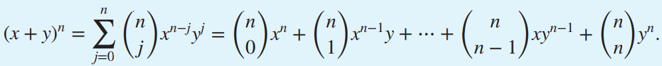

* What is the coefficient of x12y13 in the expansion of (x + y)25 ?

*Solution*: From the binomial theorem it follows that this coefficient is 25C13 = 25! 13! 12! = 5,200,300.

* What is the coefficient of x12y13 in the expansion of (2x − 3y)25 ?

*Solution* : 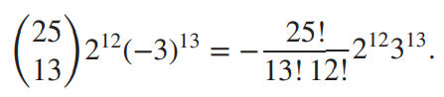

**Properties** :

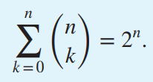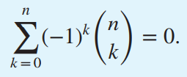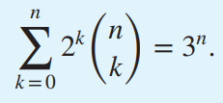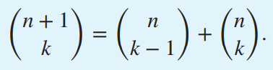This identity is called **pascal’s triangle**.

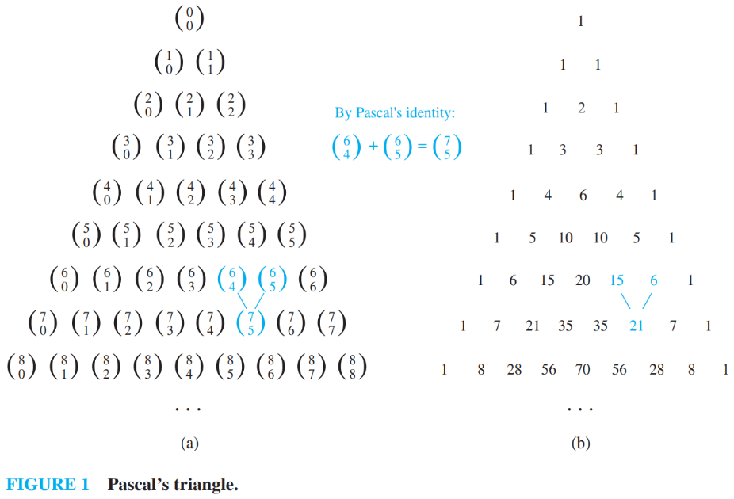

**Vandermonde’s Identity** :

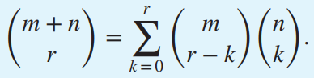

* 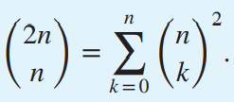

Proof : We use Vandermonde’s identity with m = r = n to obtain

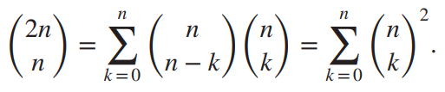

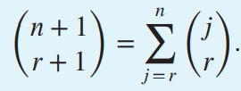

* 1. **More on Combination and Permutation** :

***4.5.1) Permutation with Indistinguishable objects*** (objects looks like same and they are same) :

* Example : How many different strings can be made by reordering the letters of the word SUCCESS?

*Solution* : C(7, 3)C(4, 2)C(2, 1)C(1, 1) = (7! / 3! 4!) ⋅ (4! / 2! 2!) ⋅ (2! / 1! 1!) ⋅ (1! / 1! 0!) = (7! / 3! 2! 1! 1!) = 420.

In general , The number of different permutations of n objects, where there are n1 indistinguishable objects of type 1, n2 indistinguishable objects of type 2, … , and nk indistinguishable objects of type k, is **n! / n1! n2! ⋯ nk!**

***4.5.2) Distributing Objects into Boxes*** :

1. 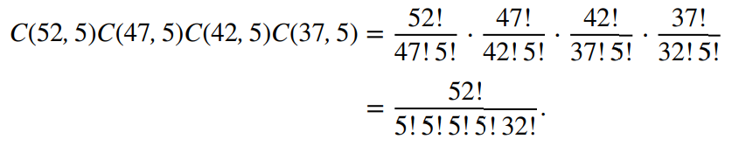**DISTINGUISHABLE OBJECTS AND DISTINGUISHABLE BOXES** : The number of ways to distribute n distinguishable objects into k distinguishable boxes so that ni objects are placed into box i, i = 1, 2, … , k, equals n! / n1! n2! ⋯ nk!

*Intuition* : Pick ni object from n, put them into box I, again select ni object from remaining n-ni and put them into boxI, and so on.

Example : How many ways are there to distribute hands of 5 cards to each of four players from the standard deck of 52 cards?

1. 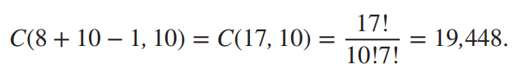**INDISTINGUISHABLE OBJECTS AND DISTINGUISHABLE BOXES :** This is same as putting lines between total balls and rearranging the lines and remember that no. of lines is equal to no. of boxes-1 , and this is same as solution of equation.

Example : How many ways are there to place 10 indistinguishable balls into eight distinguishable bins?

*Example* : The number of ways to distribute 3 black balls and 2 red balls in 2 distinct boxes is ________.

**Answer** :

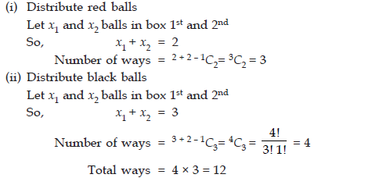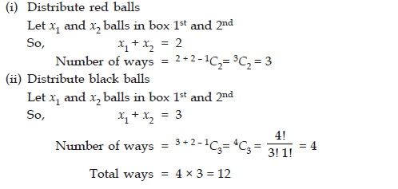 you can extend this concept

1. **DISTINGUISHABLE OBJECTS AND INDISTINGUISHABLE BOXES** : the number of ways to distribute n distinguishable objects into k indistinguishable boxes equals

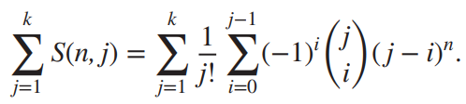The numbers S(n, j) are called **Stirling numbers** of the second kind.

Example : How many ways are there to put four different employees into three indistinguishable offices, when each office can contain any number of employees?

*Solution* : S(4, 1) + S(4, 2) + S(4, 3) = 1 + 7 + 6 = 14, after applying Stirling formula.

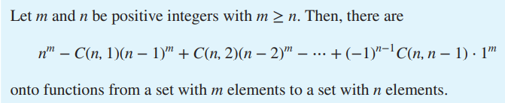

1. 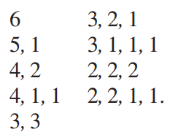**INDISTINGUISHABLE OBJECTS AND INDISTINGUISHABLE BOXES** : No formula exits, we have to write all cases. Sad!

Example : How many ways are there to pack six copies of the same book into four identical boxes, where a box can contain as many as six books?

*Solution* : For example, 4, 1, 1 indicates that one box contains four books, a second box contains a single book, and a third box contains a single book (and the fourth box is empty). We conclude that there are nine allowable ways to pack the books, because we have listed them all.

***Questions on counting :***

1. Suppose that a robot is placed on the Cartesian plane. At each step it is allowed to move either one unit up or one unit right, i.e., if it is at (i,j) then it can move to either (i+1,j) or (i,j+1).

How many distinct paths are there for the robot to reach the point (10,10) starting from the initial position (0, 0)

**Answer** : this is wonderful problem, to solve this you have basic idea like you have to take 10 steps in right and 10 steps upwards. but convert this problem into symbol like {u,u,....,r,r,....10 times} such combination will be 20!/10!10! = C(20,10).

1. Let Σ be a finite non-empty alphabet and let 2Σ∗ be the power set of Σ∗. Which one of the following is TRUE?

Both 2Σ∗ and Σ∗ are countable

2Σ∗ is countable and Σ∗ is uncountable

2Σ∗ is uncountable and Σ∗ is countable

Both 2Σ∗ and Σ∗ are uncountable

**Answer** : A set is countable means there exist a enumeration procedure to generate each of its elements and for a given element of set, it take finite step to generate it using the enumeration procedure.

Let Σ={a,b} and there exist a enumeration procedure to generate all the string of the language Σ∗.

Σ∗={ϵ,a,b,aa,ab,ba,bb,aaa,…}

Here, enumeration procedure is simply the generating string of the language by length for the fixed length string are in alphabetical order.

This way Σ∗ is countably infinite & 2Σ∗ will be uncountable set.

Because the power set of any countably infinite set is uncountable.

1. Mala has a colouring book in which each English letter is drawn two times. She wants to paint each of these 52 prints with one of k colours, such that the colour-pairs used to colour any two letters are different. Both prints of a letter can also be coloured with the same colour. What is the minimum value of k that satisfies this requirement ?

**Answer** : colour pair means that if you assign red, green to some alphabet pair then you are not allowed to use this colour combination for any other alphabet. so first we assign same colour to first k letter of 26 alphabet like C1,C1 to AA, C2C2 to BB and so on upto CkCk to (alpha)k(alpha)k. next remaining alphabet can be coloured in selecting 2 colours from k colours. So, we have k+C(k,2)>=26, solving this we will get k>=7.

1. Two girls have picked 10 roses, 15 sunflowers and 14 daffodils. What is the number of ways they can divide the flowers amongst themselves?

*1638*

*2100*

*2640*

*None of the above*

**Answer** : your approach was correct but you did some step wrong. first we distribute roses among 2 girls means x+y=10 thing. which will take 11 ways and same for other and after we multiply each ways to get final result.

1. How many substrings of different length (non-zero) can be formed from a character string of length n ?

**Answer** : very simple question, you have consider 2n as answer but string length should be different as said in question. but there are n string and length should be different so we will start with n then n-1 then n-2 and so on upto 1. Which is nothing but summation formula so answer should be n(n+1)/2.

1. There are 100 students. 85 choose Math, 80 choose Physics, 75 choose Chemistry, 70 choose Biology. What is the minimum number of students choosing all 4 subjects? Assume each student chosen at least one subject.

*15*

*10*

*5*

*Data is insufficient*

**Answer** : Let A,B,C,D ⊂ {1,2,…,100} be the four sets, with |A| = 85, |B| = 80, |C| = 75, |D| = 70. Then we want the minimum size of (A∩B∩C∩D). Combining the fact that |A∩B∩C∩D| = 100 − |A'∪B'∪C'∪D'| where A' refers to A complement, along with the fact that for any sets |X∪Y|≤|Y|+|X| we see that |A∩B∩C∩D| ≥ 100 − |A'|−|B'|−|C'|−|D'| = 10. So, option (B) is correct.

1. There are 6 jobs with distinct difficulty levels, and 3 computers with distinct processing speeds. Each job is assigned to a computer such that:

The fastest computer gets the toughest job and the slowest computer gets the easiest job.

Every computer gets at least one job.

The number of ways in which this can be done is

**Answer** : your approach is right but you stop right in between so, you made three column each representing computer first will contains high processor and last will contains low processor and middle one will contain medium one. now consider a job sequence as 1,2,3,4,5,6 now you have to assign 1 to last processor and 6 to first. 4 are remains so draw four boxes and now you can have 3 options for each box as 3 computers are there. But in question it is written that every computer gets at least one job. So, we are considering all those cases where only 1st and 3rd computer gets assign. Which we do not want. So, ans = total ways of distributing jobs among three computers - total ways of distributing jobs among first and last computer. this is true because in question it is written that every processor should get at least one job. So, 3^4 - 2^4 = 65. If you not u

* 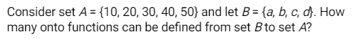As you can see number of m<n so no onto function is possible.
* 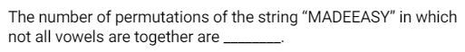you did everything correct answer is 8!/2!2! – 5!4!/2!2!. you did 8!/2!2! – 5!/2!2!.

1. A man has 7 relatives, 4 women and 3 men. His wife also has 7 relatives, 3 women and 4 men. The number of ways in which they can invite 3 women and 3 men so that 3 of them are the man’s relatives and 3 his wife’s is ________.

**Answer** : man -> 4 women and 3 men || woman -> 3 women and 4 men

(i) Man’s relatives (0 males + 3 females) + wife’s relatives (3 males + 0 females)

(ii) Man’s relatives (1 male + 2 females) + wife’s relatives (2 males + 1 female)

(iii) Man’s relatives (2 males + 1 females) + wife’s relatives (1 male + 1 females)

(iv) Man’s relative (3 males + 0 females) + wife’s relatives (0 males + 3 females)

The required number of selections will be = C(3, 0) × C(4, 3) × C(4, 3) × C(3, 0) + C(3, 1) × C(4, 2) × C(4, 2) × C(3, 1) + C(3, 2) × C(4, 1) × C(4, 1) × C(3, 2) + C(3, 3) × C(4, 0) × C(4, 0) × C(3, 3) = 485.

1. Find the number of ways 10 balls to be chosen from a box containing 10 identical blue balls, 5 identical red balls and 3 identical yellow balls _______?

**Answer** : We need no of solutions of the following x1+x2+x3=10, Where 0≤x1≤10 , 0≤x2≤5 , 0≤x3≤3.

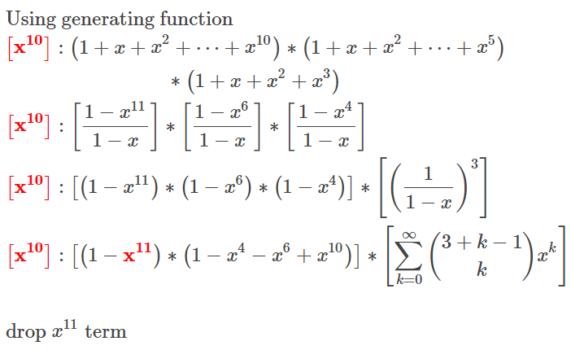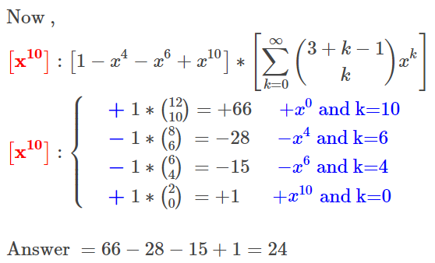

1. **Advance Counting Technique**
   1. **Applications of Recurrence Relations :**

**Rabbits and the Fibonacci Numbers** : A pair of rabbits does not breed until they are 2 months old. After they are 2 months old, each pair of rabbits produces another pair each month, find a recurrence relation for the number of pairs of rabbits on the island after n months, assuming that no rabbits ever die. Consequently, the sequence {fn} satisfies the recurrence relation fn = fn−1 + fn−2 ,for n ≥ 3 together with the initial conditions f1 = 1 and f2 = 1.

**The Tower of Hanoi Puzzle** : The rules of the puzzle allow disks to be moved one at a time from one peg to another as long as a disk is never placed on top of a smaller disk. The goal of the puzzle is to have all the disks on the second peg in order of size, with the largest on the bottom. Let Hn denote the number of moves needed to solve the Tower of Hanoi puzzle with n disks. Set up a recurrence relation for the sequence {Hn}. Hn = 2Hn−1 + 1 = 2n - 1. With initial condition H1 = 1.

* Find a recurrence relation and give initial conditions for the number of bit strings of length n that do not have two consecutive 0s. 🡪 an = an−1 + an−2

Cn = C(2n, n)∕(n + 1) = **Catalan Number.**

* 1. **Solving Linear Recurrence Relations** :

A **linear homogeneous recurrence relation of degree k** with constant coefficients is a recurrence relation of the form where c1, c2, … , ck are real numbers, and ck ≠ 0.

* The recurrence relation in the definition is **linear** because the right-hand side is a sum of previous terms of the sequence each multiplied by a function of n or by **having** **same** **power**.
* The recurrence relation is **homogeneous** because no terms occur that are not multiples of the aj s.
* The coefficients of the terms of the sequence are all **constants**, rather than functions that depend on n.
* The **degree** is k because an is expressed in terms of the previous k terms of the sequence.

*For example* **:** The recurrence relation Pn = (1.11)Pn−1 is a linear homogeneous recurrence relation of degree one. The recurrence relation fn = fn−1 + fn−2 is a linear homogeneous recurrence relation of degree two. The recurrence relation an = an−5 is a linear homogeneous recurrence relation of degree five.

The recurrence relation an = an−1 + a2n−2 is not linear. The recurrence relation Hn = 2Hn−1 +1 is not homogeneous. The recurrence relation Bn = nBn−1 does not have constant coefficients.

**Solution of LHRR :**

1. *Degree Two* : Let c1 and c2 be real numbers. Suppose that r2 − c1r − c2 = 0 (Characteristics equation) has two distinct roots r1 and r2 (Characteristics solution). Then the sequence {an} is a solution of the recurrence relation an = c1an−1 + c2an−2 if and only if an = 𝛼1r1^n + 𝛼2r2^n for n = 0, 1, 2, … , where 𝛼1 and 𝛼2 are constants. Because r1 and r2 are roots of r2 − c1r − c2 = 0, it follows that r2 1 = c1r1 + c2 and r2 2 = c1r2 + c2.

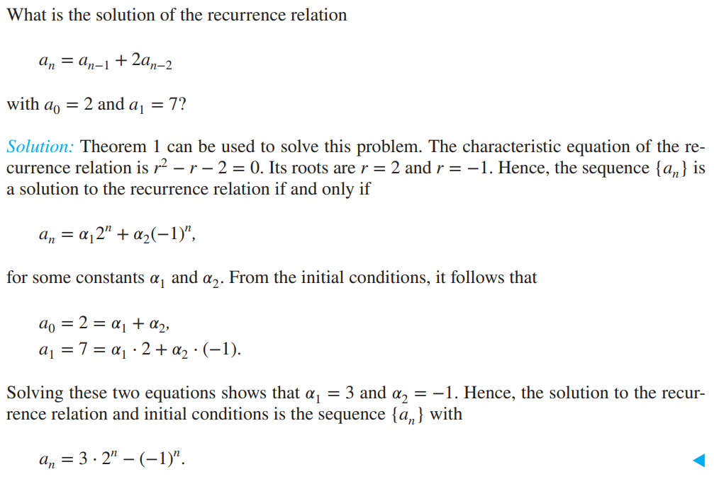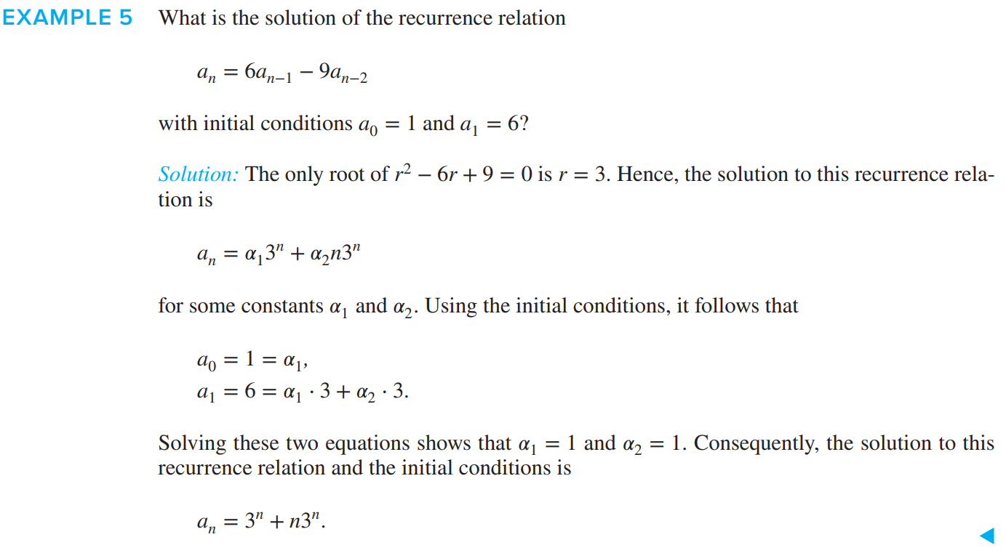

1. *General Case* :

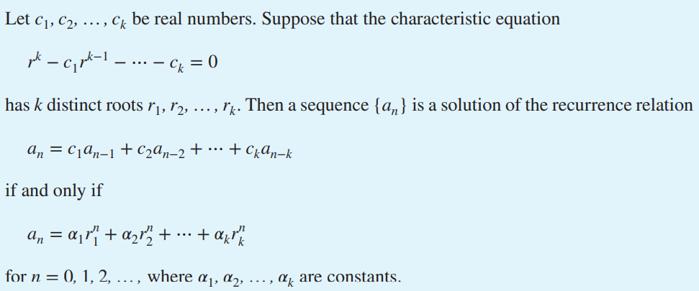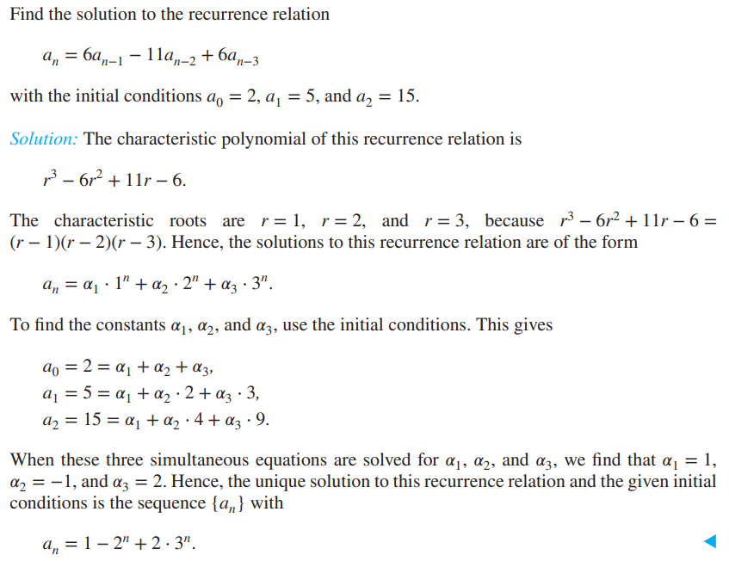

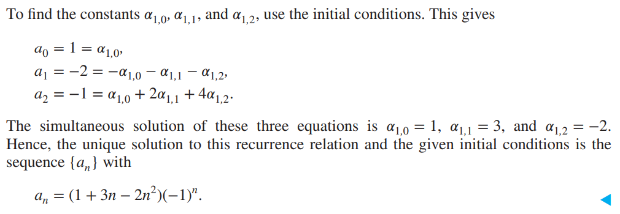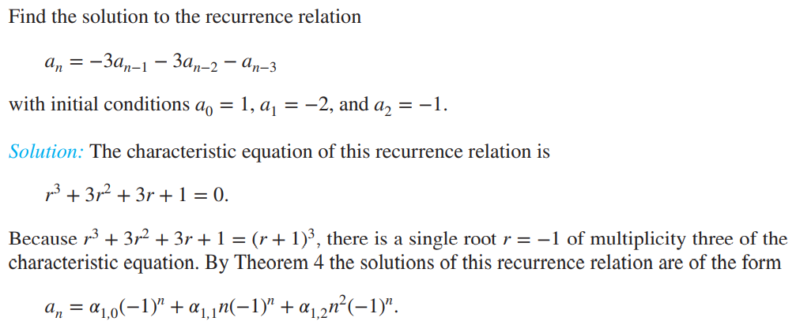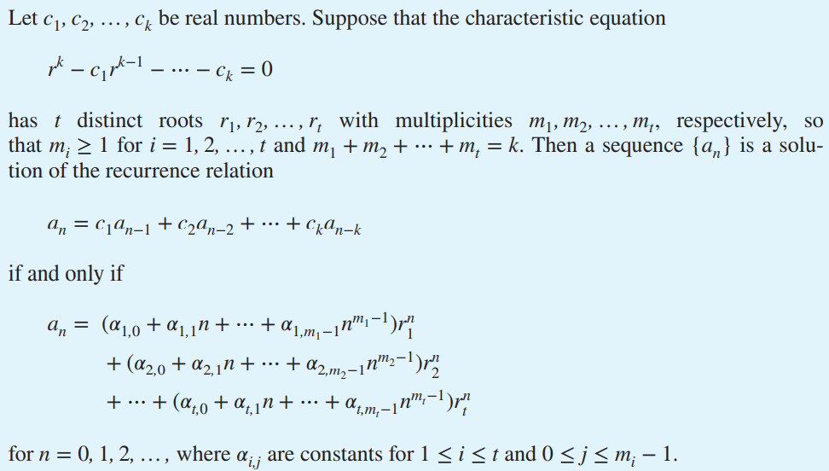

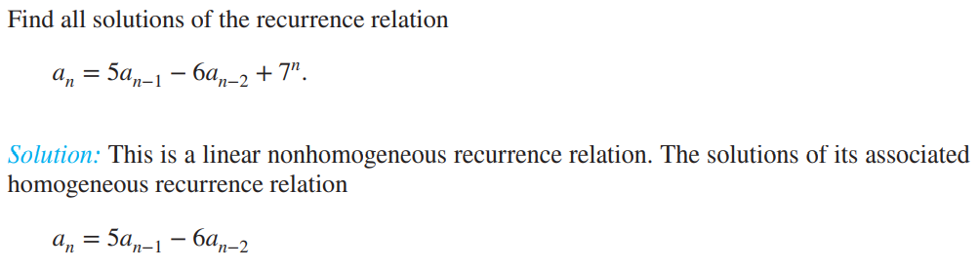

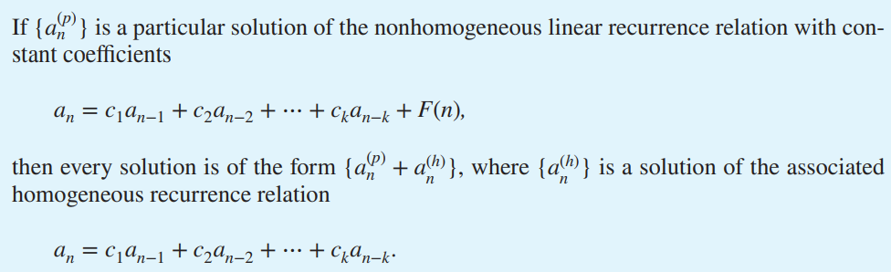

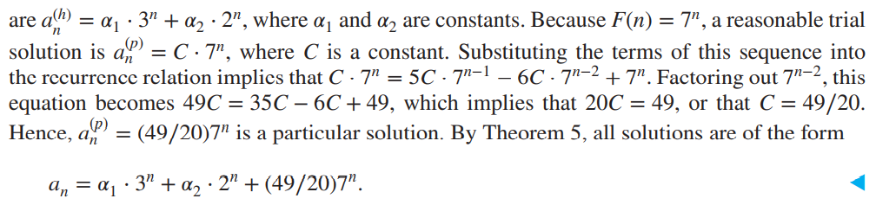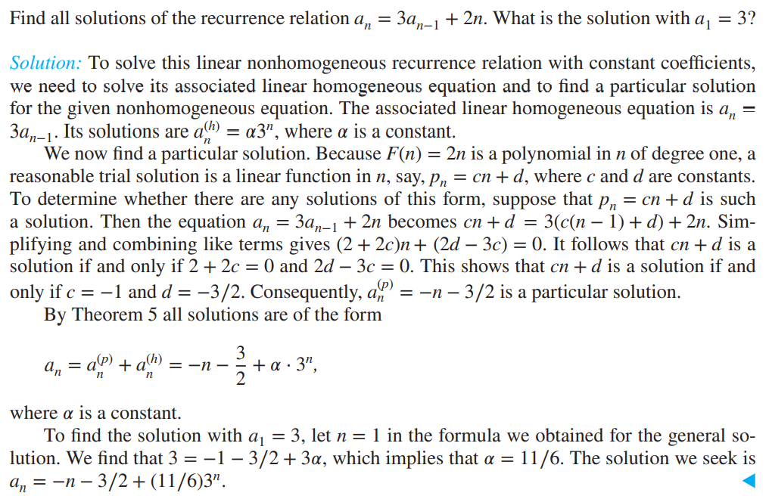

* 1. **Divide-and Conquer Algorithms and Recurrence Relations** :

Refer Generalize master theorem.

* 1. **Generating Functions :**

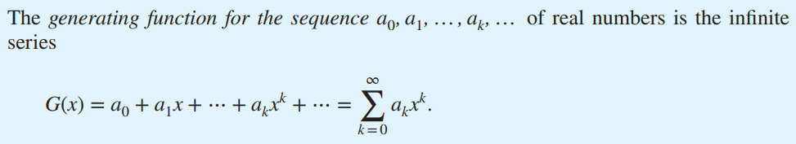

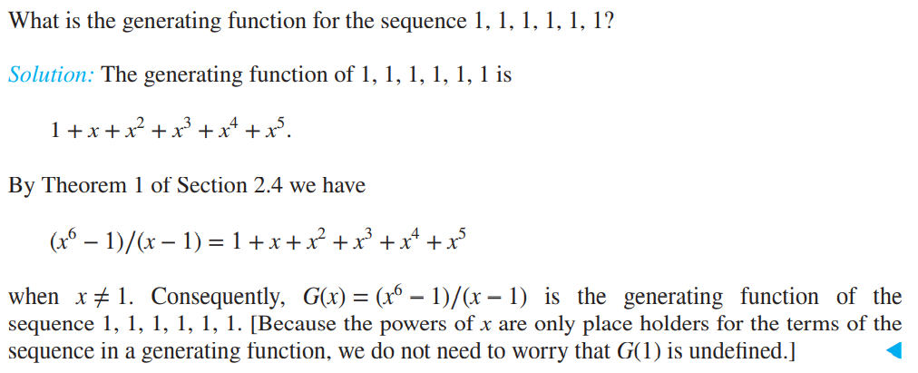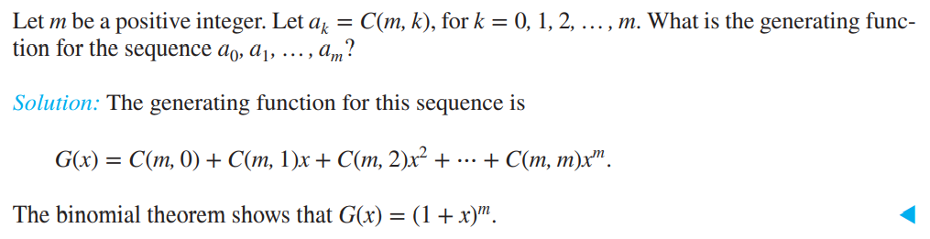

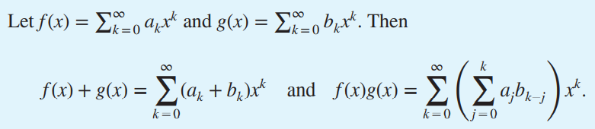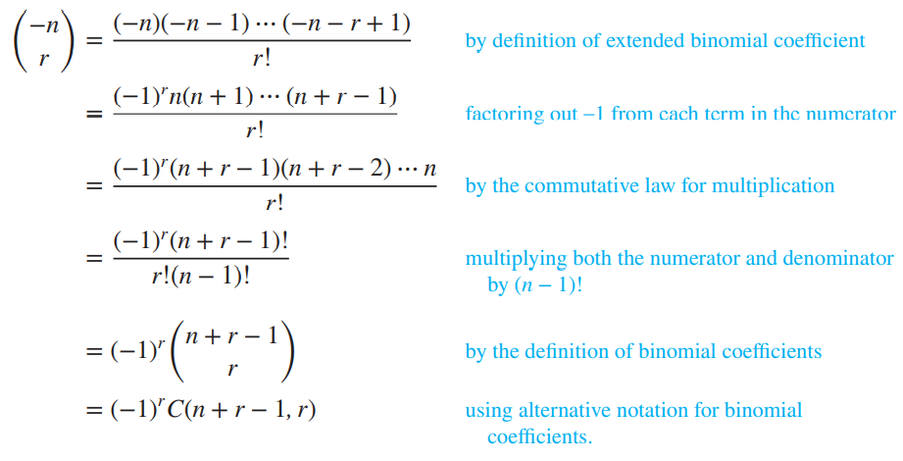

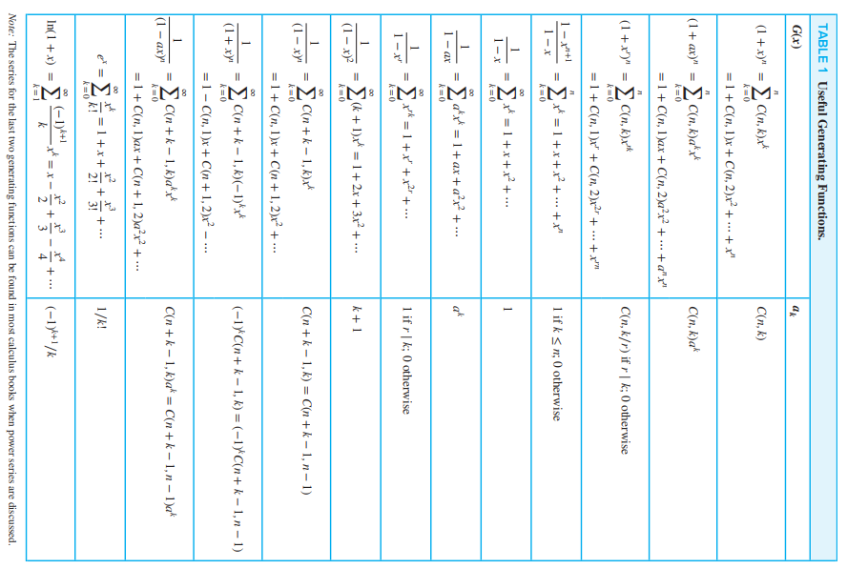

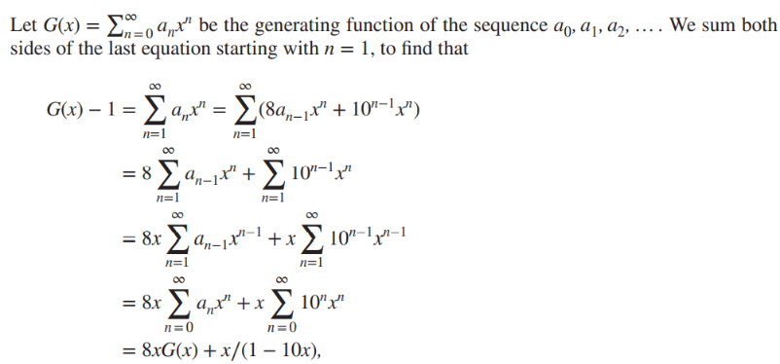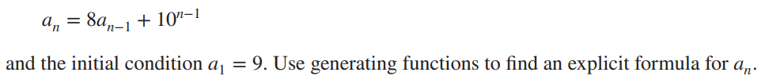**Counting Problems and Generating Functions** :

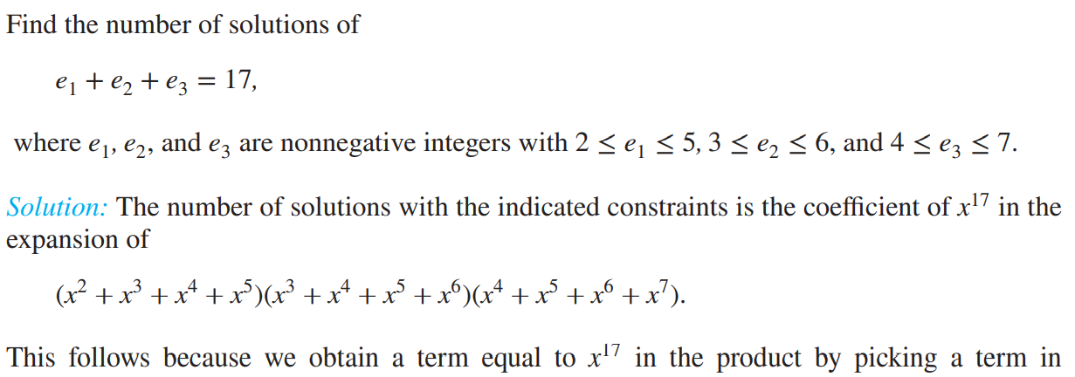

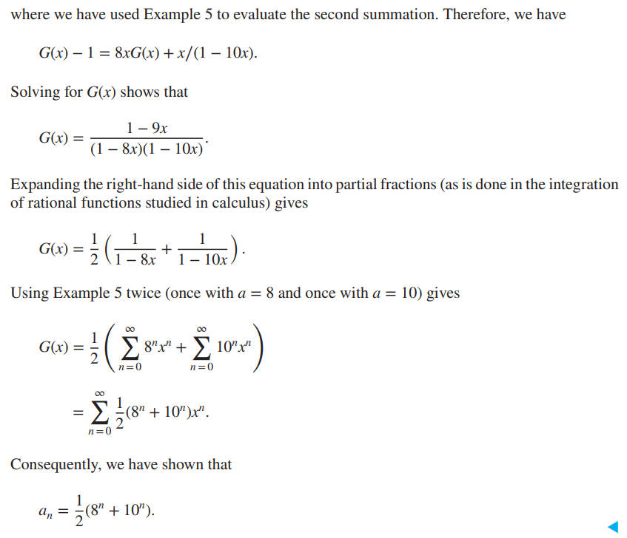**Using Generating Functions to Solve Recurrence Relations** :

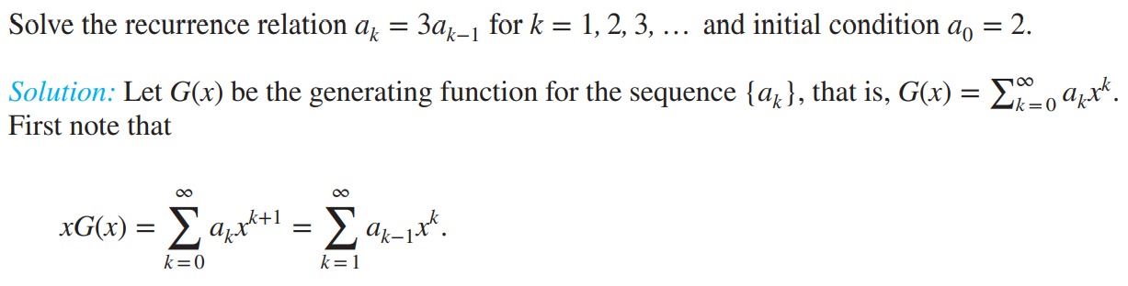

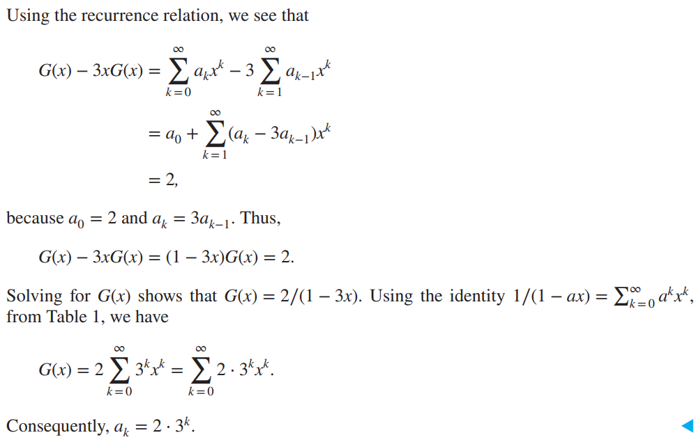

* 1. **Applications of Inclusion – Exclusion** :

No. of onto function form a set with m elements to n elements. Same as distinguishable objects into indistinguishable boxes.

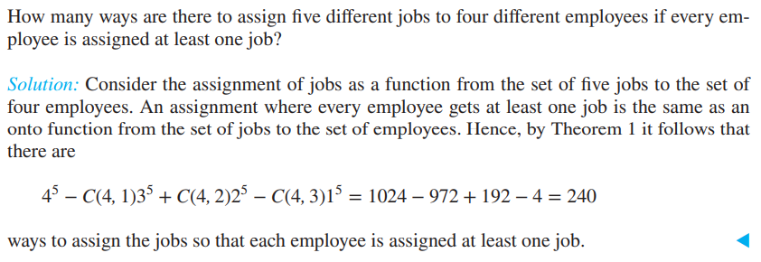

In above example, m is set of jobs and n is set of employees. Or in other word job is distinguishable and employees are indistinguishable. m = distinguishable and n = indistinguishable.

Special case : when n=m, then number of one to one function = number of onto function = number of bijection function = n!

**Inclusion – exclusion principle :**

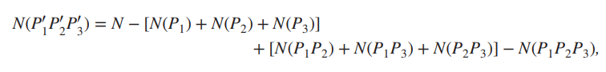

1. **Relations**
   1. **Relations and Their Properties** :

***6.1.1) Introduction*** :

* Let A and B be sets. A **binary relation** from A to B is a subset of A × B.

We use the notation aRb to denote that (a, b) ∈ R and a ̸R b to denote that (a, b) ∉ R. Moreover, when (a, b) belongs to R, a is said to be **related** to b by R.

* A relation on a set A is a relation from A to A. In other words, a relation on a set A is a subset of A × A.
* Let A be the set {1, 2, 3, 4}. Which ordered pairs are in the relation R = {(a, b) ∣ a divides b}?

*Solution*: Because (a, b) is in R if and only if a and b are positive integers not exceeding 4 such that a divides b, we see that R = {(1, 1), (1, 2), (1, 3), (1, 4), (2, 2), (2, 4), (3, 3), (4, 4)}.

***6.1.2) Property of Relation*** :

* A relation R on a set A is called **reflexive** if (a, a) ∈ R for every element a ∈ A.
* A relation R on a set A is called **symmetric** if (b, a) ∈ R whenever (a, b) ∈ R, for all a, b ∈ A.
* A relation R on a set A such that for all a, b ∈ A, if (a, b) ∈ R and (b, a) ∈ R, then a = b is called **antisymmetric**. Remark: Using quantifiers, we see that the relation R on the set A is symmetric if ∀a∀b((a, b) ∈ R → (b, a) ∈ R). Similarly, the relation R on the set A is antisymmetric if ∀a∀b(((a, b) ∈ R ∧ (b, a) ∈ R) → (a = b)).
* A relation R on a set A is called **transitive** if whenever (a, b) ∈ R and (b, c) ∈ R, then (a, c) ∈ R, for all a, b, c ∈ A.
* A relation R on set A is said to be **irreflexive** if (a, a) ∉ R for every a ∈ A.
* A relation is said to be **asymmetric** if it is both antisymmetric and irreflexive or else it is not. Every reflexive relation is also symmetric and antisymmetric.
* The relation {(1, 1), (1, 2), (1, 3), (2, 3), (3, 3)} on the set of integers {1, 2, 3} is **neither reflexive nor irreflexive**.
* Any transitive and irreflexive relation is also asymmetric.
* Consider the following relations on {1, 2, 3, 4}:

R1 = {(1, 1), (1, 2), (2, 1), (2, 2), (3, 4), (4, 1), (4, 4)},

R2 = {(1, 1), (1, 2), (2, 1)},

R3 = {(1, 1), (1, 2), (1, 4), (2, 1), (2, 2), (3, 3), (4, 1), (4, 4)},

R4 = {(2, 1), (3, 1), (3, 2), (4, 1), (4, 2), (4, 3)},

R5 = {(1, 1), (1, 2), (1, 3), (1, 4), (2, 2), (2, 3), (2, 4), (3, 3), (3, 4), (4, 4)},

R6 = {(3, 4)}. Which of these relations are reflexive, symmetric, antisymmetric, transitive?

*Solution*: R1 🡪 Non, R2 🡪 Symmetric, Transitive, R3 🡪 Reflexive, Symmetric, Transitive, R4 🡪 Antisymmetric, Transitive, R5 🡪 Reflexive, Antisymmetric, Transitive, R6 🡪 Antisymmetric.

* The “divides” relation on the set of positive integers is reflexive, antisymmetric but not symmetric.
* The equality relation is symmetric because a = b if and only if b = a.
* Less then equal to relation is antisymmetric, To see this, note that a ≤ b and b ≤ a implies that a = b.
* The terms symmetric and antisymmetric are not opposites, because a relation can have both of these properties or may lack both of them.
* Let R be a relation from a set A to a set B and S a relation from B to a set C. The **composite** of R and S is the relation consisting of ordered pairs (a, c), where a ∈ A, c ∈ C, and for which there exists an element b ∈ B such that (a, b) ∈ R and (b, c) ∈ S. We denote the composite of R and S by S ◦R.
* 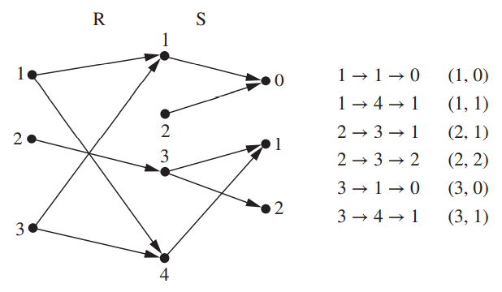What is the composite of the relations R and S, where R is the relation from {1, 2, 3} to {1, 2, 3, 4} with R = {(1, 1), (1, 4), (2, 3), (3, 1), (3, 4)} and S is the relation from {1, 2, 3, 4} to {0, 1, 2} with S = {(1, 0), (2, 0), (3, 1), (3, 2), (4, 1)}?

*Solution*: S ◦R is constructed using all ordered pairs in R and ordered pairs in S, where the second element of the ordered pair in R agrees with the first element of the ordered pair in S. For example, the ordered pairs (2, 3) in R and (3, 1) in S produce the ordered pair (2, 1) in S ◦R. Computing all the ordered pairs in the composite, we find S ◦ R = {(1, 0), (1, 1), (2, 1), (2, 2), (3, 0), (3, 1)}.

* Let R be a relation on the set A. The powers Rn, n = 1, 2, 3, … , are defined recursively by R1 = R and Rn+1 = Rn ◦ R, And hence The relation R on a set A is transitive if and only if Rn ⊆ R for n = 1, 2, 3, … .

**Note** :

1. To find transitive closure we use Floyd-Warshall algorithms which has time complexity of O(n3).
2. Number of binary relations from A to B = Number of subsets of A X B = 2|A|*|B|. And non-empty binary relations are (2|A|*|B| - 1).
   1. **n-ary Relations and Their Applications** :

* Let A1, A2, … , An be sets. An n-ary relation on these sets is a subset of A1 × A2 × ⋯ × An. The sets A1, A2, … , An are called the **domains** of the relation, and n is called its **degree**.
* Let R be the relation on N × N × N consisting of triples (a, b, c), where a, b, and c are integers with a < b < c. Then (1, 2, 3) ∈ R, but (2, 4, 3) ∉ R. The degree of this relation is 3. Its domains are all equal to the set of natural numbers.

***6.2.1) Databases and relations*** : A database consists of **records**, which are n-tuples, made up of **fields**. The fields are the entries of the n-tuples. For instance, a database of student records may be made up of fields containing the name, student number, major, and grade point average of the student. The **relational data model** represents a database of records as an n-ary relation.

Relations used to represent databases are also called **tables**, because these relations are often displayed as tables. Each column of the table corresponds to an attribute of the database.

A domain of an n-ary relation is called a **primary key** when the value of the n-tuple from this domain determines the n-tuple. Domain means values of particular attribute.

***6.2.2) Operation on n-ary relations*** :

* Let R be an n-ary relation and C a condition that elements in R may satisfy. Then the **selection operator sC** maps the n-ary relation R to the n-ary relation of all n-tuples from R that satisfy the condition C.
* 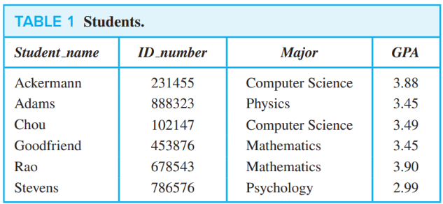To find the records of computer science majors in the n-ary relation R shown in Table 1, we use the operatorsC1 , where C1 is the condition Major=“Computer Science.” The result is the two 4- tuples (Ackermann, 231455, Computer Science, 3.88) and (Chou, 102147, Computer Science, 3.49).

Similarly, to find the records of students who have a grade point average above 3.5 in this database, we use the operator sC2 , where C2 is the condition GPA > 3.5.

* The **projection** Pi1i2,…,im where i1 < i2 < ⋯ < im, maps the n-tuple (a1, a2, … , an) to the m-tuple (ai1 , ai2 , … , aim ), where m ≤ n.

In other words, the projection Pi1,i2,…,im deletes n − m of the components of an n-tuple, leaving the i1th, i2th, … , and imth components.

* What relation results when the projection P1,4 is applied to the relation in Table 1?

Solution : Table 2

* Let R be a relation of degree m and S a relation of degree n. The **join Jp(R, S)**, where p ≤ m and p ≤ n, is a relation of degree m + n − p that consists of all (m + n − p)-tuples (a1, a2, … , am−p, c1, c2, … , cp, b1, b2, … , bn−p), where the m-tuple (a1, a2, … , am−p, c1, c2, … , cp) belongs to R and the n-tuple (c1, c2, … , cp, b1, b2, … , bn−p) belongs to S.
* What relation results when the join operator J2 is used to combine the relation displayed in Tables 5 and 6?

Solution : Table 7

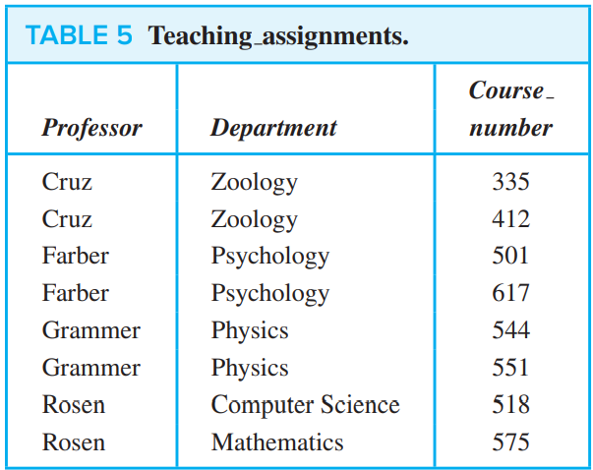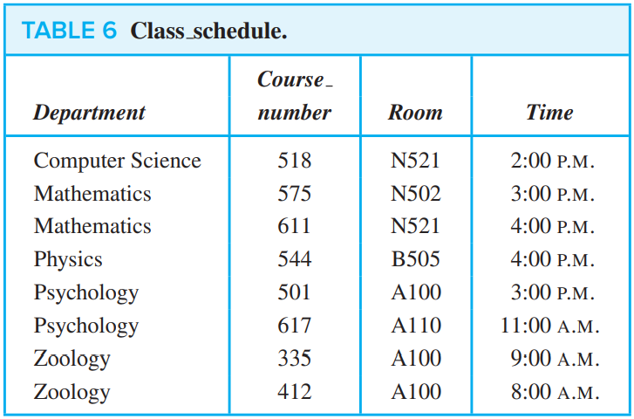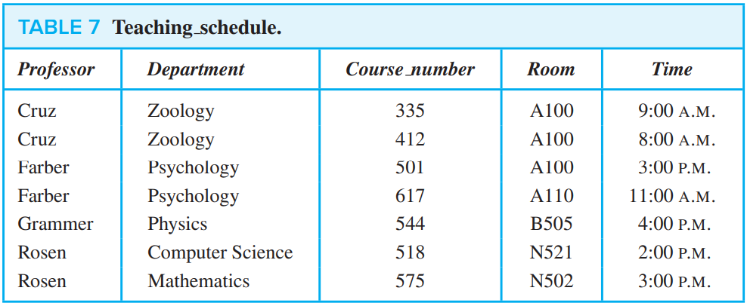

* 1. **Representing Relations** :

***6.3.1) Representing Relations Using Matrices*** : The relation R can be represented by the matrix MR = [mij], where mij = {1 if (ai , bj ) ∈ R, 0 if (ai , bj ) ∉ R.

* 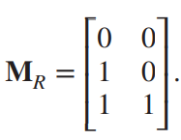Suppose that A = {1, 2, 3} and B = {1, 2}. Let R be the relation from A to B containing (a, b) if a ∈ A, b ∈ B, and a > b. What is the matrix representing R if a1 = 1, a2 = 2, and a3 = 3, and b1 = 1 and b2 = 2?

Solution: Because R = {(2, 1), (3, 1), (3, 2)}, the matrix for R is

* 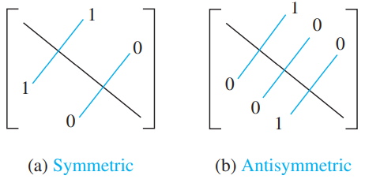Relation is reflexive if all diagonal elements are one. Relation is symmetric if transpose of matrix is equal to original matrix. MR = (MR)t. The relation R is antisymmetric if and only if (a, b) ∈ R and (b, a) ∈ R imply that a = b. Consequently, the matrix of an antisymmetric relation has the property that if mij = 1 with i ≠ j, then mji = 0.
* 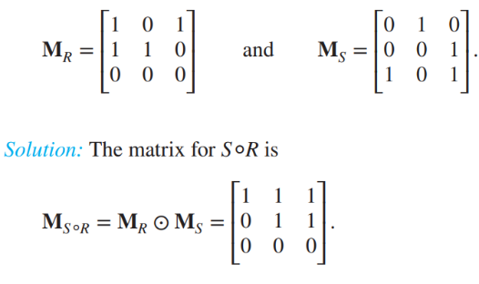The ordered pair (ai , cj ) belongs to S ◦R if and only if there is an element bk such that (ai , bk) belongs to R and (bk, cj ) belongs to S. It follows that tij = 1 if and only if rik = skj = 1 for some k.

This operation is same as matrix multiplication.

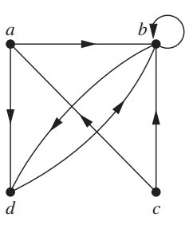

***6.3.2) Graphical Representation*** : A **directed graph**, or **digraph**, consists of a set V of vertices (or nodes) together with a set E of ordered pairs of elements of V called edges (or arcs). The vertex a is called the initial vertex of the edge (a, b), and the vertex b is called the **terminal** vertex of this edge.

* The directed graph with vertices a, b, c, and d, and edges (a, b), (a, d), (b, b), (b, d), (c, a), (c, b), and (d, b) is displayed in Figure 3.
  1. **Equivalence Relations** :
* A relation on a set A is called an **equivalence relation** if it is reflexive, symmetric, and transitive.

Two elements a and b that are related by an equivalence relation are called equivalent. The notation a ∼ b is often used to denote that a and b are equivalent elements with respect to a particular equivalence relation.

* Let R be an equivalence relation on a set A. The set of all elements that are related to an element a of A is called the equivalence class of a. The equivalence class of a with respect to R is denoted by [a]R. When only one relation is under consideration, we can delete the subscript R and write [a] for this equivalence class.
* Inverse of equivalence relation R-1 is (b,a) if (a,b) is the relation in R.
* What are the equivalence classes of 0, 1, 2, and 3 for congruence modulo 4?

Solution : The equivalence class of 0 contains all integers a such that a ≡ 0 (mod 4). The integers in this class are those divisible by 4. Hence, the equivalence class of 0 for this relation is [0] = {… ,−8,−4, 0, 4, 8, … }.

[1] = {… ,−7,−3, 1, 5, 9, … }.

[2] = {… ,−6,−2, 2, 6, 10, … }.

[3] = {… ,−5,−1, 3, 7, 11, … }.

* 1. **Partial Orderings** :
* A relation R on a set S is called a partial ordering or partial order if it is reflexive, antisymmetric, and transitive. A set S together with a partial ordering R is called a partially ordered set, or poset, and is denoted by (S, R). Members of S are called elements of the poset.
* Example : Show that the greater than or equal to relation (≥) is a partial ordering on the set of integers.

*Solution*: Because a ≥ a for every integer a, ≥ is reflexive. If a ≥ b and b ≥ a, then a = b. Hence, ≥ is antisymmetric. Finally, ≥ is transitive because a ≥ b and b ≥ c imply that a ≥ c. It follows that ≥ is a partial ordering on the set of integers and (Z, ≥) is a poset.

Similarly, The inclusion relation ⊆ is a partial ordering on the power set of a set S.

* The elements a and b of a poset (S, ) are called **comparable** if either a b or b a. When a and b are elements of S such that neither a b nor b a, a and b are called **incomparable**. If there is edge between two element in diagram then two element are comparable.

Therefore, **total number of edges in diagram or in complete graph of that diagram = comparable edges or pairs + incomparable edges or pair**

* If (S, ) is a poset and every two elements of S are comparable, S is called a totally ordered or linearly ordered set, and is called a **total order** or a **linear order**. A totally ordered set is also called a **chain**. 🡨 and that is why number total order relation is n!.

**Note :** (Note that the symbol is used to denote the relation in any poset, not just the less than or equal to relation.)

If relation is not reflexive or not antisymmetric or not transitive then it is not partial ordered. Every total order relation is also partial order. But converse is not true.

* (S, ) is a **well-ordered** set if it is a poset such that is a total ordering and every nonempty subset of S has a least element.

***6.5.1) Lexicographic order :***

* The lexicographic ordering on A1 × A2 is defined such that (a1, a2) is less than (b1, b2), that is, (a1, a2) ≺ (b1, b2), either if a1 ≺1 b1 or if both a1 = b1 and a2 ≺ b2.

For example : (3, 5) ≺ (4, 8), (4, 9) ≺ (4, 11), discreet ≺ discreetness.

***6.5.2) Hasse Diagrams*** :

Many edges in the directed graph for a finite poset do not have to be shown because they must be present. Consequently, we do not have to show these loops because they must be present; Because a partial ordering is transitive, we do not have to show those edges that must be present because of transitivity. The resulting diagram is called the Hasse diagram of (S, ).

Example : Draw the Hasse diagram representing the partial ordering {(a, b)∣a divides b} on {1, 2, 3, 4, 6, 8, 12}.

*Solution* : 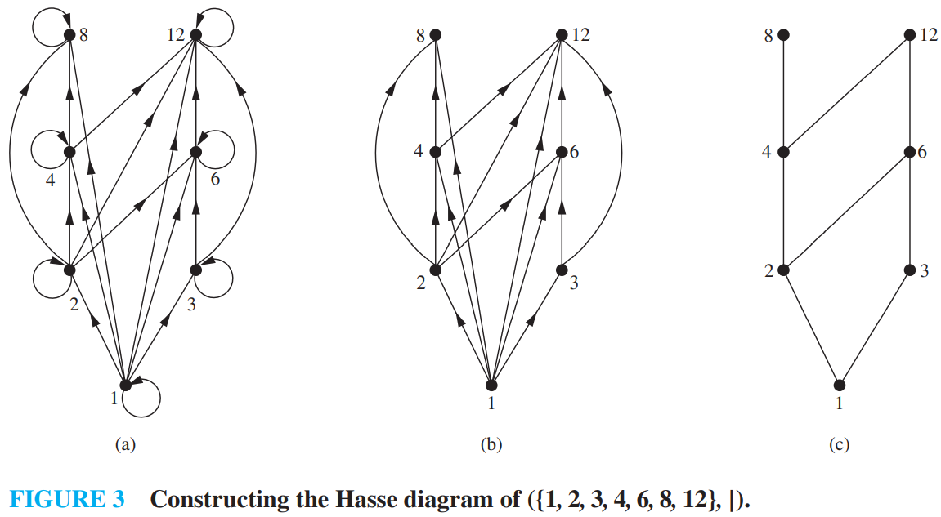

***6.5.3) Maximal and Minimal Elements*** :

**Maximal** : a is Maximal in the poset (S, ) if there is no b ∈ S such that a ≺ b. it should not be related to any element.

**Minimal** : a is minimal if there is no element b ∈ S such that b ≺ a. It should not be related by any element.

**Note** : They are represented by top and bottom elements in hasse diagram.

**Greatest** element : if it is maximal and every element is related to it. it is also called maximum element.

**Least** element : if it is minimal and it is related to every element in poset but it is not related by any element. It is also known as minimum element.

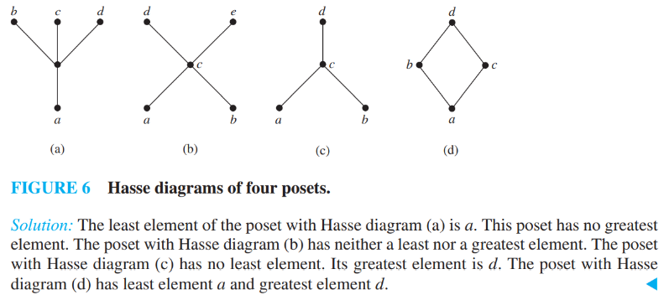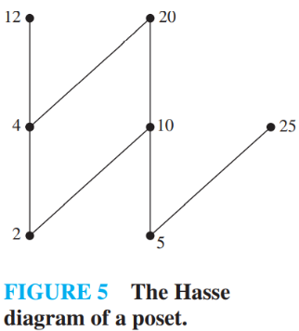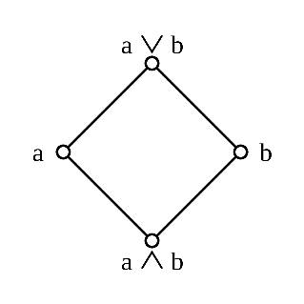

The Hasse diagram in Figure 5 for this poset shows that the maximal elements are 12, 20, and 25, and the minimal elements are 2 and 5.

**Upper bound** : If A is subset of S and u is an element of S such that a is related to u for all elements a ∈ A, then u is called an **upper bound** of A.

**Lower bound** : If A is subset of S and u is an element of S such that a is related by u for all elements a ∈ A, then u is called an lower bound of A.

**Least upper bound** : It is the least element of upper bound. This is also known as **supremum** or **join**. (V) to find this first find upper bound and then select lowest element.

**Greatest lower bound** : it is the greatest element of lower bound. This is also known as **infimum** or **meet**. (^) to find this first find lower bound and then select greatest element.

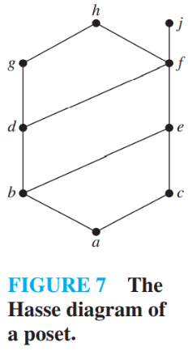

The upper bounds of {a, b, c} are e, f, j, and h, and its only lower bound is a. There are no upper bounds of {j, h}, and its lower bounds are a, b, c, d, e, and f . The upper bounds of {a, c, d, f } are f , h, and j, and its lower bound is a.

The upper bounds of {b, d, g} are g and h. Because g ≺ h, g is the least upper bound. The lower bounds of {b, d, g} are a and b. Because a ≺ b, b is the greatest lower bound.

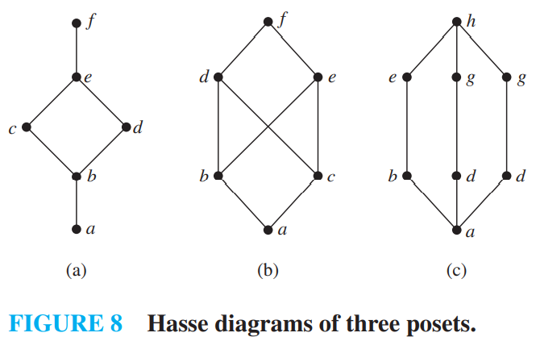***6.5.4) Lattices*** : A partially ordered set in which every pair of elements has both a least upper bound and a greatest lower bound is called a **lattice**.

The posets represented by the Hasse diagrams in (a) and (c) are both lattices because in each poset every pair of elements has both a least upper bound and a greatest lower bound, as the reader should verify. On the other hand, the poset with the Hasse diagram shown in (b) is not a lattice, because the elements b and c have no least upper bound. To see this, note that each of the elements d, e, and f is an upper bound, but none of these three elements precedes the other two with respect to the ordering of this poset.

**Complement of element in set** = two pairs are complement of each other if join of both element results in least upper bound of the system and meet of both element results in greatest lower bound of the system.

*There are three types of lattice* : (**Before checking distributed or complemented or Boolean first check if structure is lattice**)

1. **Bounded lattice** : when LUB and GLB exist for every pair of elements. Every finite lattice is bounded.
2. **Complemented lattice** : for each element at least one complement should be present. For example in figure 8a, complement of c is d, complement of f is a and so on.
3. **Distributed lattice** : for each element at most one complement should be present. For example in figure 8c, complement of e is g,g so it is not distributed lattice.
4. **Boolean Algebra** : A lattice is said to be Boolean Algebra if it is complemented and distributed. Means it have exactly one complement.

**THEOREM** : Poset [Dn, /] is called Boolean algebra if n has distinct prime factorization and its number of factor should be power of 2. Lattice diagram of Boolean algebra is n-cube graph. Where n is number of distinct prime number. For example : D210 = 2 x 3 x 5 x 7. There are 4 elements. So cardinality is 4 of poset.

Topological Sort :

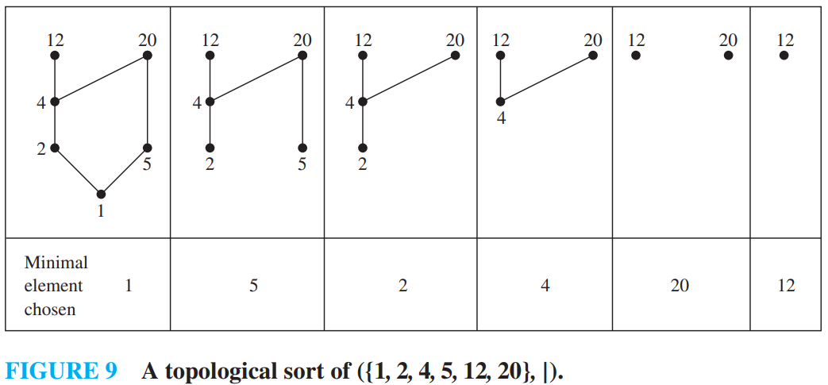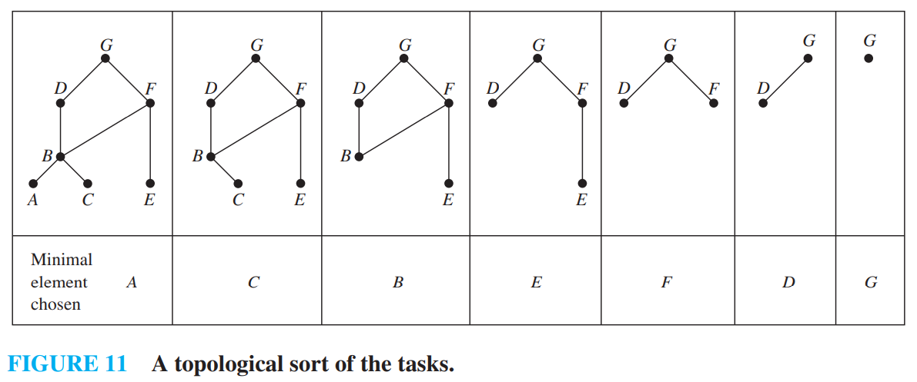

Important :

1. **Semigroup :**

A finite or infinite set ‘S′ with a binary operation ‘ο′ (Composition) is called semigroup if it holds following two conditions simultaneously −

Closure − For every pair (a,b)∈S,(aοb) has to be present in the set S.

Associative − For every element a,b,c∈S,(aοb)οc=aο(bοc) must hold.

Example

* The set of positive integers (excluding zero) with addition operation is a semigroup. For example, S={1,2,3,…}

Here closure property holds as for every pair (a,b)∈S,(a+b) is present in the set S. For example, 1+2=3∈S]

Associative property also holds for every element a,b,c∈S,(a+b)+c=a+(b+c). For example, (1+2)+3=1+(2+3)=5

1. **Monoid :**

A monoid is a semigroup with an identity element. The identity element (denoted by e or E) of a set S is an element such that (aοe)=a, for every element a∈S. An identity element is also called a unit element. So, a monoid holds three properties simultaneously − Closure, Associative, Identity element.

Example :

* The set of positive integers (excluding zero) with multiplication operation is a monoid. S={1,2,3,…}

Here closure property holds as for every pair (a,b)∈S,(a×b) is present in the set S. [For example, 1×2=2∈S and so on]

Associative property also holds for every element a,b,c∈S,(a×b)×c=a×(b×c) [For example, (1×2)×3=1×(2×3)=6 and so on]

Identity property also holds for every element a∈S,(a×e)=a [For example, (2×1)=2,(3×1)=3 and so on]. Here identity element is 1.

1. **Group** :

A group is a monoid with an inverse element. The inverse element (denoted by I) of a set S is an unique element such that (aοI)=(Iοa)=e, where e is identity element. for each element a∈S. So, a group holds four properties simultaneously - i) Closure, ii) Associative, iii) Identity element, iv) Inverse element. The order of a group G is the number of elements in G and the **Order of an element in a group is the least positive integer n such that an is the identity element of that group G.** Where an means operation is applied n times. **Minimum order of any group is 1 which is nothing but order of identity element**. Every element in Group have unique inverse element. Order of inverse is same as order of that element.

Example : Consider group <G, +4>, where +4 is modulo 4 operators. And G={0,1,2,3}, O(0) = 1 as it is identity element. O(1) = 4, because after applying addition 4 times we get 0. Similarly, O(2) = 2, O(3) = 4.

**Lagrange's Theorem**: The order of every subgroup of G divides the order of G. and ***if the order of group is not prime is can or cannot be cyclic but if it’s prime number then it is cyclic for sure.***

{e} is a subgroup of any group G called the trivial subgroup. Any subgroup other than {e} is called non trivial.

1. **Abelian Group :**

An abelian group G is a group for which the element pair (a,b)∈G always holds commutative law. So, a group holds five properties simultaneously - i) Closure, ii) Associative, iii) Identity element, iv) Inverse element, v) Commutative.

If every element of group is inverse of itself then group is Abelian group.

Example :

* The set of positive integers (including zero) with addition operation is an abelian group. G={0,1,2,3,…}

Here closure property holds as for every pair (a,b)∈S,(a+b) is present in the set S. [For example, 1+2=2∈S and so on]

Associative property also holds for every element a,b,c∈S,(a+b)+c=a+(b+c) [For example, (1+2)+3=1+(2+3)=6 and so on]

Identity property also holds for every element a∈S,(a×e)=a [For example, (2×1)=2,(3×1)=3 and so on]. Here, identity element is 1.

Commutative property also holds for every element a∈S,(a×b)=(b×a) [For example, (2×3)=(3×2)=3 and so on]

1. **Cyclic Group and Subgroup :**

A cyclic group is a group that can be generated by a single element. Every element of a cyclic group is a power of some specific element which is called a generator. A cyclic group can be generated by a generator ‘g’, such that every other element of the group can be written as a power of the generator ‘g’.

Example

* The set of complex numbers {1,−1,i,−i} under multiplication operation is a cyclic group.

There are two generators i and –i as i^1=i, i^2=−1, i^3=−i, i^4=1 and also (–i)^1=−i, (–i)^2=−1, (–i)^3=i, (–i)^4=1 which covers all the elements of the group. Hence, it is a cyclic group.

**NOTE** :-

1. Order mean number of elements that group contains. If order of any group or subgroup is prime number then it is cyclic. A cyclic group is always an abelian group but not every abelian group is a cyclic group. The rational numbers under addition is not cyclic but is abelian.
2. Total number of generators of group G of order n is number of positive integers that are relatively prime to n which is nothing but Euler totient function.
3. Total Number of divisors of number n = (ki +1) (kj + 1),…where n = piki x pjkj , where pi, pj,… are prime factorization of n and ki, kj is power of primes.
4. Intersection of two subgroups of a group is always group.
5. (ab)-1 = b-1a-1

A subgroup H is a subset of a group G (denoted by H≤G) if it satisfies the four properties simultaneously − Closure, Associative, Identity element, and Inverse.

A subgroup H of a group G that does not include the whole group G is called a proper subgroup (Denoted by H<G**). A subgroup of a cyclic group is cyclic and a abelian subgroup is also abelian.**

Example :

* Let a group G={1,i,−1,−i}, size of subgroup is multiple of size of group. Here you can see 1,2 is multiple of 4. 4 is also but it is proper subgroup in this particular example.

Then some subgroups are H1={1},H2={1,−1},

This is not a subgroup − H3={1,i} because that (i)−1=−i is not in H3

1. **Partially Ordered Set (POSET) :**

A partially ordered set consists of a set with a binary relation which is reflexive, antisymmetric and transitive. "Partially ordered set" is abbreviated as POSET.

Examples :

* The set of real numbers under binary operation less than or equal to (≤) is a poset.

Let the set S={1,2,3} and the operation is ≤

The relations will be {(1,1),(2,2),(3,3),(1,2),(1,3),(2,3)}

This relation R is reflexive as {(1,1),(2,2),(3,3)}∈R

This relation R is anti-symmetric, as

{(1,2),(1,3),(2,3)}∈R and {(2,1),(3,1),(3,2)}∉R

This relation R is also transitive as {(1,2),(2,3),(1,3)}∈R.

Hence, it is a poset.

The vertex set of a directed acyclic graph under the operation ‘reachability’ is a poset.

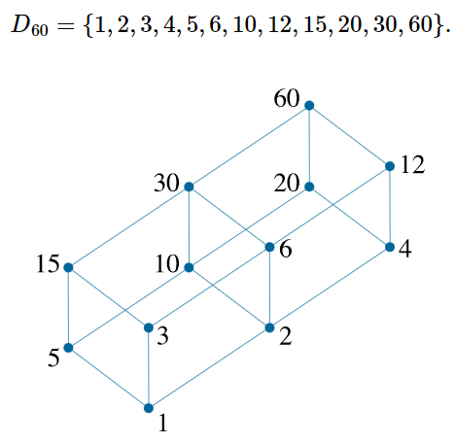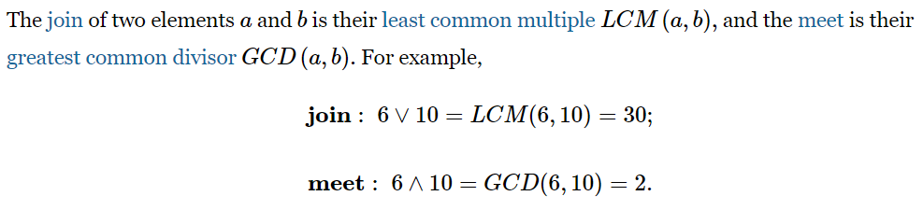

1. **Linearly Ordered Set** :

A **Linearly ordered set** or **Total ordered set** is a **partial order set** in which every pair of elements is comparable. The elements a,b∈S are said to be comparable if either a≤b or b≤a holds. Trichotomy law defines this total ordered set. A totally ordered set can be defined as a distributive lattice having the property {a∨b,a∧b}={a,b} for all values of a and b in set S.

Example :

* The powerset of {a,b} ordered by ⊆ is a totally ordered set as all the elements of the power set P={∅,{a},{b},{a,b}} are comparable.

Example of non-total order set

* A set S={1,2,3,4,5,6} under operation x divides y is not a total ordered set.

Here, for all (x,y)∈S,x|y has to hold but it is not true that 2 | 3, as 2 does not divide 3 or 3 does not divide 2. Hence, it is not a total ordered set.

1. **Chains, Antichain, Height and Width** :

Chain and antichain etc all counts are not count of edges but count of vertices.

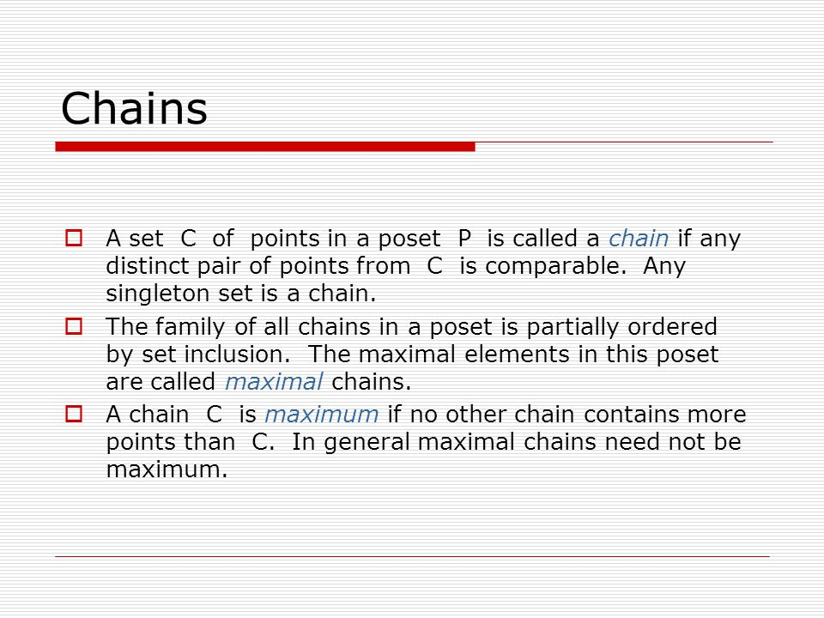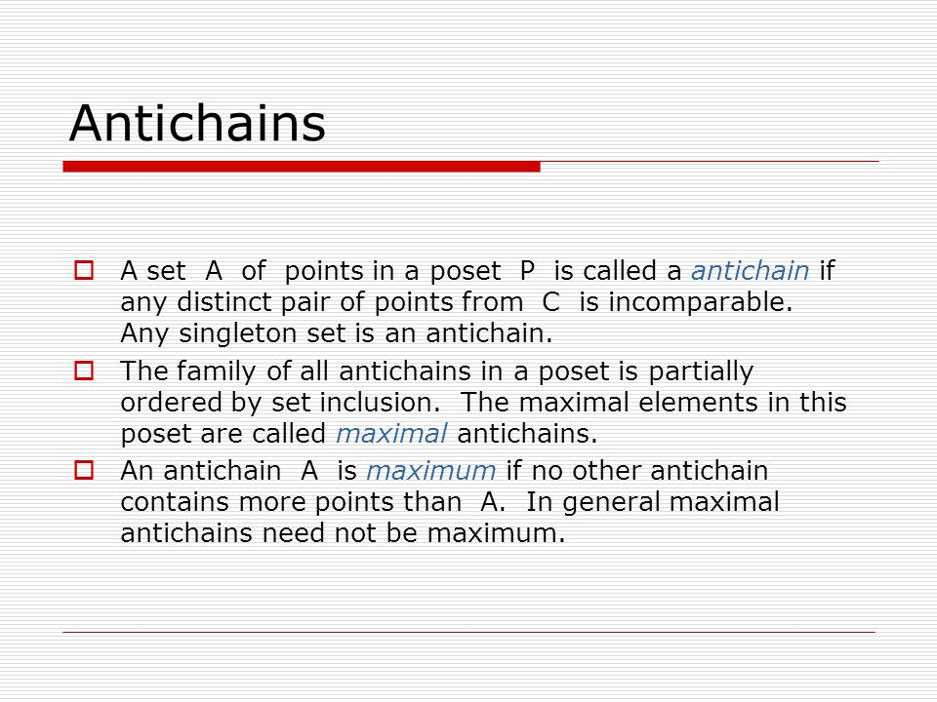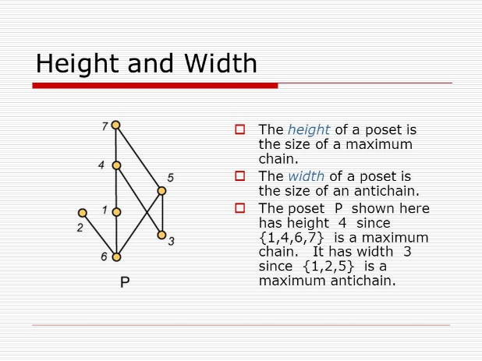

***Questions on sets*** :

1. Let G be a group of order 6, and H be a subgroup of G such that 1<|H|<6. Which one of the following options is correct?

*Both G and H are always cyclic*

*G may not be cyclic, but H is always cyclic*

*G is always cyclic, but H may not be cyclic*

*Both G and H may not be cyclic*

**Answer** : Lagrange's Theorem : The order of every subgroup of G divides the order of G. So, Subgroup (H) of G can be the order of 1,2,3,6 but 6 is not possible as we need a proper sub-group as mentioned in the question.

Now, any Group of prime order is cyclic. If the order is not-prime both cyclic and acyclic groups are possible.

Order of G=6– Not a prime number so G may or may not be cyclic.

Order of H={1,2,3} – 2 and 3 are prime numbers and Group with 1 element is cyclic. So, H is always cyclic.

G may not be cyclic, but H is always cyclic.

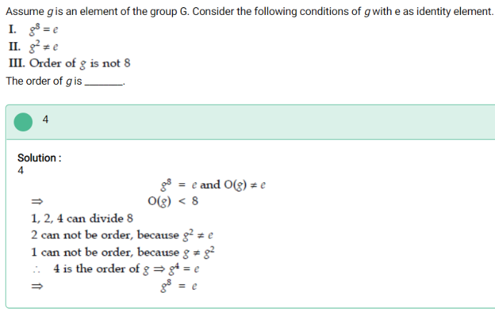

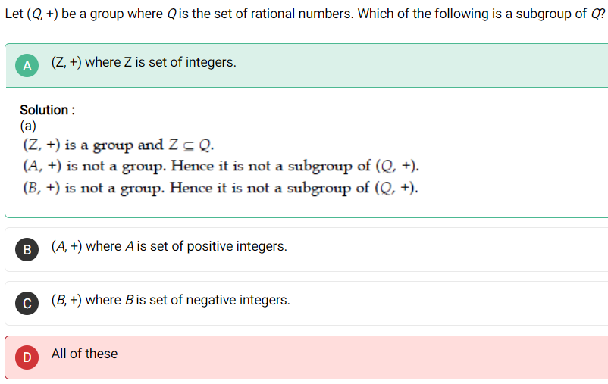

🡨 in this question set of integer is group because 5+(-5) =0 so here -5 becomes the inverse of 5 but when you consider option B and C you will find that there does not any inverse that is belongs to that same set.

1. Consider the partition of a set having 3 block of 5 elements each, 4 block of 2 elements each and 2 block of 3 elements in each block. Find the cardinality of equivalence relation.

**Answer** : **Number of equivalence relation = number of different partition of cardinality of set = Bell number = 1, 1, 2, 5, 15, 52, 203,…**

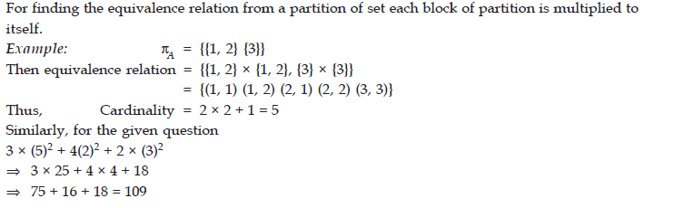

1. 

**Answer** :

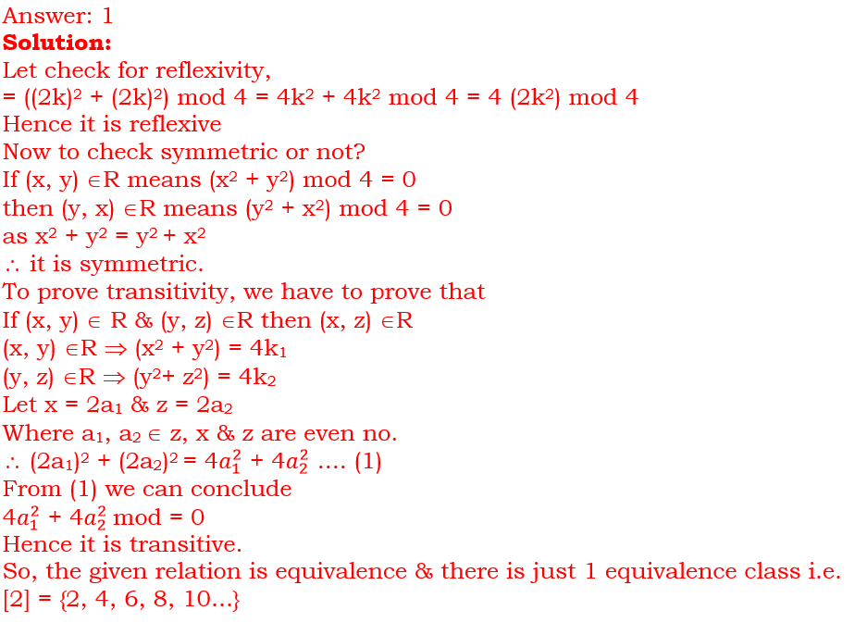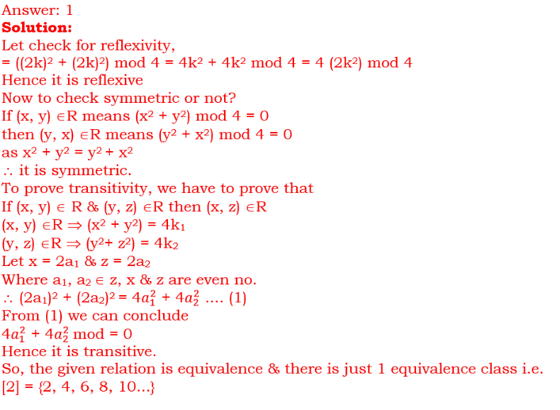

1. Let A = {1, 2, 3, 5, 7, 9, 11} and R is a relation on A. Let R have 3 equivalence classes with maximum cardinality, then what is the cardinality of R?

**Answer** : There are 7 elements in set A. So, there can be four partition of size 3.

223, 115, 421, 331. To find equivalence relation we square and add. We get cardinality as 17, 27, 21, 19.

Maximum is 27.

1. **GRAPHS**

* A graph G = (V, E) consists of V, a nonempty set of vertices (or nodes) and E, a set of edges. Each edge has either one or two vertices associated with it, called its endpoints. An edge is said to connect its endpoints.

**Finite Graph** : Graph having finite edges and finite vertices

**Infinite** **Graph** : Graph having infinite edges and infinite vertices.

**Simple Graph** : A graph in which each edge connects two different vertices and where no two edges connect the same pair of vertices is called a simple graph.

**Multigraph** : Graphs that may have multiple edges connecting the same vertices are called multigraphs.

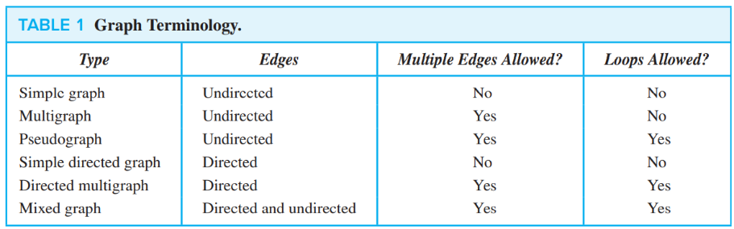**Directed Graph** : G(V, E) consists of a nonempty set of vertices V and a set of directed edges (or arcs) E. Each directed edge is associated with an ordered pair of vertices. The directed edge associated with the ordered pair (u, v) is said to start at u and end at v.

**Undirected Graph** : As name indicate.

**Regular graph** : Graph having vertex of equal degree. K-regular graph means each vertex has degree equal to K.

* 1. **Graph Terminology and Special Types of Graphs**:
* Two vertices u and v in an undirected graph G are called adjacent (or neighbors) in G if u and v are endpoints of an edge e of G. Such an edge e is called incident with the vertices u and v and e is said to connect u and v.
* The set of all neighbors of a vertex v of G = (V, E), denoted by N(v), is called the neighborhood of v. If A is a subset of V, we denote by N(A) the set of all vertices in G that are adjacent to at least one vertex in A. So, N(A) = ⋃ v∈A N(v).
* The degree of a vertex in an undirected graph is the number of edges incident with it, except that a loop at a vertex contributes twice to the degree of that vertex. The degree of the vertex v is denoted by deg(v).

A vertex of degree zero is called **isolated**. A vertex is **pendant** if and only if it has degree one.

**THE HANDSHAKING THEOREM** : Let G = (V, E) be an undirected graph with m edges. Then 2m = ∑ v∈V deg(v). (Note that this applies even if multiple edges and loops are present.)

Example : How many edges are there in a graph with 10 vertices each of degree six?

Solution: Because the sum of the degrees of the vertices is 6 ⋅ 10 = 60, it follows that 2m = 60 where m is the number of edges. Therefore, m = 30.

* An undirected graph has an even number of vertices of odd degree.
* In a graph with directed edges the in-degree of a vertex v, denoted by deg−(v), is the number of edges with v as their terminal vertex. The out-degree of v, denoted by deg+(v), is the number of edges with v as their initial vertex.
* Let G = (V, E) be a graph with directed edges. Then ∑ v∈V deg−(v) = ∑ v∈V deg+(v) = |E|
* Total number of distinct tree possible with n node is nn-2 and total number of possible tree with n nodes (not distinct) is 2n-n.

***Types of graph*** :

1. Complete graph : A complete graph on n vertices, denoted by Kn, A simple graph for which there is at least one pair of distinct vertex not connected by an edge is called noncomplete.

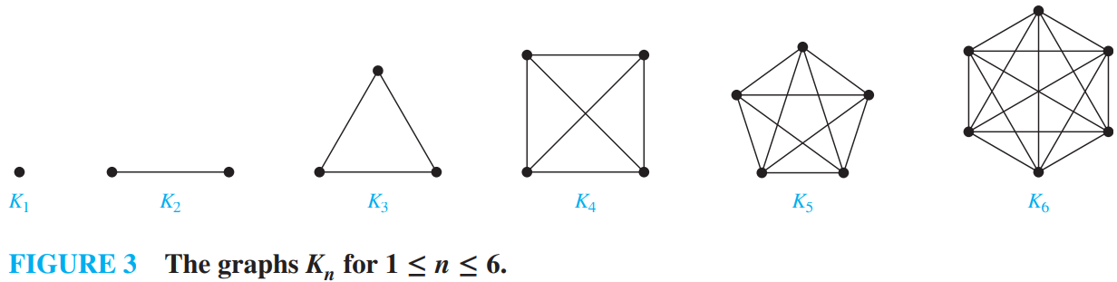 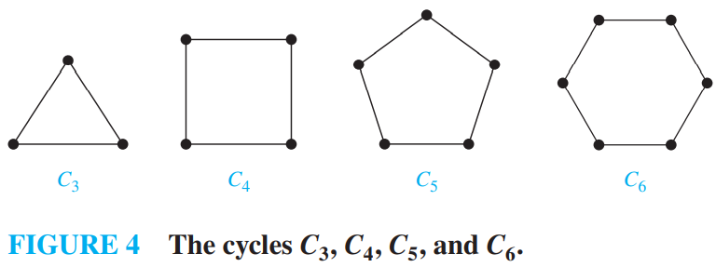

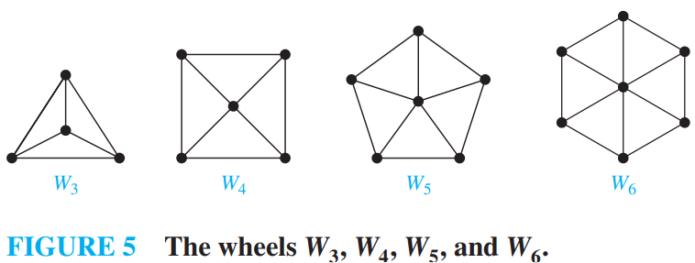 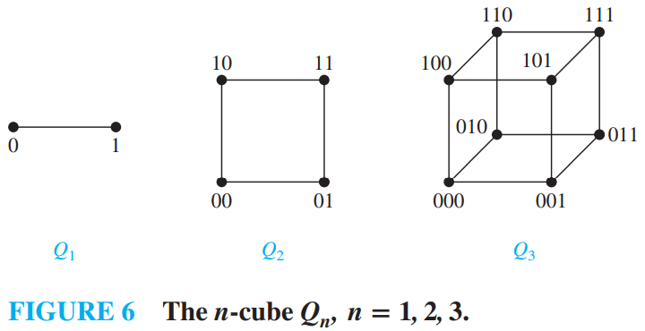

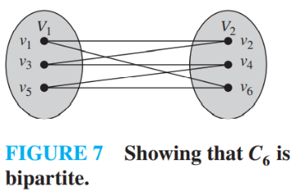

* A simple graph G is called bipartite if its vertex set V can be partitioned into two disjoint sets V1 and V2 such that every edge in the graph connects a vertex in V1 and a vertex in V2 (so that no edge in G connects either two vertices in V1 or two vertices in V2). When this condition holds, we call the pair (V1, V2) a bipartition of the vertex set V of G.
* A simple graph is bipartite if and only if it is possible to assign one of two different colors to each vertex of the graph so that no two adjacent vertices are assigned the same color.

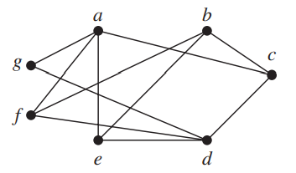We begin by arbitrarily assigning red to a. Then, we must assign blue to c, e, f , and g, because each of these vertices is adjacent to a. To avoid having an edge with two blue endpoints, we must assign red to all the vertices adjacent to either c, e, f , or g. This means that we must assign red to both b and d (and means that a must be assigned red, which it already has been). We have now assigned colors to all vertices, with a, b, and d red and c, e, f , and g blue. Checking all edges, we see that every edge connects a red vertex and a blue vertex.

*Complete* Bipartite Graphs :

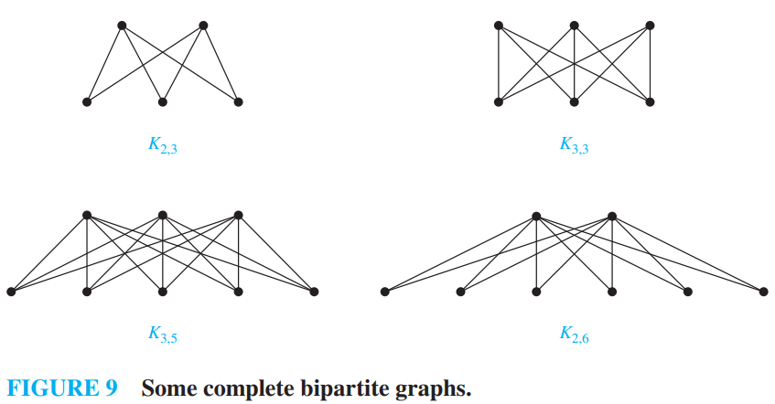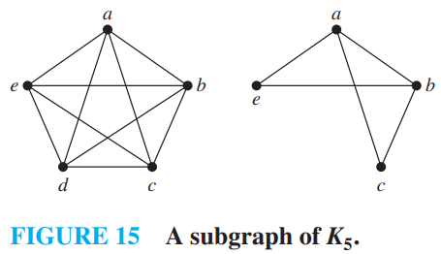

* A subgraph of a graph G = (V, E) is a graph H = (W, F), where W ⊆ V and F ⊆ E. A subgraph H of G is a proper subgraph of G if H ≠ G.
* A partition of a set S is collection of disjoint non-empty subsets of S that have S as their union. Disjoint means no element should be common in any subset.
* There is a slightly difference between subgraph and induced subgraph. Induced subgraph is a subgraph with a property that if both end-points of an edge are in the subgraph, then that edge should be present in the induced subgraph as well.
  1. **Representing Graphs and Graph Isomorphism** :

Two graphs have exactly the same form, in the sense that there is a one-to-one correspondence between their vertex sets that preserves edges. In such a case, we say that the two graphs are **isomorphic**.

***7.2.1) Representing Graphs*** :

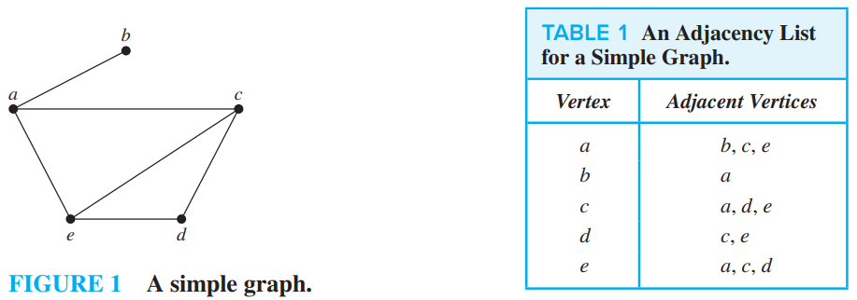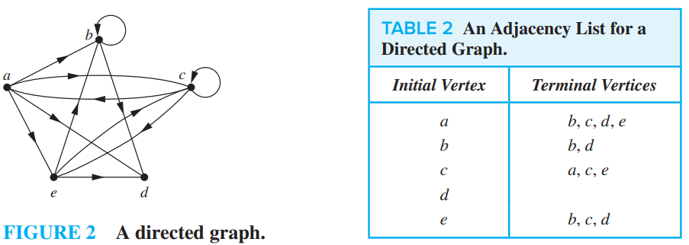

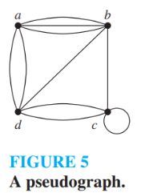

*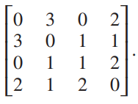****7.2.2) Adjacency Matrices*** : The adjacency matrix A (or AG) of G, with respect to this listing of the vertices, is the n x n zero–one matrix with 1 as its (i, j)th entry when vi and vj are adjacent, and 0 as its (i, j)th entry when they are not adjacent.

When a simple graph contains relatively few edges, that is, when it is **sparse**, it is usually preferable to use adjacency lists rather than an adjacency matrix to represent the graph. A simple graph is **dense**, that is, suppose that it contains many edges, such as a graph that contains more than half of all possible edges.

***7.2.3) Incidence Metrices*** : Select vertices and see how many edges are falling into it.

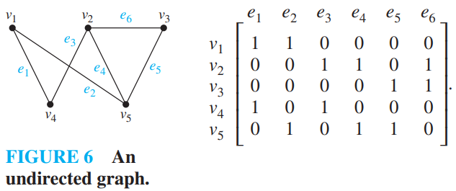 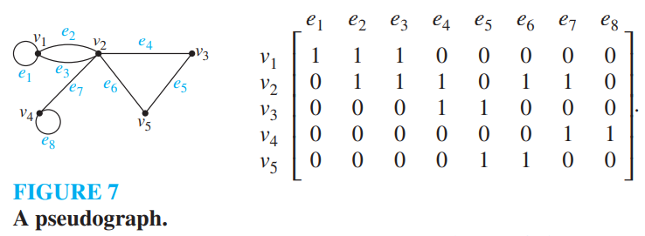

***7.2.4) Isomorphism of Graphs*** : The simple graphs G1 = (V1, E1) and G2 = (V2, E2) are isomorphic if there exists a one-to one and onto function f from V1 to V2 with the property that a and b are adjacent in G1 if and only if f(a) and f(b) are adjacent in G2, for all a and b in V1. Such a function f is called an **isomorphism**. Two simple graphs that are not isomorphic are called **non-isomorphic**.

*Example of Isomorphic Graph* :

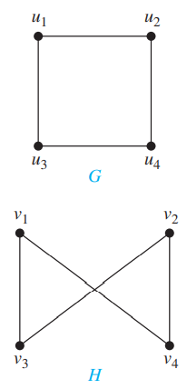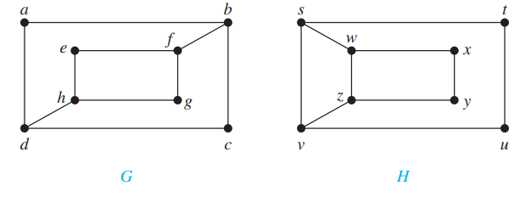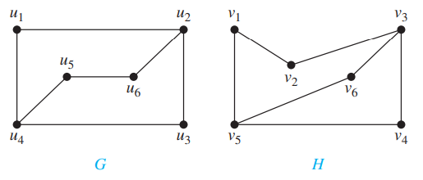

* 1. **Connectivity** :

*Basic Terminology* : A **path** is a sequence of edges that begins at a vertex of a graph and travels from vertex to vertex along edges of the graph. Vertices do not repeat in path.

* Let n be a nonnegative integer and G an undirected graph. A *path* of length n from u to v in G is a sequence of n edges e1, … , en of G for which there exists a sequence x0 = u, x1, … , xn−1, xn = v of vertices such that ei has, for i = 1, … , n, the endpoints xi−1 and xi . When the graph is *simple*, we denote this path by its vertex sequence x0, x1, … , xn (because listing these vertices uniquely determines the path). The path is a circuit if it begins and ends at the same vertex, that is, if u = v, and has length greater than zero. The path or circuit is said to *pass through* the vertices x1, x2, … , xn−1 or *traverse* the edges e1, e2, … , en. A path or circuit is *simple* if it does not contain the same edge more than once.
* An undirected graph is called **connected** if there is a path between every pair of distinct vertices of the graph. An undirected graph that is not connected is called **disconnected**. We say that we disconnect a graph when we remove vertices or edges, or both, to produce a disconnected subgraph.
* There is a simple path between every pair of distinct vertices of a connected undirected graph.

CONNECTED COMPONENTS : A **connected component** of a graph G is a connected subgraph of G that is not a proper subgraph of another connected subgraph of G.

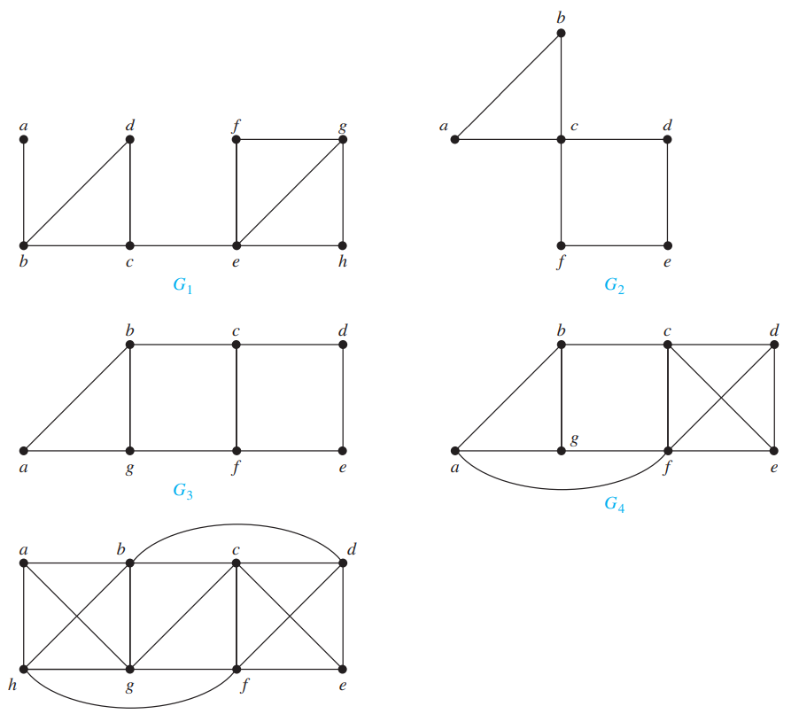Sometimes the removal from a graph of a vertex and all incident edges produces a subgraph with more connected components. Such vertices are called **cut vertices**(or articulation points). The removal of a cut vertex from a connected graph produces a subgraph that is not connected. Analogously, an edge whose removal produces a graph with more connected components than in the original graph is called a **cut edge** or **bridge**.

**VERTEX CONNECTIVITY** : Not all graphs have cut vertices. For example, the complete graph Kn, where n ≥ 3, has no cut vertices. Connected graphs without cut vertices are called **nonseparable** graphs.

𝜅(G) is minimum number of vertices that can be removed from G to either disconnect G or produce a graph with a single vertex.

*Example* : we know that 𝜅(G1) = 1. Similarly, 𝜅(G2) = 1, because c is a cut vertex of G2. The reader should verify that G3 has no cut vertices, but that {b, g} is a vertex cut. Hence, 𝜅(G3) = 2. Similarly, because G4 has a vertex cut of size two, {c, f }, but no cut vertices. It follows that 𝜅(G4) = 2. The reader can verify that G5 has no vertex cut of size two, but {b, c, f } is a vertex cut of G5. Hence, 𝜅(G5) = 3.

EDGE CONNECTIVITY : A set of edges E′ is called an **edge cut** of G if the subgraph G − E′ is disconnected. The edge connectivity of a graph G, 𝜆 is the lowercase Greek letter lambda. denoted by 𝜆(G), is the *minimum number* of edges in an edge cut of G.

*Example* : G1 has a cut edge, so 𝜆(G1) = 1. The graph G2 has no cut edges, as the reader should verify, but the removal of the two edges {a, b} and {a, c} disconnects it. Hence, 𝜆(G2) = 2. Similarly, 𝜆(G3) = 2, because G3 has no cut edges, but the removal of the two edges {b, c} and { f, g} disconnects it. The reader should verify that the removal of no two edges disconnects G4, but the removal of the three edges {b, c}, {a, f }, and { f, g} disconnects it. Hence, 𝜆(G4) = 3. Finally, the reader should verify that 𝜆(G5) = 3, because the removal of any two of its edges does not disconnect it, but the removal of {a, b}, {a, g}, and {a, h} does.

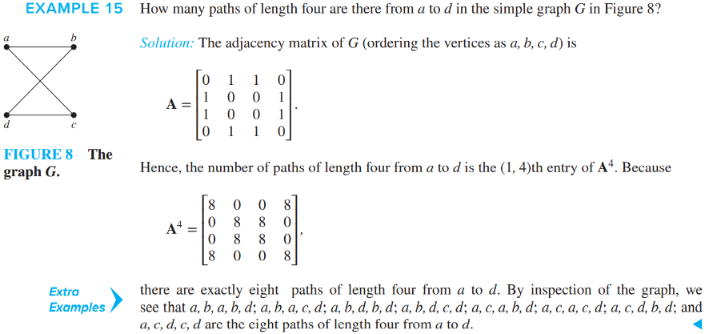

𝜅(G) ≤ 𝜆(G) ≤ minv∈V deg(v).

***Connectedness in Directed Graphs*** :

* A directed graph is strongly connected if there is a path from a to b and from b to a whenever a and b are vertices in the graph. A single vertex is also strongly connected.
* A directed graph is weakly connected if there is a path between every two vertices in the underlying undirected graph.
* Adding edge to a directed graph can decrease the number of strongly connected components by any number.

***Counting number of paths form vertex to vertex*** : Let G be a graph with adjacency matrix A with respect to the ordering v1, v2, … , vn of the vertices of the graph (with directed or undirected edges, with multiple edges and loops allowed). The number of different paths of length r from vi to vj , where r is a positive integer, equals the (i, j)th entry of Ar .

* 1. **Euler and Hamilton’s Path** **and Circuits (Euler = edges, Hamilton = vertex)**:

***7.4.1) Euler Paths and Circuits*** : A Euler circuit in a graph G is a simple circuit containing every edge of G. An Euler path in G is a simple path containing every edge of G. (Path means starting point and ending point should not be the same.)

*Example* : path means ending vertex might be different but in circuit ending vertex should be the same.

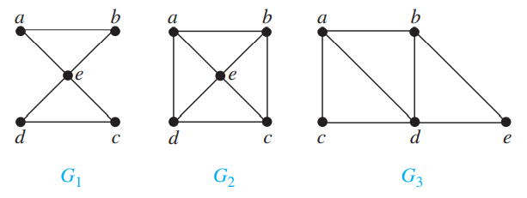The graph G1 has an Euler circuit, for example, a, e, c, d, e, b, a. Neither of the graphs G2 or G3 has an Euler circuit (the reader should verify this). However, G3 has an Euler path, namely, a, c, d, e, b, d, a, b. G2 does not have an Euler path (as the reader should verify).

* A connected multigraph with at least two vertices has an *Euler circuit* if and only if each of its vertices has even degree.
* A connected multigraph has a *Euler path* but not a *Euler circuit* **if and only if** it has exactly two vertices of odd degree.
* For a graph to be **Euler graph** all the degrees must be Even for all nodes. In any graph all the Odd degree nodes are connected with a node.

***7.4.2) Hamilton’s Paths and Circuits*** : A simple path in a graph G that passes through every vertex exactly once is called a *Hamilton path*, and a simple circuit in a graph G that passes through every vertex exactly once is called a *Hamilton circuit*. That is, the simple path x0, x1, … , xn−1, xn in the graph G = (V, E) is a Hamilton path if V = {x0, x1, … , xn−1, xn} and xi ≠ xj for 0 ≤ i < j ≤ n, and the simple circuit x0, x1, … , xn−1, xn, x0 (with n > 0) is a Hamilton circuit if x0, x1, … , xn−1, xn is a Hamilton path.

*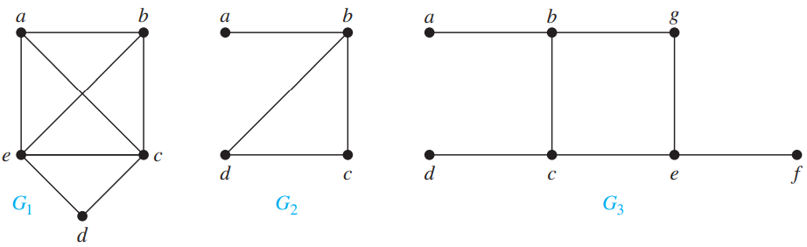Example* : G1 has a Hamilton circuit: a, b, c, d, e, a. There is no Hamilton circuit in G2 (this can be seen by noting that any circuit containing every vertex must contain the edge {a, b} twice), but G2 does have a Hamilton path, namely, a, b, c, d. G3 has neither a Hamilton circuit nor a Hamilton path, because any path containing all vertices must contain one of the edges {a, b}, {e, f }, and {c, d} more than once.

**DIRAC’S THEOREM** : If G is a simple graph with n vertices with n ≥ 3 such that the degree of every vertex in G is at least n∕2, then G has a Hamilton circuit.

**ORE’S THEOREM** : If G is a simple graph with n vertices with n ≥ 3 such that deg(u) + deg(v) ≥ n for every pair of nonadjacent vertices u and v in G, then G has a Hamilton circuit.

* A graph is called **Hamilton’s graph** if it has Hamilton’s circuit. Similarly, for Euler ‘s graph.
  1. 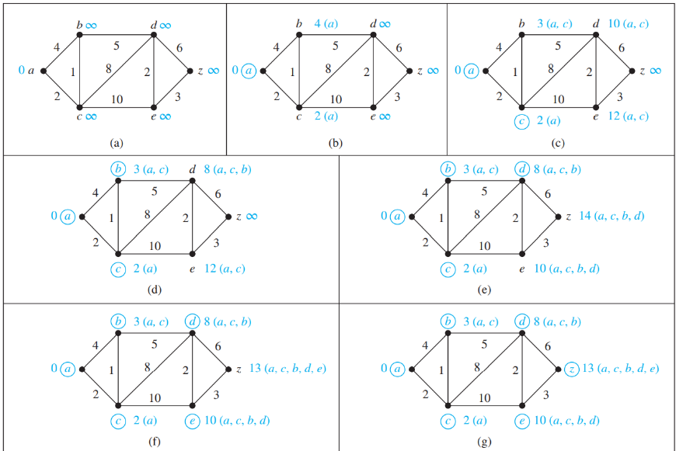**Shortest Path :**

***7.5.1) Shortest Path algorithm*** :

**Dijkstra’s Algorithm** : select minimum and check if its current value, if it is greater than update it with minimum value. And update it’s **through s**et.

Dijkstra’s algorithm uses O(n2) operations (additions and comparisons) to find the length of a shortest path between two vertices in a connected simple undirected weighted graph with n vertices.

* 1. **Planar Graph** :

A graph is called **planar** if it can be drawn in the plane without any edges crossing (where a crossing of edges is the intersection of the lines or arcs representing them at a point other than their common endpoint). Such a drawing is called a *planar representation* of the graph.

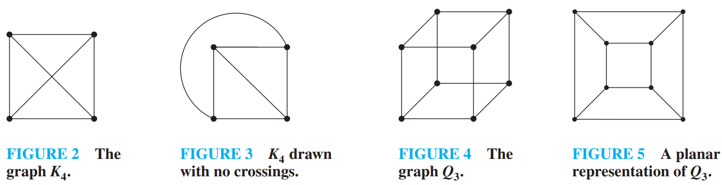 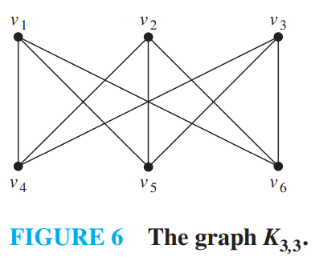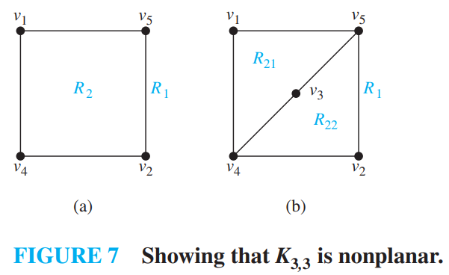

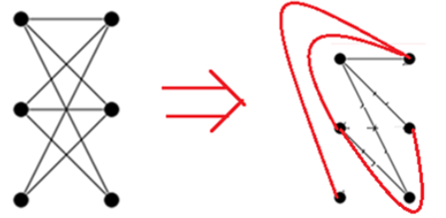

**Euler’s Formula** : Let G be a connected planar simple graph with e edges and v vertices. Let r be the number of regions in a planar representation of G. Then r = e − v + 2. Include outside region in r as well.

Example :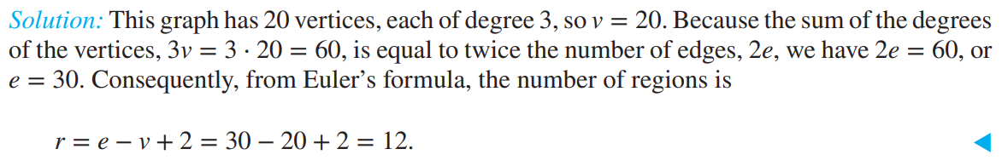

* If G is a connected planar simple graph with e edges and v vertices, where v ≥ 3, then e ≤ 3v − 6. Mean it can have maximum of 3v-6 edges in simple planer graph.
* If G is a connected planar simple graph, then G has a vertex of degree not exceeding five.

***Proof***: If G has one or two vertices, the result is true. If G has at least three vertices, by Corollary 1 we know that e ≤ 3v − 6, so 2e ≤ 6v − 12. If the degree of every vertex were at least six, then because 2e = ∑ v∈V deg(v) (by the handshaking theorem), we would have 2e ≥ 6v. But this contradicts the inequality 2e ≤ 6v − 12. It follows that there must be a vertex with degree no greater than five.

* If graph has one cycle it is called unicycle and its number of vertices = number of edges

**Degree of region :** Which is defined to be the number of edges on the boundary of this region.

* The sum of the degrees of the regions is exactly twice the number of edges in the graph, because each edge occurs on the boundary of a region exactly twice (either in two different regions, or twice in the same region). Because each region has degree greater than or equal to three. To visualize this think about triangle and its two region.

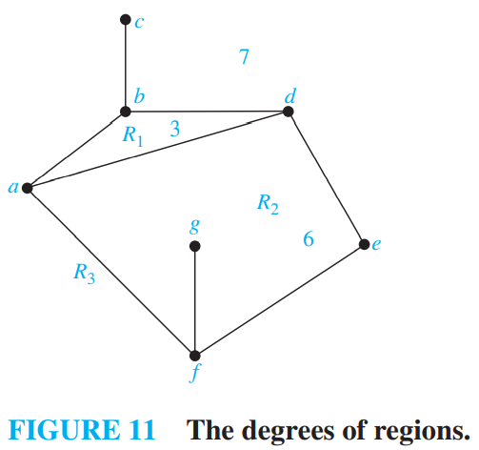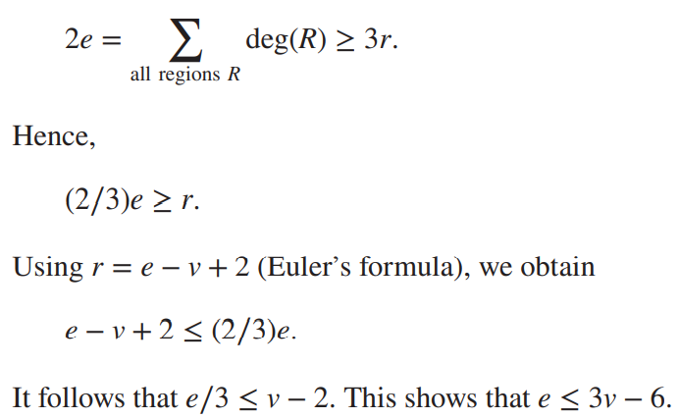

**Kuratowski’s Theorem** : If a graph is planar, so will be any graph obtained by removing an edge {u, v} and adding a new vertex w together with edges {u, w} and {w, v}. Such an operation is called an elementary subdivision. The graphs G1 = (V1, E1) and G2 = (V2, E2) are called homeomorphic if they can be obtained from the same graph by a sequence of elementary subdivisions.

* A graph is nonplanar if and only if it contains a subgraph homeomorphic to K3,3 or K5.
  1. **Graph coloring** :

A *coloring of a simple graph* is the assignment of a color to each vertex of the graph so that no two adjacent vertices are assigned the same color.

* The **chromatic number** of a graph is the least number of colors needed for a coloring of this graph. The chromatic number of a graph G is denoted by 𝜒(G). (Here 𝜒 is the Greek letter chi.)

**THE FOUR COLOR THEOREM** : The chromatic number of a planar graph is no greater than four.

**NOTE** : 𝜒(Kn) = n

The complete bipartite graph 𝜒 (Km,n) = 2

𝜒(Cn) = 2 if n is an even positive integer with n ≥ 4 and 𝜒(Cn) = 3 if n is an odd positive integer with n ≥ 3.

* **Matching, Maximal, maximum and Perfect matching of graph** :

**Matching** : Given a graph G=(V,E), a matching M in g is a set of pairwise non-adjacent edges, none of which are loops; that is, not two edges share common vertices.

**Maximal Matching** : A Matching is maximal if we cannot add more edges to the matching set. It is smallest matching but we cannot add more edges. Adding means not adding edges to the graph but to add edges of a graph into matching set.

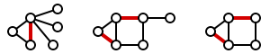

**Maximum matching** : A matching that contains the largest possible number of edges. Thus, every maximum matching is maximal, but not every maximal matching is a maximum matching.

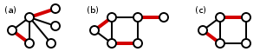

A **perfect matching** of a graph is a matching (i.e., an independent edge set) in which every vertex of the graph is incident to exactly one edge of the matching. A perfect matching is therefore a matching containing n/2 edges (the largest possible), meaning perfect matchings are only possible on graphs with an even number of vertices. Perfect matching of complete graph with even “n” vertices is given by (n-1)!!. Double factorial. Nine perfect matching of cube graph is shown below :

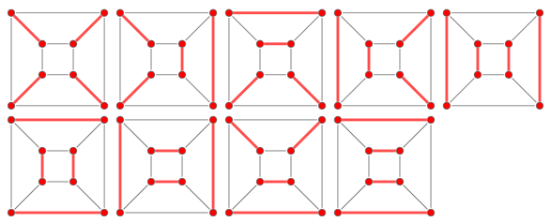

**Complete matching** : A complete matching has every vertex in the graph incident to exactly one edge in the matching.

* The number of distinct undirected cycle of length n is (n-1)!/2.
* **Edge cover :** An edge cover of a graph is a set of edges such that every vertex of the graph is incident to at least one edge of the set.

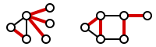 this is not minimal. 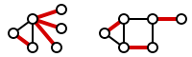 this is minimal.

* **Vertex Cover** : A vertex cover (sometimes node cover) of a graph is a set of vertices that includes at least one endpoint of every edge of the graph.

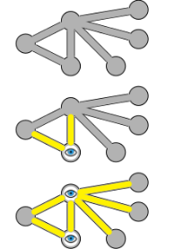 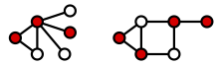 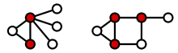This is minimal.

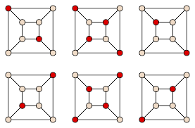Hence, vertex cover if this graph is {1,2,4,5}.

* **Independent set**, stable set, coclique or anti-clique is a set vertex in a graph, no two of which are adjacent. That is, it is a set S of vertices such that for every two vertices in s, there is no edge connecting the two. 🡪
* Matching number (M) + Edge cover number (E) = Number of vertices(n)
* Independence Number (I) + vertex cover number(C) = number of vertices(n)
* In any bipartite graph, |M| = |C| (Konig’s theorem). and when |M|=|C| then M is maximal matching and C is minimal vertex cover.

1. **TREES**
   1. **Introduction to trees** :

* A tree is a connected undirected graph with no simple circuits.
* An undirected graph is a tree if and only if there is a unique simple path between any two of its vertices.

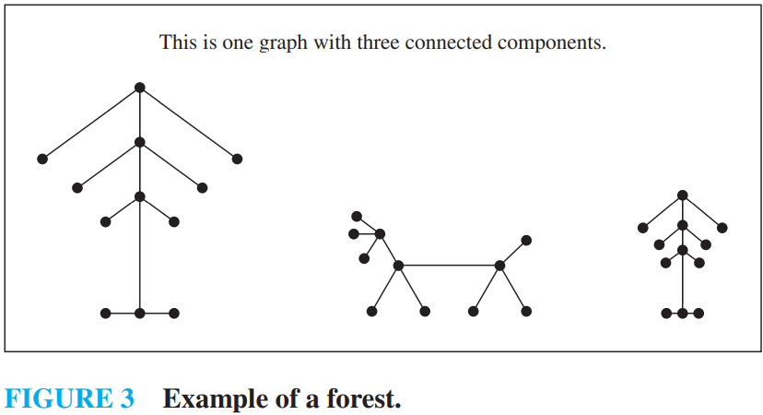 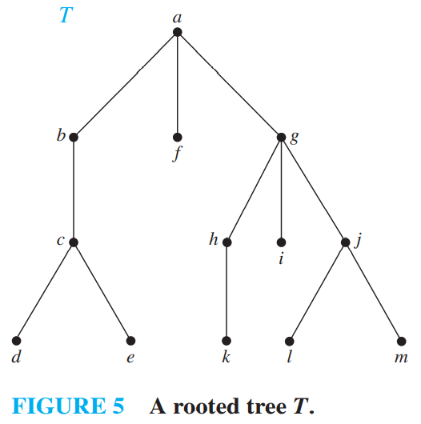

Total number of edges in forest = total number of components * (total number of vertices/total number of component – 1) = total number of vertices – total number of components. This result can be shown using pigeonhole principle.

***8.1.1) Rooted tree*** : A **rooted tree** is a tree in which one vertex has been designated as the root and every edge is directed away from the root.

* Vertices with the same parent are called **siblings**.
* The **ancestors** of a vertex other than the root are the vertices in the path from the root to this vertex, excluding the vertex itself and including the root (that is, its parent, its parent’s parent, and so on, until the root is reached).
* The **descendants** of a vertex v are those vertices that have v as an ancestor.
* A vertex of a rooted tree is called a **leaf** if it has no children.
* Vertices that have children are called **internal** vertices. The root is an internal vertex unless it is the only vertex in the graph, in which case it is a leaf.

*Figure 5* : The parent of c is b. The children of g are h, i, and j. The siblings of h are i and j. The ancestors of e are c, b, and a. The descendants of b are c, d, and e. The internal vertices are a, b, c, g, h, and j. The leaves are d, e, f , i, k, l, and m.

* A rooted tree is called an **m-ary tree** if every internal vertex has no more than m children. The tree is called a full m-ary tree if every internal vertex has exactly m children. An m-ary tree with m = 2 is called a **binary tree**.

***8.1.2) Properties of tree*** :

* A tree with n vertices has n − 1 edges.
* A full m-ary tree with i internal vertices contains n = mi + 1 vertices.
* A full m-ary tree with

(i) n vertices has i = (n − 1)∕m internal vertices and l = [(m − 1)n + 1]∕m leaves.

(ii) i internal vertices has n = mi + 1 vertices and l = (m − 1)i + 1 leaves.

(iii) l leaves has n = (ml − 1)∕(m − 1) vertices and i = (l − 1)∕(m − 1) internal vertices.

* A rooted m-ary tree of height h is **balanced** if all leaves are at levels h or h − 1.
* There are at most mh leaves in an m-ary tree of height h.
* If an m-ary tree of height h has l leaves, then h ≥ ⌈logm l⌉. If the m-ary tree is full and balanced, then h = ⌈logm l⌉.
  1. **Application of trees** :

***8.2.1) Binary search tree*** : A binary tree in which each child of a vertex is designated as a right or left child, no vertex has more than one right child or left child, and each vertex is labeled with a key, which is one of the items.

* The height of Binary search tree is greater than or equal to h = ⌈log2(n + 1)⌉.

***8.2.2) Decision tree*** : A rooted tree in which each internal vertex corresponds to a decision, with a subtree at these vertices for each possible outcome of the decision, is called a decision tree.

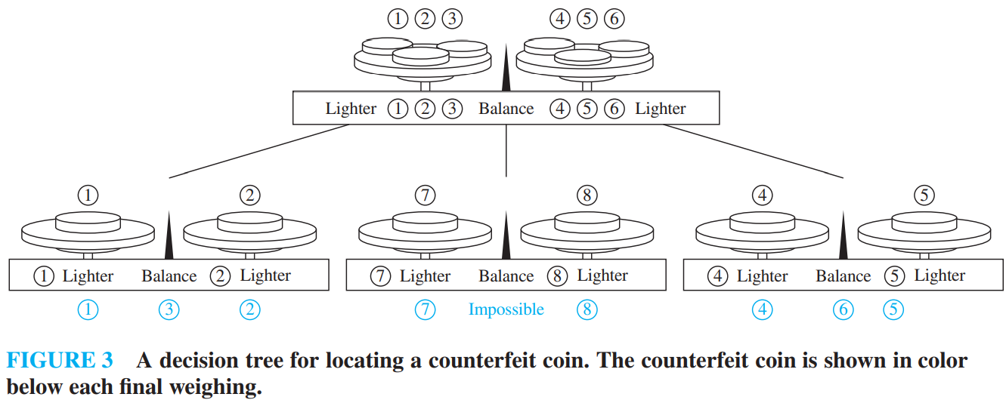

How many balance should needed to calculate false coin from three identical coin ?

Solution : There are two cases (i) weight of false coin is mentioned for example it is more than other coin or less, (ii) weight of false coin is not mentioned like in first case

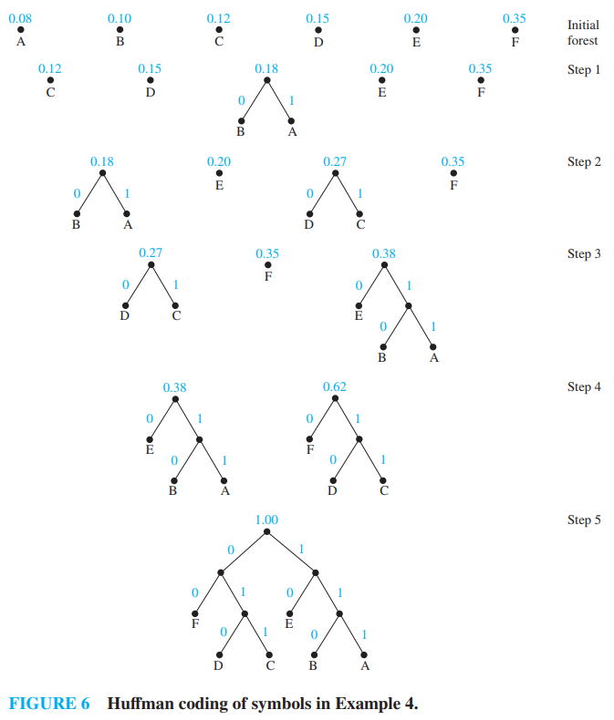In first case answer is ONE, first we put two of the coin in balanced, if both weights the same then third coin is false. If it weights more or less than coin is that.

In second case answer is TWO, first put two of the coin in balanced, if both weights the same then third coin is false, If it weights more or less than we put third coin to check.

* A sorting algorithm based on binary comparisons requires at least ⌈lg n!⌉ comparisons. ⌈lg n!⌉ is Θ(n lg n).
* The number of comparisons used by a sorting algorithm to sort n elements based on binary comparisons is Ω(n log n).
* The average number of comparisons used by a sorting algorithm to sort n elements based on binary comparisons is Ω(n log n).

**Huffman coding problem** :

Use Huffman coding to encode the following symbols with the frequencies listed: A: 0.08, B: 0.10, C: 0.12, D: 0.15, E: 0.20, F: 0.35. What is the average number of bits used to encode a character?

*Solution*: The encoding produced encodes A by 111, B by 110, C by 011, D by 010, E by 10, and F by 00. The average number of bits used to encode a symbol using this encoding is 3 ⋅ 0.08 + 3 ⋅ 0.10 + 3 ⋅ 0.12 + 3 ⋅ 0.15 + 2 ⋅ 0.20 + 2 ⋅ 0.35 = 2.45.

a=<00>,b=<01>,c=<11>,d=<101> This cannot be the sequence in Huffman encoding as Huffman encoding gives us optimal result and d = 101 makes no sense. I mean 10 should be there as 101 is not optimal or you can say minimum.

* 1. **Tree Traversal** :

***8.3.1) Traversal Algorithm*** : We will describe three of the most commonly used such algorithms, preorder traversal, inorder traversal, and postorder traversal.

Preorder traversal: Visit root, visit subtrees left to right

Inorder traversal: Visit leftmost subtree, visit root, visit other subtrees left to right

Postorder traversal: Visit subtrees left to right; visit root

***8.3.2) Infix, Prefix, Postfix operation*** : Make tree and do respective traversal.

* To solve prefix operation, take one stack then put element form right side when encounter symbol do operation on first two operand and push the result back into the stack.
* To solve postfix operation, take one stack then put element from left side when encounter symbol do that operation first two operand and push the result back into the stack.

Infix operation is easy, as you are doing calculation from first standard.

You can do the same thing with other than mathematical symbol like compound preposition.

* 1. **Spanning Tree** :

Let G be a simple graph. A spanning tree of G is a subgraph of G that is a tree containing every vertex of G.

* A simple graph is connected if and only if it has a spanning tree. Connected means graph is not forest. Means we can reach every element in tree. Therefore, it is connected.

We can build Spanning tree by following :

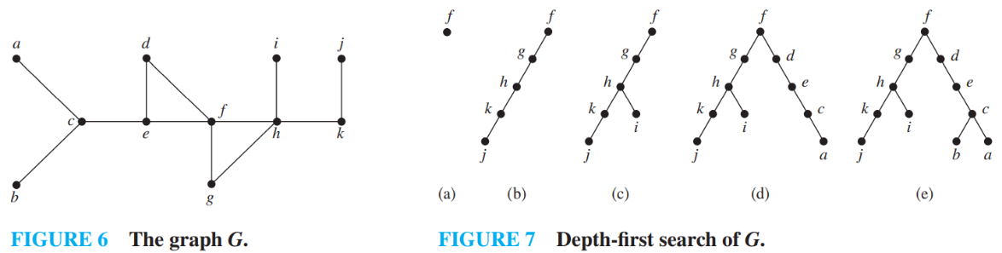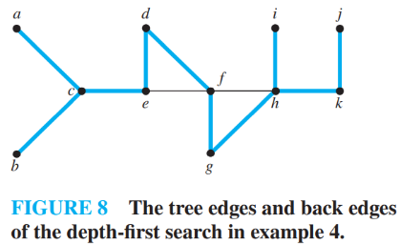

1. Depth first search : Depth-first search is also called **backtracking**, because the algorithm returns to vertices previously visited to add paths.
2. Breadth-First Search :

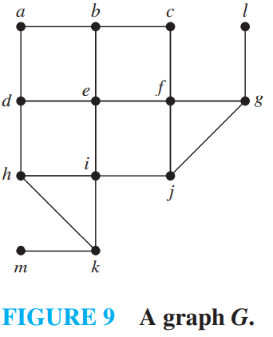 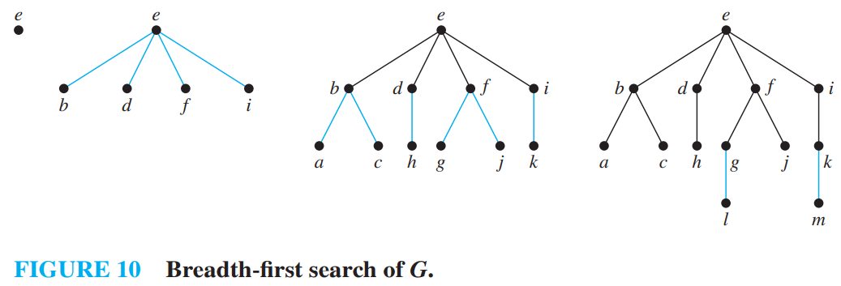

**Backtracking Application** : Graph coloring, N-queens problem

* 1. **Minimum spanning tree** : Finding a spanning tree so that the sum of the weights of the edges of the tree is minimized. Or in more technical term : A minimum spanning tree in a connected weighted graph is a spanning tree that has the smallest possible sum of weights of its edges.

***Algorithms*** :

1. **Prim’s Algorithms** :

Begin by choosing any edge with smallest weight, putting it into the spanning tree. Successively add to the tree edges of minimum weight that are incident to a vertex already in the tree, never forming a simple circuit with those edges already in the tree. Stop when n − 1 edges have been added. Edges are selected as they are travers.

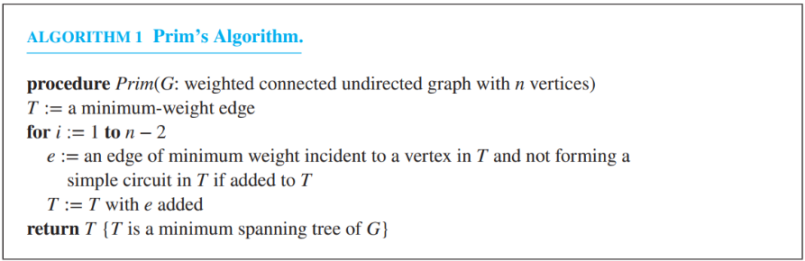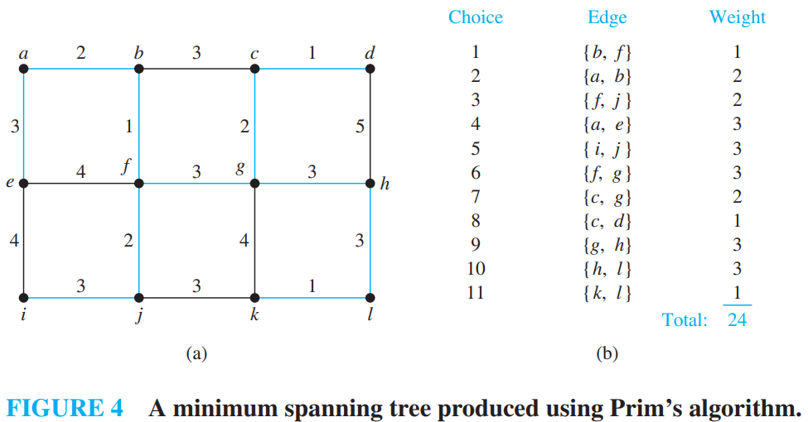

1. **Kruskal’s Algorithms** :

Successively add edges with minimum weight that do not form a simple circuit with those edges already chosen. Stop after n − 1 edges have been selected. Edges are selected by sorting.

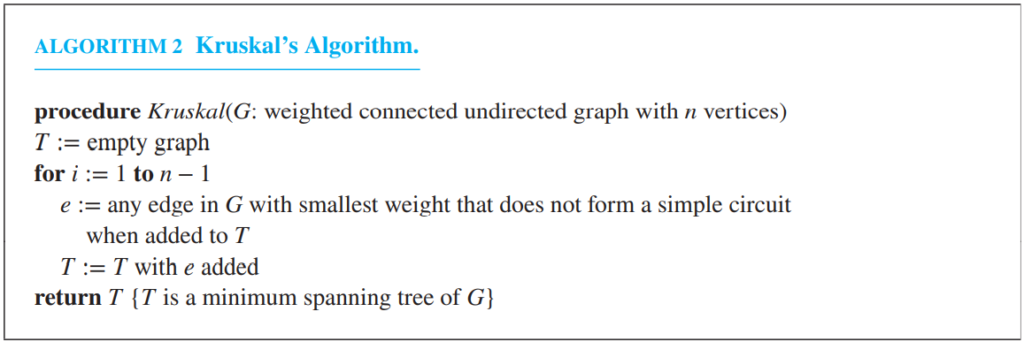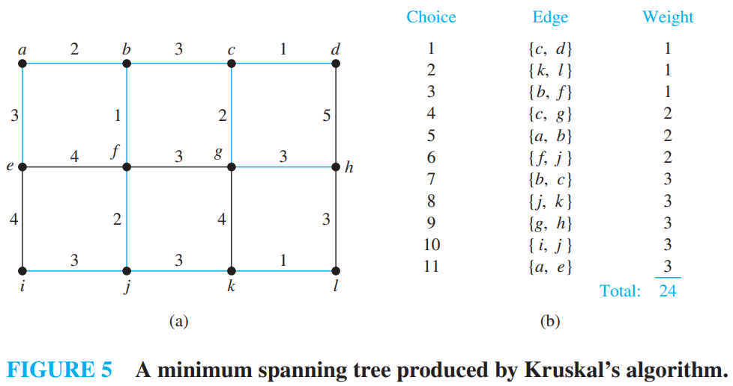

**Note** : Kruskal’s algorithm can be carried out using O(m log m) operations and Prim’s algorithm can be carried out using O(m log n) operations. Consequently, it is preferable to use Kruskal’s algorithm for graphs that are **sparse**, that is, where m is very small compared to C(n, 2) = n(n − 1)∕2, the total number of possible edges in an undirected graph with n vertices. Otherwise, there is little difference in the complexity of these two algorithms.

***Connected components*** :

Connected components means set of vertex {u,v,w,…} consists of at least one vertex such that we can travel form u to v, v to u, u to w, w to u, v to w, w to v, and so on.

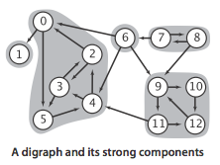 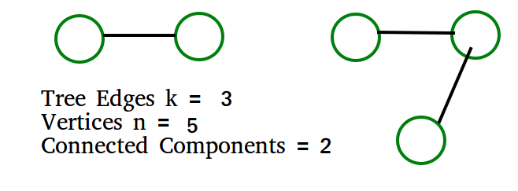

Example : In a depth-first traversal of a graph G with n vertices, k edges are marked as tree edges. The number of connected components in G is n-k. but in example given below k refers to connected components.

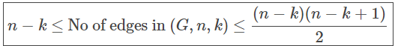🡨 most important formula.

The most efficient algorithms to find number of connected components in undirected graph having n vertices and m edges is Tarjan’s algorithm having time complexity of **O(n+m)**.

**Nullity of graph (N) :** Nullity of graph is the number of closed region so r = e-v+2 here closed region is rc=e-v+1 and ro=1. So by adding we get r = rc + ro. So nullity can be calculated by rc = e-v+1.

**Line graph** :

The line graph L(G) of a simple graph G is defined as follows:

* There is exactly one vertex v(e) in L(G) for each edge e in G.
* For any two edges e and e’ in G, L(G) has an edge between v(e) and v(e’), if and only if e and e’ are incident with the same vertex in G.

conversion of graph to line graph.

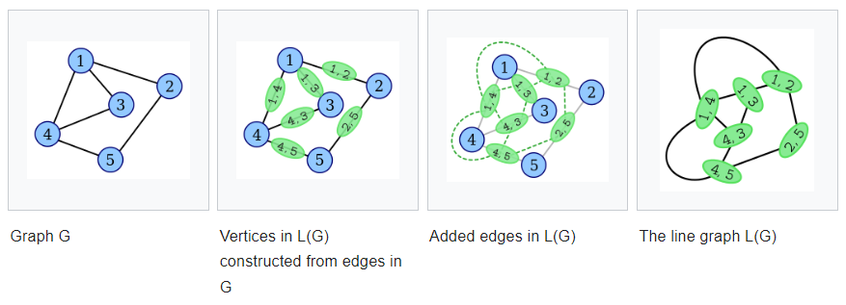

In line graph, number of vertices = numver of edges in G and number of edges = sum of square of degree of vertices in G divided by 2 minus number of edges in G.

**Edge-Disjoint Subgraphs** : Two (or more) subgraphs g1 and g2 of a graph G are said to be edge disjoint if g1 and g2 do not have any edges in common. Note that although edge-disjoint graphs do not have any edge in common, they may have vertices in common. Subgraphs that do not even have vertices in common are said to be **vertex disjoint**.

**Clique** in graph is the subgraph which is complete graph. 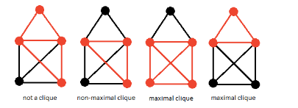

**Topological Ordering** :

1. First select node with 0 indegree.
2. If not present then topological ordering is not possible.
3. If present then, remove it and find next 0 indegree vertex or node. And repeat process.

*Example* :

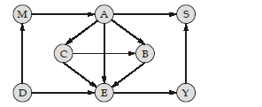

**Answer** : DMACBEYS

***Questions on Graph theory*** :

1. The line graph L(G) of a simple graph G is defined as follows: · There is exactly one vertex v(e) in L(G) for each edge e in G. · For any two edges e and e' in G, L(G) has an edge between v(e) and v(e'), if and only if e and e'are incident with the same vertex in G. Which of the following statements is/are TRUE?

(P) The line graph of a cycle is a cycle.

(Q) The line graph of a clique is a clique.

(R) The line graph of a planar graph is planar.

(S) The line graph of a tree is a tree.

*P only*

*P and R only*

*R only*

*P, Q and S only*

**Answer** : see the definition and make counter example of following sentence you will find that first option is correct.

1. Let G be a complete undirected graph on 6 vertices. If vertices of G are labeled, then the number of distinct cycles of length 4 in G is equal to

**Answer** : From 6 vertices we can select 4 distinct vertices in 6C4=15 ways.

Now, with 4 vertices, we can form only 3 distinct cycles. [See below]

So, total no. of distinct cycles of length 4=15×3=45.

No. of cyclic permutations of n objects =(n−1)! and for n=4, we get 3!=6 ways. But number of distinct cycles in a graph is exactly half the number of cyclic permutations as there is no left/right ordering in a graph. For example a−b−c−d and a−d−c−b are different permutations but in a graph they form the same cycle.

1. Which of the following statements is true for every planar graph on n vertices?

*The graph has a vertex-cover of size at most 3n/4*

*The graph is Eulerian*

*The graph is connected*

*The graph has an independent set of size at least n/3*

**Answer** : Independent set mean set of vertices which are not connected by any edges which is equivalent to say that clique in complemented graph.

Vertex cover (starts for vertices and delete all the edges except one edge continue this process till we have pairs of vertices): https://www.tutorialspoint.com/design_and_analysis_of_algorithms/design_and_analysis_of_algorithms_vertex_cover.htm

Independent Set ≥ ⌈n/k⌉ where,

n is the number of vertices and k is the chromatic number

For any planar graph, k≥3 and k≤4, therefore, the Independent set is at least ⌈n/4⌉.

Hence (D) is false.

Now we know that size of Vertex Cover + Independent Set Number =n.

If Independent set number ≥⌈n/4⌉ then,

Vertex cover ≤n−(n/4)

Vertex Cover ≤3n/4

1. Let G be the non-planar graph with the minimum possible number of edges. Then G has

*10 edges and 6 vertices*

*10 edges and 5 vertices*

*9 edges and 6 vertices*

*9 edges and 5 vertices*

**Answer** : You have considered just one type of graph i.e. complete graph having 5 vertices. Try with other graph for example K5 and K3,3 are minimum non-planar graphs. These graphs have 5 vertices with 10 edges in K5 and 6 vertices with 9 edges in K3,3 graph.

1. Which of the following graphs has an Eulerian circuit?

*The complement of a cycle on 25 vertices*

*A complete graph on 90 vertices*

*Any k-regular graph where kis an even number.*

*None of the above*

**Answer** : A graph has Eulerian Circuit if following conditions are true. a) All vertices with non-zero degree are connected. We don’t care about vertices with zero degree because they don’t belong to Eulerian Cycle or Path (we only consider all edges). b) All vertices have even degree.

Let us analyse all options.

A) Any k-regular graph where k is an even number. is not Eulerian as a k regular graph may not be connected example regular means all have vertices have same degree but it can be tree which does not have circuit(property b is true, but a may not)

B) A complete graph on 90 vertices is not Eulerian because all vertices have degree as 89 (property b is false)

C) The complement of a cycle on 25 vertices is Eulerian. In a cycle of 25 vertices, all vertices have degree as 2. In complement graph, all vertices would have degree as 22 and graph would be connected.

1. Consider an undirected graph G where self-loops are not allowed. The vertex set of G is {(i, j): 1 <= i <= 12, 1 <= j <= 12}. There is an edge between (a, b) and (c, d) if |a − c| <= 1 and |b − d| <= 1. The number of edges in this graph is __________.

**Answer** : if you draw carefully draw diagram you will ding this is maze type structure with cross inside it so calculation becomes : 11*11*2 (this is for 2 cross edges) + 11*12*2 (this is for 11 edges and 12 vertices, vertically and horizontally) = 506.

1. The 2^n vertices of a graph G corresponds to all subsets of a set of size n, for n >= 6. Two vertices of G are adjacent if and only if the corresponding sets intersect in exactly two elements. The number of connected components in G is:

*n*

*n+2*

*2n/2*

*2n / n*

**Answer** : 2^n is nothing but power set here, and only n vertices are there so set containing NULL, {v1},{v2},...,{vn} are disconnected sets means they are not adjacent because no two elements are common. and remaining 2^n - (n+1) element are connected so number of connected components are (n+1) + 1 = n+2.

Which one is not planar :

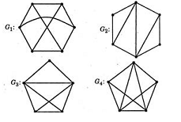Answer is a by elimination.

1. Let s and t be two vertices in a undirected graph G + (V, E) having distinct positive edge weights. Let [X, Y] be a partition of V such that s ∈ X and t ∈ Y. Consider the edge e having the minimum weight amongst all those edges that have one vertex in X and one vertex in Y. Let the weight of an edge e denote the congestion on that edge. The congestion on a path is defined to be the maximum of the congestions on the edges of the path. We wish to find the path from s to t having minimum congestion. Which one of the following paths is always such a path of minimum congestion?

*a path from s to t in the minimum weighted spanning tree*

*a weighted shortest path from s to t*

*an Euler walk from s to t*

*a Hamiltonian path from s to t*

**Answer** : e is the lightest edge in graph means it must be included in spanning tree. option c and d are wrong because Euler walk and Hamiltonian path contains all the vertices and we want minimum congestion from s to t means it should be option A, option b is wrong because it may happen that both s and t are not connected but spanning tree guaranties that it must be covered in tree with minimum weight form one vertex to another.

1. Let G = (V, E) be any connected undirected edge-weighted graph. The weights of the edges in E are positive. Consider the following statements:

The path between a pair of vertices in a minimum spanning tree of an undirected graph is necessarily the shortest (minimum weight) path.

Minimum Spanning Tree of G is always unique and shortest path between a pair of vertices may not be unique.

Which of the above statements is/are necessarily true?

*(1) only*

*(2) only*

*both (1) and (2)*

*neither (1) nor (2)*

**Answer** : first statement is incorrect because cycle with same edge is the counterexample. and if the weight are not distict then there may be more than one spanning tree so both are incorrect.

1. Let G be a graph with 100! vertices, with each vertex labelled by a distinct permutation of the numbers 1, 2, ..., 100. There is an edge between vertices u and v if and only if the label of u can be obtained by swapping two adjacent numbers in the label of v. Let y denote the degree of a vertex in G, and z denote the number of connected components in G. Then y + 10z =

**Answer** : We have to find 2 things here, the degree of every vertex(which will be same for all vertices) and number of connected components.

Instead of 100, let's solve this by taking lesser value, say 4.

With 4! vertices, each vertex is a permutation of {1,2,3,4}. So, we have vertices like {1,2,3,4}, {1,3,2,4}, {4,1,3,2},… etc.

Here {1,2,3,4} will be connected with

{2,1,3,4}

{1,3,2,4}

{1,2,4,3}

To get this list, just take 2 adjacent numbers and swap them. eg. {1,2,3,4} swap 1 and 2 to get {2,1,3,4}.

The given 3 are the only permutations we can get by swapping only 2 adjacent numbers from {1,2,3,4}. So, the degree of vertex {1,2,3,4} will be 3. Similarly for any vertex it's degree will be 3.

Here we got ‘‘3" because we can chose any 3 pairs of adjacent numbers. So, with n, we have n−1 adjacent pairs to swap. So, degree will be n−1.

In our question, degree will be 100−1=99

Now let's see how many connected components we have.

It will be 1. Why?

If one can reach from one vertex to any other vertex, then that means that the graph is connected.

Now if we start with a vertex say {1,2,3,4} we can reach to other vertex, say {4,3,2,1} by the following path:

{1234}→{1243}→{1423}→{4123}→{4132}→{4312}→{4321}

Just take two adjacent numbers and swap them. With this operation you can create any permutation, from any given initial permutation.

This way you can show that from any given vertex we can reach any other vertex. This shows that the graph is connected and the number of connected components is 1.

y=99 and z=1

∴y+10z=99+10∗1=109.

1. The number of possible min-heaps containing each value from {1, 2, 3, 4, 5, 6, 7} exactly once is _______. Note -This was Numerical Type question.

*80*

*8*

*20*

*210*

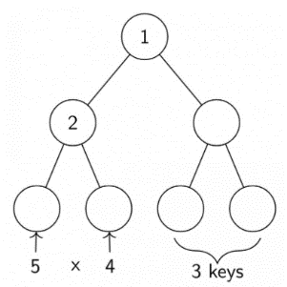**Answer** : first node 1 is straight now in the second raw 2 is also fixed and can take place two position. now there are 5 number remains so at the right side of 2 it can take 5 ways and at left it can take 4 ways also remaining talking about 3 remaining nodes so smallest one will take third node and there are two ways for 6th node and one way 7th node, so 5*4*2 now 2 can take 2nd and 3rd position so 5*4*2*2 = 80.

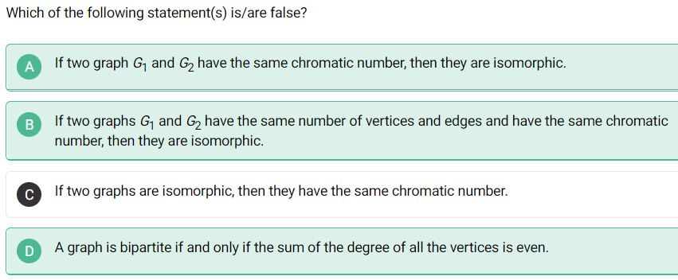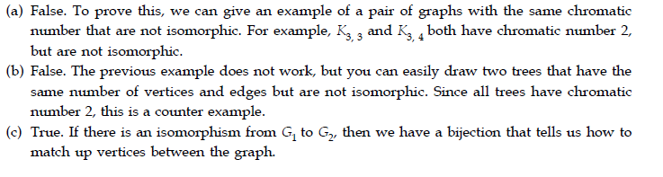

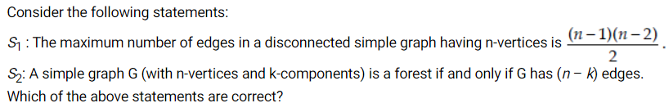maximum number of edges will happen when the disconnected components are less. Minimum disconnected component is 2. And to get maximum edges. Take n-1 edges and make complete graph and leave 1 vertex along as one component. So now edges will be (n-1)(n-2)/2 with K(n-1). Now second option is also correct.

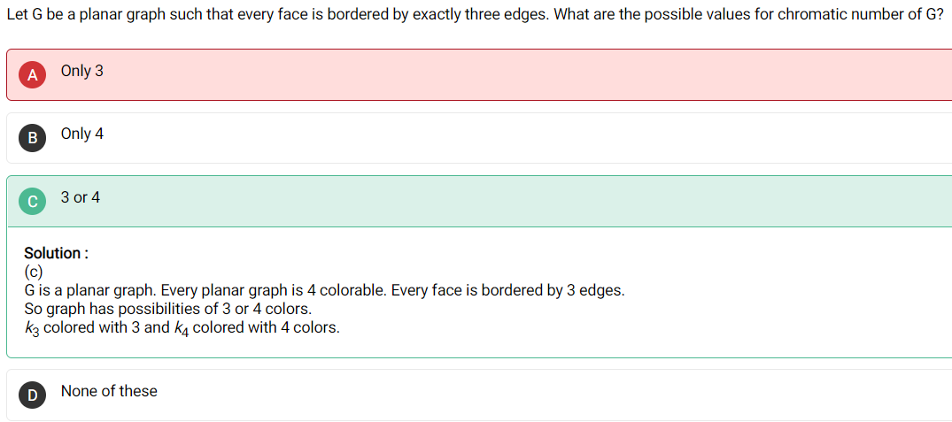just try more example if you get time. You have considered K3 and other shape which accidently gave same answer as 3 so you decided to choose 3 but try K4 because is also satisfy this property.

1. Let G be a complete undirected graph on 7 vertices. If vertices of G are labelled, then the number of distinct cycles of length 5 in G is equal to

**Answer** :

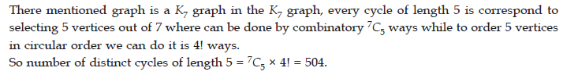

1. **Boolean Algebra**
   1. **Boolean Function :**

We translate each 1 into a T, each 0 into an F, each Boolean sum into a disjunction, each Boolean product into a conjunction, and each complementation into a negation.

***9.1.1) Boolean functions and Expressions :***

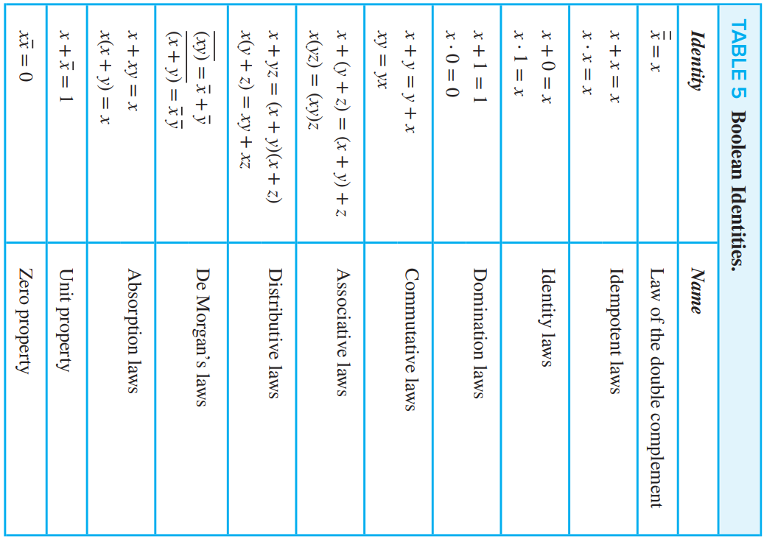Bn = {(x1, x2, … , xn) ∣ xi ∈ B for 1 ≤ i ≤ n} is the set of all possible n-tuples of 0s and 1s. The variable x is called a **Boolean variable** if it assumes values only from B, that is, if its only possible values are 0 and 1. A function from Bn to B is called a **Boolean function of degree n**.

Boolean functions F and G of n variables are equal if and only if F(b1, b2, … , bn) = G(b1, b2, … , bn) whenever b1, b2, … , bn belong to B. Two different Boolean expressions that represent the same function are called equivalent. For instance, the Boolean expressions xy, xy + 0, and xy ⋅ 1 are equivalent. The complement of the Boolean function F is the function F, where F(x1, … , xn) = F’(x1, … , xn). Let F and G be Boolean functions of degree n. The Boolean sum F + G and the Boolean product FG are defined by

(F + G)(x1, … , xn) = F(x1, … , xn) + G(x1, … , xn),

(FG)(x1, … , xn) = F(x1, … , xn)G(x1, … , xn).

* How many different Boolean functions of degree n are there?

*Solution*: From the product rule for counting, it follows that there are 2n different n-tuples of 0s and 1s. Because a Boolean function is an assignment of 0 or 1 to each of these 2n different n-tuples, the product rule shows that there are 22^n different Boolean functions of degree n.

***9.1.2) Duality of Boolean expressions*** : The dual of a Boolean expression is obtained by interchanging Boolean sums and Boolean products and interchanging 0s and 1s.

* Find the duals of x(y + 0) and x ⋅ 1 + (y + z).

Solution: Interchanging ⋅ signs and + signs and interchanging 0s and 1s in these expressions produces their duals. The duals are x + (y ⋅ 1) and (x + 0)(yz), respectively.

* 1. **Representing Boolean Functions** :

***9.2.1) Sum-of-Products Expansions*** **OR disjunctive normal form**: There are three types : 1) From diagram, 2) From given data, 3) From equation

1. *From diagram* :

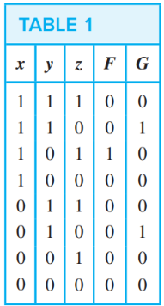F(x,y,z) = xy’z … cause form diagram it can be easily seen that it is one only in third row.

G(x,y,z) = xyz’ + x’yz’ … cause it value is one when y=1,z=0 and for both values of x.

* A **literal** (one variable) is a Boolean variable or its complement. A **minterm** (groups of variable that forms Boolean function) of the Boolean variables x1, x2, … , xn is a Boolean product y1y2 ⋯ yn, where yi = xi or yi = xi . Hence, a minterm is a product of n literals, with one literal for each variable.

A minterm has the value 1 for one and only one combination of values of its variables. More precisely, the minterm y1y2 … yn is 1 if and only if each yi is 1, and this occurs if and only if xi = 1 when yi = xi and xi = 0 when yi = x’i .

1. *From given data* : Find a minterm that equals 1 if x1 = x3 = 0 and x2 = x4 = x5 = 1, and equals 0 otherwise.

The minterm (x1’ x2 x3’ x4 x5) has the correct set of values.

1. *From equation* : Find the sum-of-products expansion for the function F(x, y, z) = (x + y)z’.

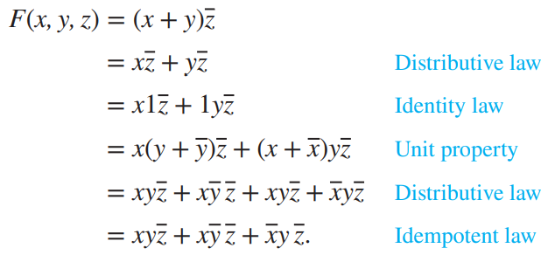

***9.2.2) Functional Completeness*** : Because every Boolean function can be represented using these operators we say that the set {⋅,+, − } is **functionally complete**. Such sets exist. Define two operators, the ∣ or NAND operator, defined by 1 ∣ 1 = 0 and 1 ∣ 0 = 0 ∣ 1 = 0 ∣ 0 = 1; and the ↓ or NOR operator, defined by 1 ↓ 1 = 1 ↓ 0 = 0 ↓ 1 = 0 and 0 ↓ 0 = 1. Both of the sets {∣} and { ↓ } are functionally complete.

x = x ∣ x,

xy = (x ∣ y) ∣ (x ∣ y)

x + y = (x ∣ x) ∣ (y ∣ y)

x = x ↓ x.

xy = (x ↓ x) ↓ (y ↓ y).

x + y = (x ↓ y) ↓ (x ↓ y).

* 1. **Logic Gates** :

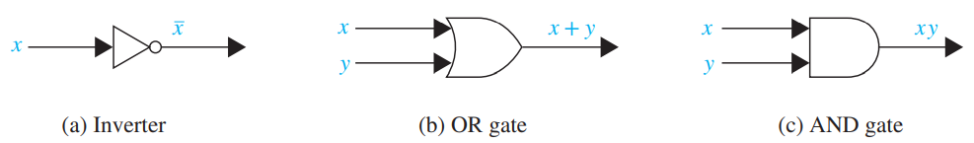

All logic gates like inverter, OR gate, AND gate is combinational circuits. Circuits have no memory capabilities. Such circuits are called **combinational circuits** or **gating networks**.

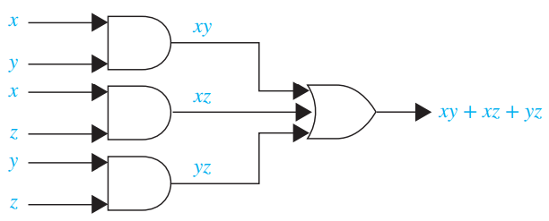

* *Example* : A committee of three individuals decides issues for an organization. Each individual votes either yes or no for each proposal that arises. A proposal is passed if it receives at least two yes votes. Design a circuit that determines whether a proposal passes.

*Solution* :

***9.3.1) Adder*** :

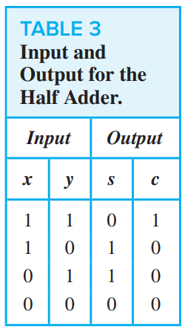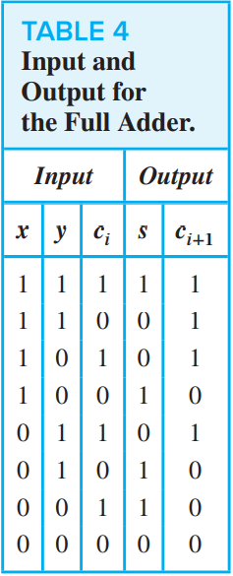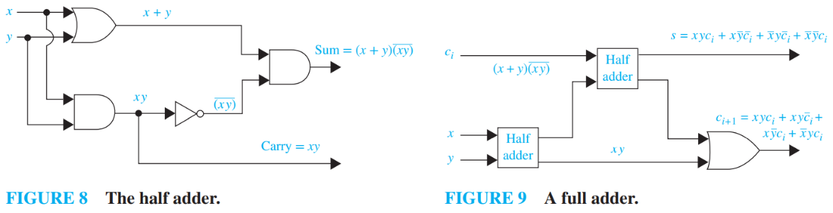

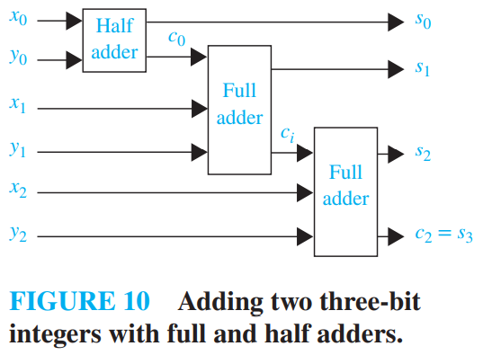

The circuit that we are designing is called the **half adder**, because it adds two bits, without considering a carry from a previous addition. We use the **full adder** to compute the sum bit and the carry bit when two bits and a carry are added.

* 1. 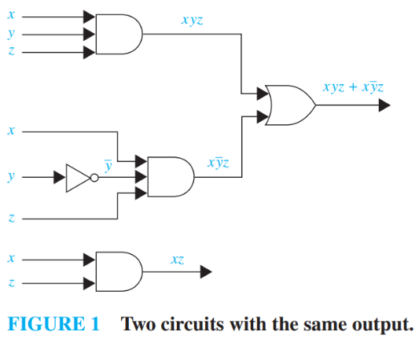**Minimization of Circuits** :

Finding such a sum of products is called **minimization of the Boolean function**.

**COMPLEXITY OF BOOLEAN FUNCTION MINIMIZATION** : Unfortunately, minimizing Boolean functions with many variables is a computationally intensive problem. It has been shown that this problem is an NP-complete problem, so the existence of a polynomial-time algorithm for minimizing Boolean circuits is unlikely.

***9.4.1) Karnaugh Maps*** :

A K-map for a Boolean function in these two variables consists of four cells, where a 1 is placed in the cell representing a minterm if this minterm is present in the expansion. Cells are said to be **adjacent** if the minterms that they represent differ in exactly one literal.

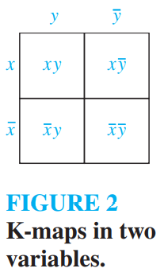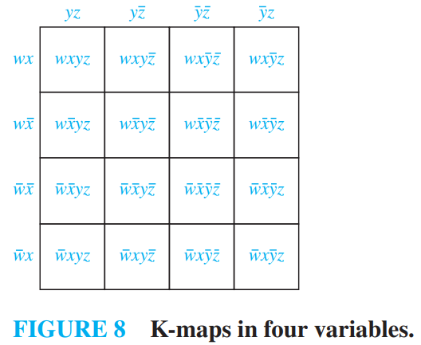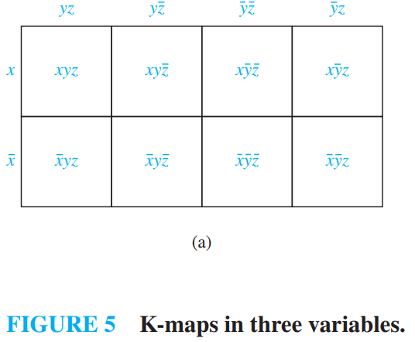

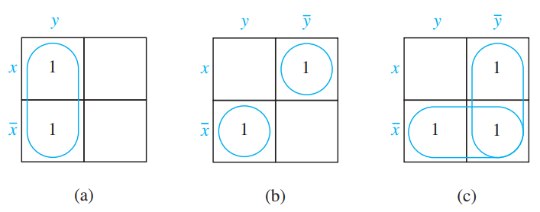

* Find the K-maps and minimize following : (a) xy + x’y, (b) xy’ + x’y, and (c) xy’ + x’y + x’ y’.

*Solution* : (a) y, (b) x’y + xy’, and (c) x’ + y’

* 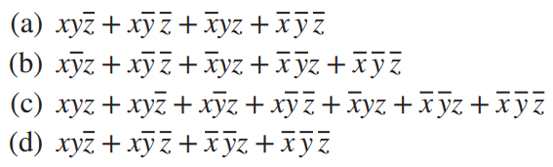Use K-maps to minimize these sum-of-products expansions.

*Solution* : (a) xz’ + y’z’ + x’yz, (b) y’ + x’z, (c) x + y’ + z, and (d) xz’ + x’y’.

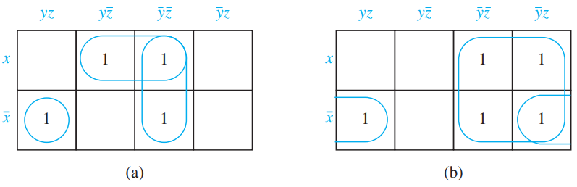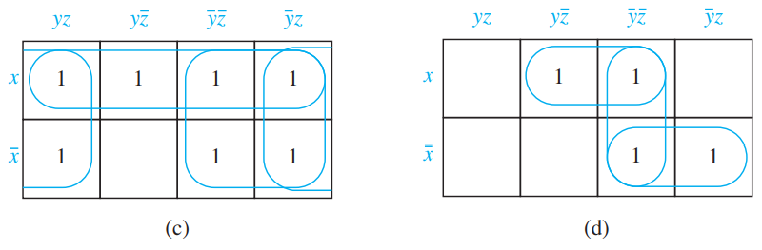

* Use K-maps to simplify these sum-of-products expansions.

*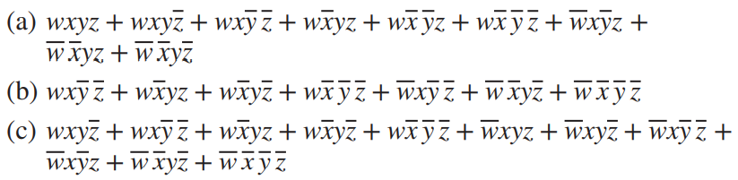Solution* : (a) wyz + wxz’ + wx’y’ + w’x’y + w’xy’z

(b) y’z’ + wx’y + x’z’

(c) z’ + w’x + wx’y

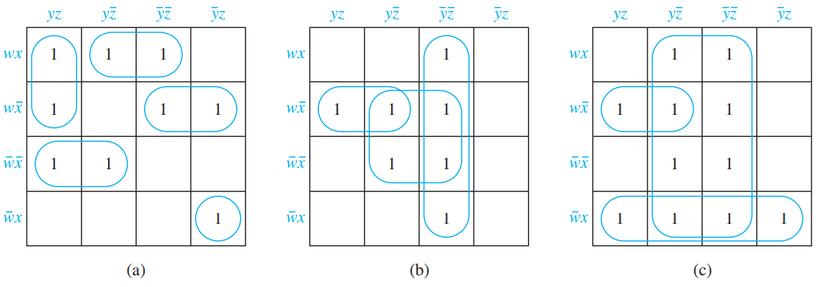

We use a rectangle containing 2⌊n∕2⌋ rows and 2⌈n∕2⌉ columns. (These K-maps contain 2n cells because ⌈n∕2⌉ + ⌊n∕2⌋ = n.), Where n represent number of variables.

***9.4.2) Don’t Care Conditions*** : A d is used in a K-map to mark those combinations of values of the variables for which the function can be arbitrarily assigned.

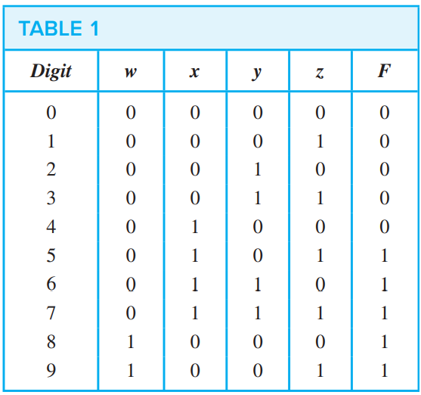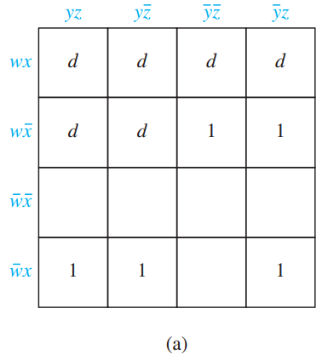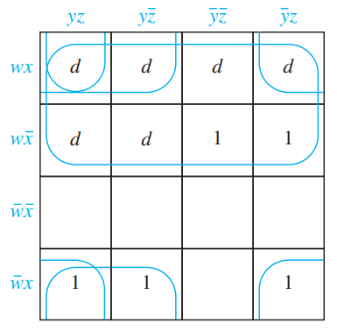

F(x, y, z) = w + xy + xz

Always choose square because it can eliminate two variables. Second priority is rectangle and then line then small bug lines.

***PREVIOUS YEAR QUESTION*** :

Set Theory & Algebra – 122 (1, 2, 3)

Linear Algebra – 77 (4, 5)

Numerical Methods and Calculus – 93 (6, 7)

Graph Theory – 91 (8, 9)

Combinatorics – 22 (10)

Propositional and First Order Logic – 89 (11, 12)

**NOTE** :

1. Refine : Make minor changes so as to improve or clarify (a theory or method)
2. Number of function form A to B such that A and B have a, b elements is **b^a** and relation is **2^ab.**
3. 
4. Look all the condition including OR and AND operation. You did mistake in equivalence relation in gate question.
5. Set of Rational numbers are countable. Rational numbers are of the form p/q where p,q are integers. Enumeration procedure, take p+q and write down all possible values (positive and negative).
6. Total number of binary operation possible with set having n element = nn^2
7. Total number of binary functions having n binary element = 22n
8. If the degree sequence is zero then it is not necessary in case of tree that it is valid degree sequence. You also have to check for vertices and edges. It should be e = v – 1.
9. N different equivalence classes on a set with M elements is same as N partition of M number. For example, 3 partition of 5 number is 1,2,2 or 3,1,1 or 2,1,2 but not 0,1,4. It should not include zero.

***Set Theory & Algebra*** :

1. The number of equivalence relations of the set {1,2,3,4} is

*15*

*16*

*24*

*4*

**Answer** : No. of Equivalence Relations on a set of n elements is given by the nth BELL number Bn.

1. Let G be a finite group on 84 elements. The size of a largest possible proper subgroup of G is _______ . Note - This was Numerical Type question.

*42*

*84*

*1*

*28*

**Answer** : According to Lagrange's theorem, states that for any finite group G, the order (number of elements) of every subgroup H of G divides the order of G. Therefore, possible subgroups of group on 84 elements are : 1, 2, 3, 4, 6, 7, 12, 14, 21, 28, 42, 84. Subgroups with element 1 and 84 are trivial groups. The size of a largest possible proper subgroup of G is 42.

1. Consider the set of integers I. Let D denote “divides with an integer quotient” (e.g. 4D8 but 4D7). Then D is

*Reflexive, not symmetric, transitive*

*Not reflexive, not antisymmetric, transitive*

*Reflexive, antisymmetric, transitive*

*Not reflexive, not antisymmetric, not transitive*

**Answer** : 4D8 here 4 divides 8 and quotient is 8/4= 2 i.e. an integer

For reflexivity for all x∈I,R(x,x) but this is violated for x=0. So, given relation is not reflexive.

For symmetry, for all x,y∈I,R(x,y)⟹R(y,x). This is violated for x=2,y=1.

For anti-symmetry, for all x,y∈I,(R(x,y)∧R(y,x))⟹x=y. We have R(−1,1) and R(1,−1) so R is not anti-symmetric.

For transitivity, for all x,y,z∈I,R(x,y)∧R(y,z)⟹R(x,z). As per the rule of division this holds.

1. The number of elements in the power set of { {1, 2}, {2, 1, 1}, {2, 1, 1, 2} } is

*3*

*8*

*4*

*2*

**Answer** : first see the definition of set : each element of set should be distinct and hence 211 represent 12 only and hence 12 and 21 represent only one 12 so total element in this set is {1,2} and we can arrange this element in two ways as 2^1 = 2.